VIETNAM NATIONAL UNIVERSITY OF HO CHI MINH CITY

THE INTERNATIONAL UNIVERSITY

SCHOOL OF COMPUTER SCIENCE AND ENGINEERING



**TOUR MANAGEMENT MOBILE APP USING FLUTTER**

By

Vuong Lam Kiet – ITITIU14050

A thesis submitted to the School of Computer Science and Engineering in partial fulfillment of the requirements for the degree of Bachelor of Computer Science

Ho Chi Minh city, VietNam

Year 2020

**TOUR MANAGEMENT MOBILE APP USING FLUTTER**

APPROVED BY

**ACKNOWLEDGEMENTS**

Firstly, my deepest gratitude and appreciation I would like to give to Prof. Tran Thanh Tung, without whom I would not be able to achieve my goal for this thesis. His support in the field of knowledge and his encouragement has been a tremendous motivation for me to be able to complete this thesis.

I would also like to express my appreciation to Mr.Dang Tam Nhan and my friends who have also been very helpful guides for me throughout my work. In addition, my appreciation and respect would also be given to the faculty of the School of Computer Science of International University, for all the help and guidance. My gratitude also goes toward the members of my reading and examination committee.

**TABLE OF CONTENTS**

ACKNOWLEDGEMENT

TABLE OF CONTENTS

LIST OF FIGURES

LIST OF TABLES

ABSTRACT

CHAPTER I: INTRODUCTION

CHAPTER II: LITERATURE REVIEW/ RELATED WORKS

CHAPTER III: METHODOLOGIES / REQUIREMENT ANALYSIS AND DESIGN

CHAPTER IV: IMPLEMENTATIONS AND RESULTS

CHAPTER V: DISCUSSION AND EVALUATION

CHAPTER VI: CONCLUSION & FURTHER WORKS

**LIST OF FIGURES**

**LIST OF TABLES**

**ABSTRACT**

Technologies is one of the many ever-growing trend in the modern world, with the growth of which brings about many innovative products to help us in many aspect of life. One of which is the mobile devices, small yet smart, nimble yet powerful, smartphones have taken over the world as a must have personal devices for everyone. As smartphone becomes smarter and more efficient, many applications are being introduced to help better improve the many requirements and the many satisfactory needs of everyone. One of those needs is travelling, travelling comes in many forms, but the most popular one that we can think of is touring. Touring itself is a collection of options, a tour can be self-guided or guided by a tour guide, with the introduction of personal devices we have the addition of virtual tours, audio-guided tours, video-guided tours, even location-based trigger tours. Despite the fact that mobile devices created many new innovative form of tours, the problem still exist in handling the traditional self-guided or guided tour. The solution is to find a way in which the application of mobile devices can be put into improving the traditional guided tours, making them into a newer, more innovative, more controlled and yet more interesting.

**CHAPTER I**

**INTRODUCTION**

**1.1 BACKGROUND**

With the ever-growing trend of development of technology, mobile devices are getting more and more powerful and convenient to aid users in many everyday tasks. The growth of mobile devices brings along the growth of mobile applications and mobile application development frameworks, which are also becoming more resourceful in creating many helpful applications for many purposes. One of the many applications that we can put into good use is the campus tour management application. The idea was inspired by the current state of the IU Ambassador campus tour program, the program has been conducted for many years and still runs in a manual way, which led to many conflicts and problem. The IU Tour App idea was created with the goal of resolving those problems and make IU Ambassador a more controlled, better organized and smoother operation.

**1.2 PROBLEM STATEMENT**

The current state of the IU Ambassador program has some flaws that can be stated from observing the operation such as:

* There is a lack of control in the way the program is operated
* Management level staffs usually have problems trying to communicate with the guides during operation for any updates and vice versa.
* The planning of the program can sometime be very hectic and confusing
* Planing with problem can not be fixed immediately and updates can not be reached on time which cause conflicts in tour groups
* Management level staff lacks many information on the students who went on the tour, and the program also lacks the helpful evaluation and feedback from the students.

The problems stated above would be later translated into user requirement for the application. This thesis aims to find the resolution for the problems in the form of a mobile application for all members of operation as well as the member of participants on the tour.

**1.3 SCOPE & OBJECTIVES**

With the many functions and application possibilities, this thesis aim to focus the application on the IU Ambassador program. The main goal is to take care of the role and responsibilities of the management level and guide level along with the addition of the evaluation collection from the participant. The app should provide a digitalized management process, with real-time enabled functions, all comes in a super compact package of a mobile device. In this thesis, I will demonstrate the research and implementation of the application to help fix the current problematic state of the on-going IU Ambassador program, with the aim to further improve the quality of operation of the program alongside with the addition of extra helpful features to help the program more in the future.

**1.4 ASSUMPTION AND SOLUTION**

With the assumption of that every member of both the operator and the participant should have on-hand a mobile device, the idea of an application for those mobile devices to better improve the quality of the tour for all is quite feasible. Users from the operator team can be able to track the progress, updates and communicate with each other more conveniently, whereas the users from the participant team can see where they are going, they should be able to contact their guide more efficiently and they can provide more of their precious evaluations about the many features of the tour, these evaluations shall be used for further improving the quality of the tour and the application.

**1.5 STRUCTURE OF THESIS**

The following is a brief description of the structure of this thesis through each chapter.

* Chapter 1: Introduction

In this chapter, the background information of this thesis will be introduced, along with the statement for the current problems. Then the scopes and objectives of the thesis will also be defined. Assumptions and solutions for the implementation of this thesis will also be introduced in this chapter.

* Chapter 2: Literature Review

In this chapter, the technologies and tools used in development for the application in this thesis will be discussed. The tools and technologies will be introduced, compared with many alternatives. Also in this chapter, the steps to set up the tools and techniques will be shown in very detailed instructions.

* Chapter 3: Methodologies – User Requirement Analysis and Design

In this chapter, the user requirements will be gathered based upon the problem statements. The design for the system to accommodate the user requirements will be shown. This chapter will hold the many designs for the system such as Use Case, Architecture, Sequence, ERD. The concept design for the user interface of the application will also be shown in this chapter.

* Chapter 4: Implementation & Result
* Chapter 5: Discusstion & Evaluation
* Chapter 6: Conclusion & Further Works

**CHAPTER II**

**LITERATURE REVIEW**

**2.1 MOBILE APPLICATION**

***2.1.1 What is a mobile application?***

Mobile applications, also known as “apps” for short, are simply software that were created by developers and can be installed onto a mobile device such as a smartphone or a tablet. These apps are generally small in size in order not to take up much storage, installation is very easy for all devices types, the idea of an appstore for mobile devices was first brought about by Apple,Inc.



*Figure 1: Illustration of mobile applications*

***2.1.2 Why choose a mobile application ?***

Mobile applications depend heavily on the devices where they were installed on, therefore in some certain cases, many functions or services can be limited to the resources provided by the devices. However, technology is always growing so the resource limit would not be an issue for long, hence mobile apps with their compact size, convenience and features would be an exceptional solution for the active nature of the IU campus tour as well as to show how powerful the mobile devices are in practice.

***2.1.3 Types of mobile application ?***

Mobile applications are divided into two main categories: Native and Non-Native. In general, Native apps are platform-specific whereas Non-Native (also known as hybrid) apps don’t rely too heavy on whichever platform they are working on. The following are the breakdown on the advantages and disadvantages of the two types of apps.

|  |  |  |
| --- | --- | --- |
|  | **Advantages** | **Disadvantages** |
| **Native Apps** | _ Official tools and frameworks by the platform.  _ Native appearance, native performance.  _ Quick to be on demand with official platform updates. (Updates from platform will reach native apps faster).  _ Better performance, independent of the Internet.  _ Fast and simple integration with devices resources. (Native language can get access to device resources). | _ High cost. (iOS uses Swift that can only be found on an expensive Mac).  _ Low flexibility. (Native apps can only be written in native language, transferring is very difficult).  _ Time-consuming. (Developers will need to make many version of apps for each platform).  _ Prone to bugs. (Platform updates will affect native app directly, new updates can bring bugs, developers will have to work with both Android and iOS to make sure the app is running optimally). |
| **Non-Native (Hybrid) App** | _ Low cost. (Universal tools and frameworks).  _ Ease of development. (Non-native languages can be some familiar languages such as JavaScript, PHP).  _ High flexibility. (Code once, run on all platform withour rewriting).  _ Native look and feel.  _ Less prone to bugs from updates.  (Official updates will be modified to fit with the framework, this will ease the app update process). | _ Slightly lower performance than native apps.  _ Requires Internet connection to operate. (Some non-native apps are web-based apps, so they will need an Internet connection to function).  _ Slightly low on integration with device resources. (Non-native languages needs additional libraries to be able to integrate with the device resources, this can sometimes be a problem for any big, complex applications). |

*Table 1: Comparing Native apps and Non-Native apps*

***2.1.3 Why choose the option of a cross-platform mobile application?***

Firstly, the goal of this thesis is to create a robust solution to help improve the quality of the traditional guided campus tour. A mobile app will be the supporting tool to help digitialize the many processes of the tour, since many people will have different phones with different operating system, a cross-platform app will be the best choice to make the app available to anyone. Secondly, as mentioned in Table 1 above, we find that though Native apps have the highest performance and easiest integration with any resources that will be very fitting to any big, complex application solution. However, the application for the tour will need to be simple, easy to use so in order to help with ease of development, cost efficiency and high flexibility, Non-native apps are the winning choices. In addition, the tools and frameworks to create Non-native apps are always changing and evolving, hence the performance gap between Native and Non-native apps is getting slimmer and slimmer from time to time. For these reasons, we find that Non-native app is the best choice for the application in this thesis.

**2.2 FLUTTER PROGRAMMING FRAMEWORK**

***2.2.1 What is Flutter?***



*Figure 2: Flutter Logo*

Flutter is a cross-platform mobile application development frameworks that produce Non-native apps. Flutter was developed and backed by Google,Inc. The framework ultilize the Dart language as its main developing language for creating mobile apps. With Flutter, developers will have the following benefits

* *Flexibility in development*

The framework is able to create both iOS and Android apps without the need to switch IDE or coding technique. Flutter is also available to create web application, which is still in beta.

* *Single code base development*

Flutter ultilize Dart as its only development language. Dart is a very powerful yet easy language to pick up. Dart with its vast libraries and widgets can be used to create both iOS and Android apps in one single set of code. Just write once and the app will be able to run on both system.

* *Everything in Flutter is a widget*

For any developers with background in native apps or web applications. Flutter is very easy to pick up and use. Everything in Flutter is a widget, Flutter has a big library of widgets that support building UIs, handling interactions, handling logic flows, state management, integrations with other services or systems.

* *Feature packed, ready to use out-of-the-box*

Flutter is loaded with features that support developers during and even after the process of making the applications. Some significant features can be: Hot Reload, Developer Tools, Firebase integrations, UI widgets libraries.

* *Native UI, Native performance*

Flutter apps can have Native like behaviors, such as the native like performance and the UI with native theming (Cupertino for iOS, Material for Android).

***2.2.2 Comparing to alternatives (React Native)***

One other very popular framework for developing mobile applications that many people use is known as React Native which uses JavaScript as its main language. It is based on ReactJS and was developed by Facebook. The comparison for the two are as followed.

|  |  |  |
| --- | --- | --- |
| **Criteria** | **Flutter** | **React Native** |
| **Development language** | Dart. Newer, faster in compilation than JavaScript. | JavaScript. Old, well-known, slower than Dart. |
| **Popularity** | Dart and Flutter level popularity is quite decent but is being adopted by many developers. | React Native with JavaScript have a higher popularity compare to Dart and Flutter. |
| **Performance** | Flutter has a built-in set of components that works with native components directly without the need for any bridge connections between. This makes Flutter faster in execution of native related processes. | React Native need to use Flux (a bridging component) to make a bridge connection to the native components. This makes React Native slower in speed and reduce the performance of the app. |
| **Setup & Configuration** | Both have simple CLI commands for setting up development environment. However, Flutter has a more detailed guide compare to React Native | |
| **Testing Support** | Flutter has a set of testing kits that can be very helpful for developers during the development phase as well as the testing phase of the application. Testing are available for UI, widgets, integrations testing. | React Native provide snapshot testing of app (Jest) but there is no testing kit available for in-depth UI testing, integration testing or release testing. React Native would require third party testing tools like Appium or Detox. |
| **Release Support – CI/CD** | Flutter app can easily be released right from the command line. Flutter also has many CI/CD support tools (CodeMagic). | App release on React Native is very manual. React Native also lack the tools to support CI/CD processes, though it can be set up via Nevercode. |

*Table 2: Comparing Flutter and React Native*



*Figure 3: Flutter versus React Native illustration*

From the features comparison of Table 2, we find that although Flutter and Dart is still new and not very well-known for many developers, it is more powerful and more resourceful compared to React Native. Flutter is more prepared, packed with more built-in features. In addition, Flutter development is also more efficient and applications made with Flutter also perform better than React Native. Hence, the winner in this comparison is Flutter.

**2.3 DART PROGRAMMING LANGUAGE**

***2.3.1 What is Dart?***



*Figure 4: Dart programming language logo*

Dart is a compiled-type programming language that was developed by Google. Dart is used as the only development language in the Flutter framework for creating cross-platform mobile applications. Dart can also be used to create web application thanks to its powerful DartJS compiler that helps translate Dart to JavaScript. The features that come with Dart can be listed as followed:

* *Support for AOT (Ahead Of Time) and JIT (Just In Time) code compilation*

JIT: Code compilation and program execution happens right at the moment the developers finish writing or editing the code. JIT is the foundation of Hot Reload in Flutter.

AOT: Used mainly during the deployment phase. This feature provide the resource integration, plugins and translation of code to native machine code which is really helpful and productive to make any updates, patches.

* *Feature packed, highly optimized for building responsive UI*

Dart is very productive and rich in features that build the foundation for Flutter. One of those features is Hot Reload, a very useful feature to help developers check the outcome of the application as they are writing their code for the application. Dart is very optimized for building UIs, with static analysis on the code the are being written to help ensure TypeSafe, reduce on errors and ease the development process.

* *Familiar syntax, native like coding style*

For any developers with basic OOP knowledge, Dart though seems to be intimidating can be picked up quite easily since the behavior of the language is very similar to any other OOP languages such as Swift or Kotlin or JavaScript.

* *Fast development on all platforms*

Dart with a single code base can be applied on both Android and iOS devices. With DartJS, the code can also be applied for web applications. The language also has back-end integration.

***2.3.2 Comparing to alternatives (JavaScript)***

Flutter uses Dart whereas React Native ultilize an iteration of JavaScript. Below is the table to compare the features between the two languages.

|  |  |  |
| --- | --- | --- |
| **Criteria** | **Dart** | **JavaScript** |
| **Ease of use** | New language. Syntax and coding style are similar to Java and JavaScript. | Matured language. Used by many framework (Angular, React, Vue), easy syntax. |
| **Community Acknowledgement** | Young, small in scale but is still growing at a fast rate. | Large community, great support from others. |
| **Learning Curve** | Google’s vast and detailed docuamentation is highly resourceful for developers with OOP background from any other language to pick up Dart. | With basic knowledge of programming, JavaScript can be learnt relatively easy. However, the syntax can sometimes be quite tricky. |
| **Performance** | Almost twice as fast as JavaScript. Powerful features like AOT and JIT to help ease the development process. | Feels fast, but in fact is slower than Dart in performance speed. Only faster than Java. |
| **IDE Support** | Both can be used on any lightweight editor, or any well-known IDE such as VSCode or Android Studio. | |
| **Type Safety** | Both loose and strong prototyping are available, making sure no typos are left before compilation. | Interpreted language, can be “duck typed”, prone to typos and errors caught during run time. |
| **Platform Application** | Dart in Flutter can be use for iOS, Android with just one single code set. DartJS for web applications. | Used in React Native for iOS, Android apps with their respective code. Also used in web development (React). |
| **Commercial Uses** | Google apps, WorkTrail, Alibaba, Grab, etc. | Facebook, Instagram, AirBnB, etc. |

*Table 3: Comparing Dart and JavaScript*



*Figure 5: Dart vs JavaScript illustration*

As we can see from the features comparison of Table 3, Dart is younger, less popuplar comparing to JavaScript. Despite that, Dart is more powerful, more resourceful than JavaScript and to some groups of developers Dart can be considered to be a good replacement for JavaScript. With its many features, easy learning curve and its flexibility, Dart is getting more and more recognition in the developer communities.

**2.4 FIREBASE BACK-END SERVICE**

***2.4.1 What is Firebase?***



*Figure 6: Firebase logo*

Firebase is a Backend-as-a-Service (BaaS) developed by Firebase,Inc. Firebase provide a web and mobile application development platform for any Flutter applications. Google acquired Firebase, it is now maintained and integrated into the Google Cloud Platform by Google, this makes integration with Flutter apps more seamless and effortless than before. Firebase is a NoSQL type database, suitable for small to medium scale applications and support for real-time updates features. Some of the benefits from Firebase can be as followed:

* *Highly comprehensive development platform for mobile applications*

Firebase NoSQL database nature is highly suitable for applications that require real-time processes. The data is highly scalable, with many option of storage that support real-time updates such as Realtime Database, Cloud Firestore. Moreover, Fireabse provides many other features that can enhance the experience of mobile applications such as Cloud Messaging or In-App Messaging for push notifcations, Authentication service with phone authentication, email authentication, Crash Analytics to measure application performance.

* *Large collection of extensions*

Firebase provide extensions to connect with many functions that Google has such as: Text Translation, Mail Triggers, Images Triggers, with many more functions is still in beta and waiting to be added to the list.

* *Google Cloud Platform integration*

Firebase has been integrated to the Google Cloud Platform, therefore many services have also been integrated to Firebase such as AdMob, Marketing Platform, etc. are available for the deployment of applications.

***2.4.2 Why choose Firebase ? Comparing to alternatives (MongoDB) ?***



*Figure 7: Comparing Firebase with MongoDB illustration*

Firebase is suitable for small-scale applications, whereas MongoDB aims toward larger scale applications. Though lacking in security, performance and is younger in comparison with MongoDB, Fireabase is more well-known among the mobile applications developer communities due to its vast integration modules and feature libraries. Firebase also supports many mobile application development languages such as Swift, Dart, Java, JavaScripts, more than what MongoDB supports. Access methods for Firebase is also more flexible compared to MongoDB, Firebase data and services can be accessed with RESTful HTTP APIs, JavaScript APIs, Android/ iOS APIs (supports for mobile apps), meanwhile MongoDB can only be accessed using proprietary protocols using JSONs. Firebase with its flexibility, high level of support for mobile app development is clearly the perfect choice.

**2.5 SETTING UP DEVELOPMENT ENVIRONMENT**

***2.5.1 Setting up Dart.***

For using Dart, there is an option for developers who are getting to know the language, they can go and try the language on DartPad, an online editor provided by the Dart development team.

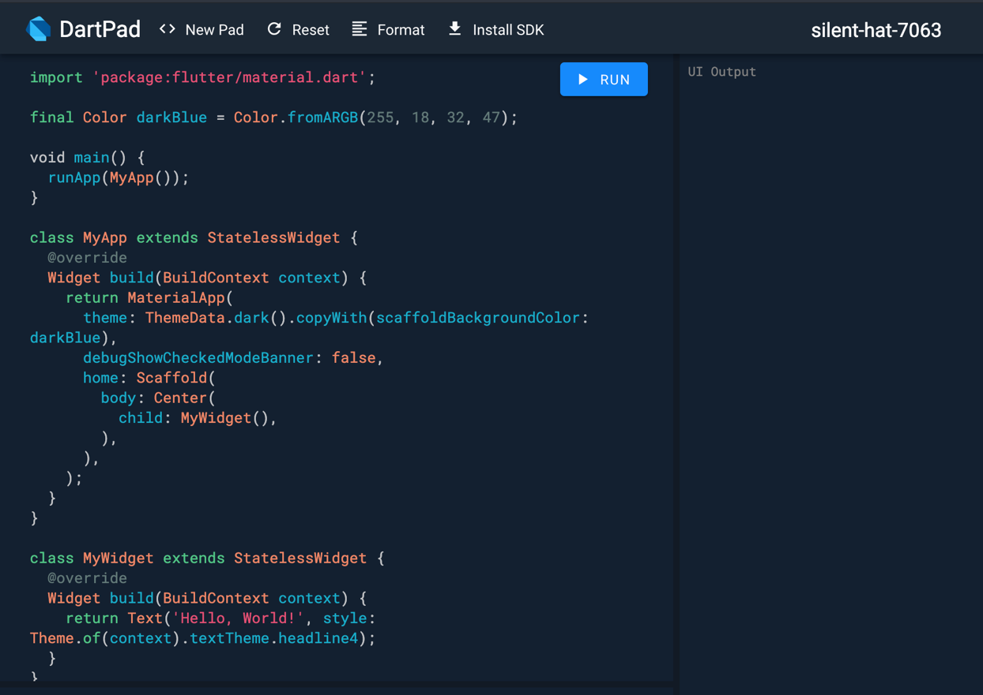

*Figure 8: UI of online editor DartPad*

For developers who wish to install Dart onto their machines and use it locally, the instruction available on the official Dart website. The procedure for installing the Dart SDK to a Mac computer is as followed:

1. Dart can be installed easily using the command line. Firstly, launch Terminal on Mac and install HomeBrew. HomeBrew is a package installer/manager that we can download and install easily using the command line:



*Figure 9: HomeBrew install command*

1. We can then use HomeBrew to install Dart with the following command.

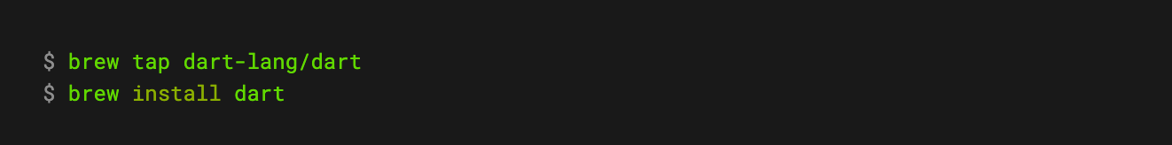

*Figure 10: Dart install command*

1. The terminal shall take care of the rest of the install. After the installation is completed, we can check the status, version of Dart by typing : ***brew info dart***

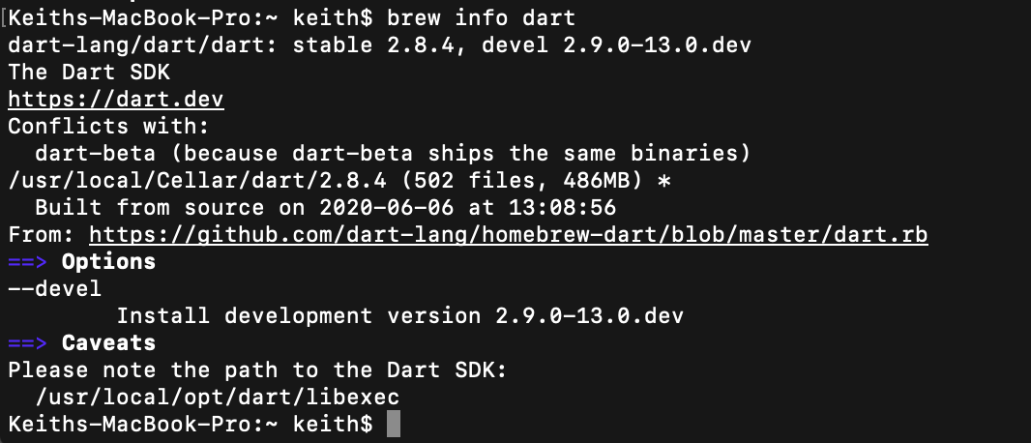

*Figure 11: Dart version check results*

1. After this, Dart is installed onto our machine. Dart can be used with any simple, lightweight text editors. All Dart files created will be mark with a “.dart” file extension. Dart can also be used to create mobile applications with Flutter, with the help of Android Studio or Visual Studio Code.

***2.5.2 Setting up Flutter.***

Flutter has a large library of documentations for installing and using Flutter on our machine. The steps for installing and start using Flutter is as followed:

1. Get the Flutter SDK from the official Flutter website (flutter.dev), extract the downloaded content and put the SDK in a globally accessible place on our machine.

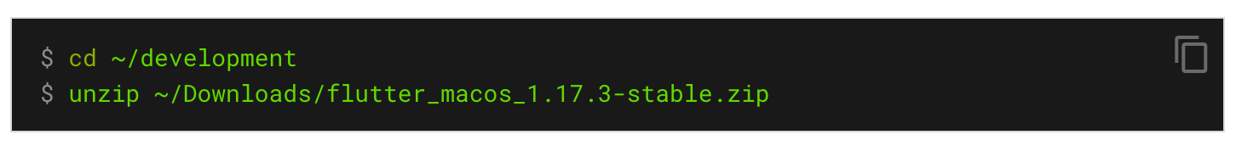

*Figure 12: Flutter SDK installing commands*

1. Flutter can be used by either Android Studio or Visual Studio Code (VSCode). Both IDE have a fair amount of plug-ins and extensions to help ease the development and enhance the experience for developers working with Flutter.

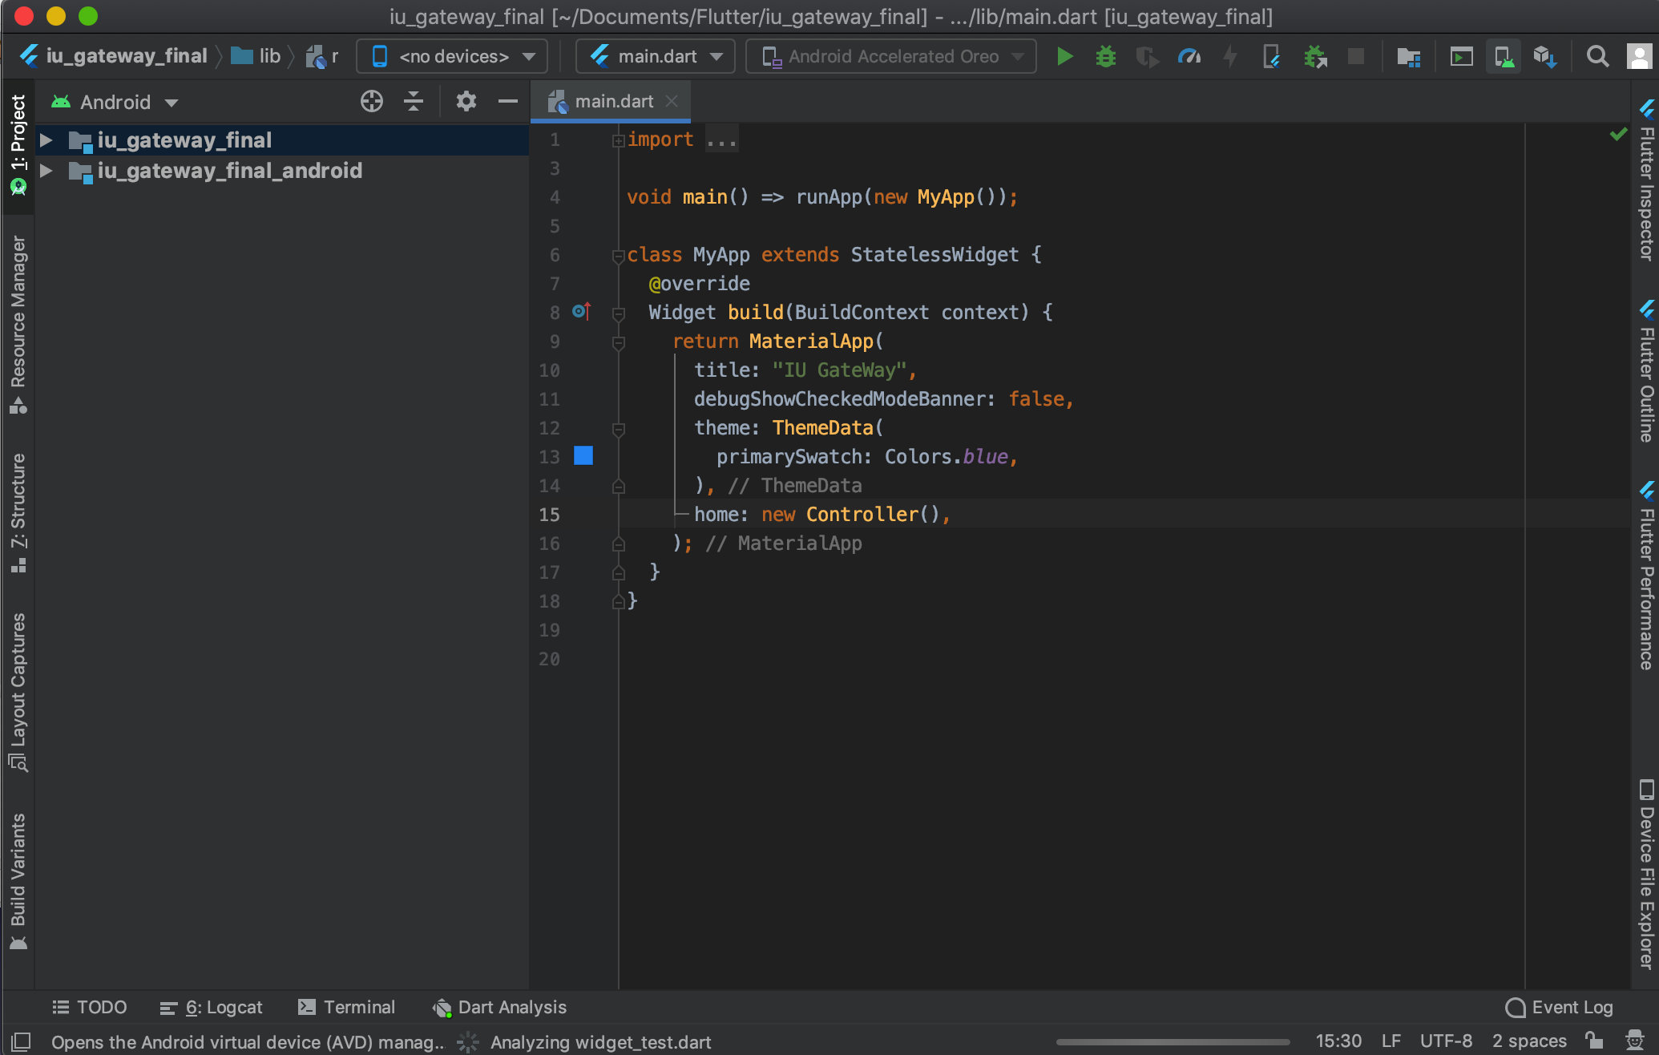

*Figure 13: Android Studio with Flutter support plug-ins installed*

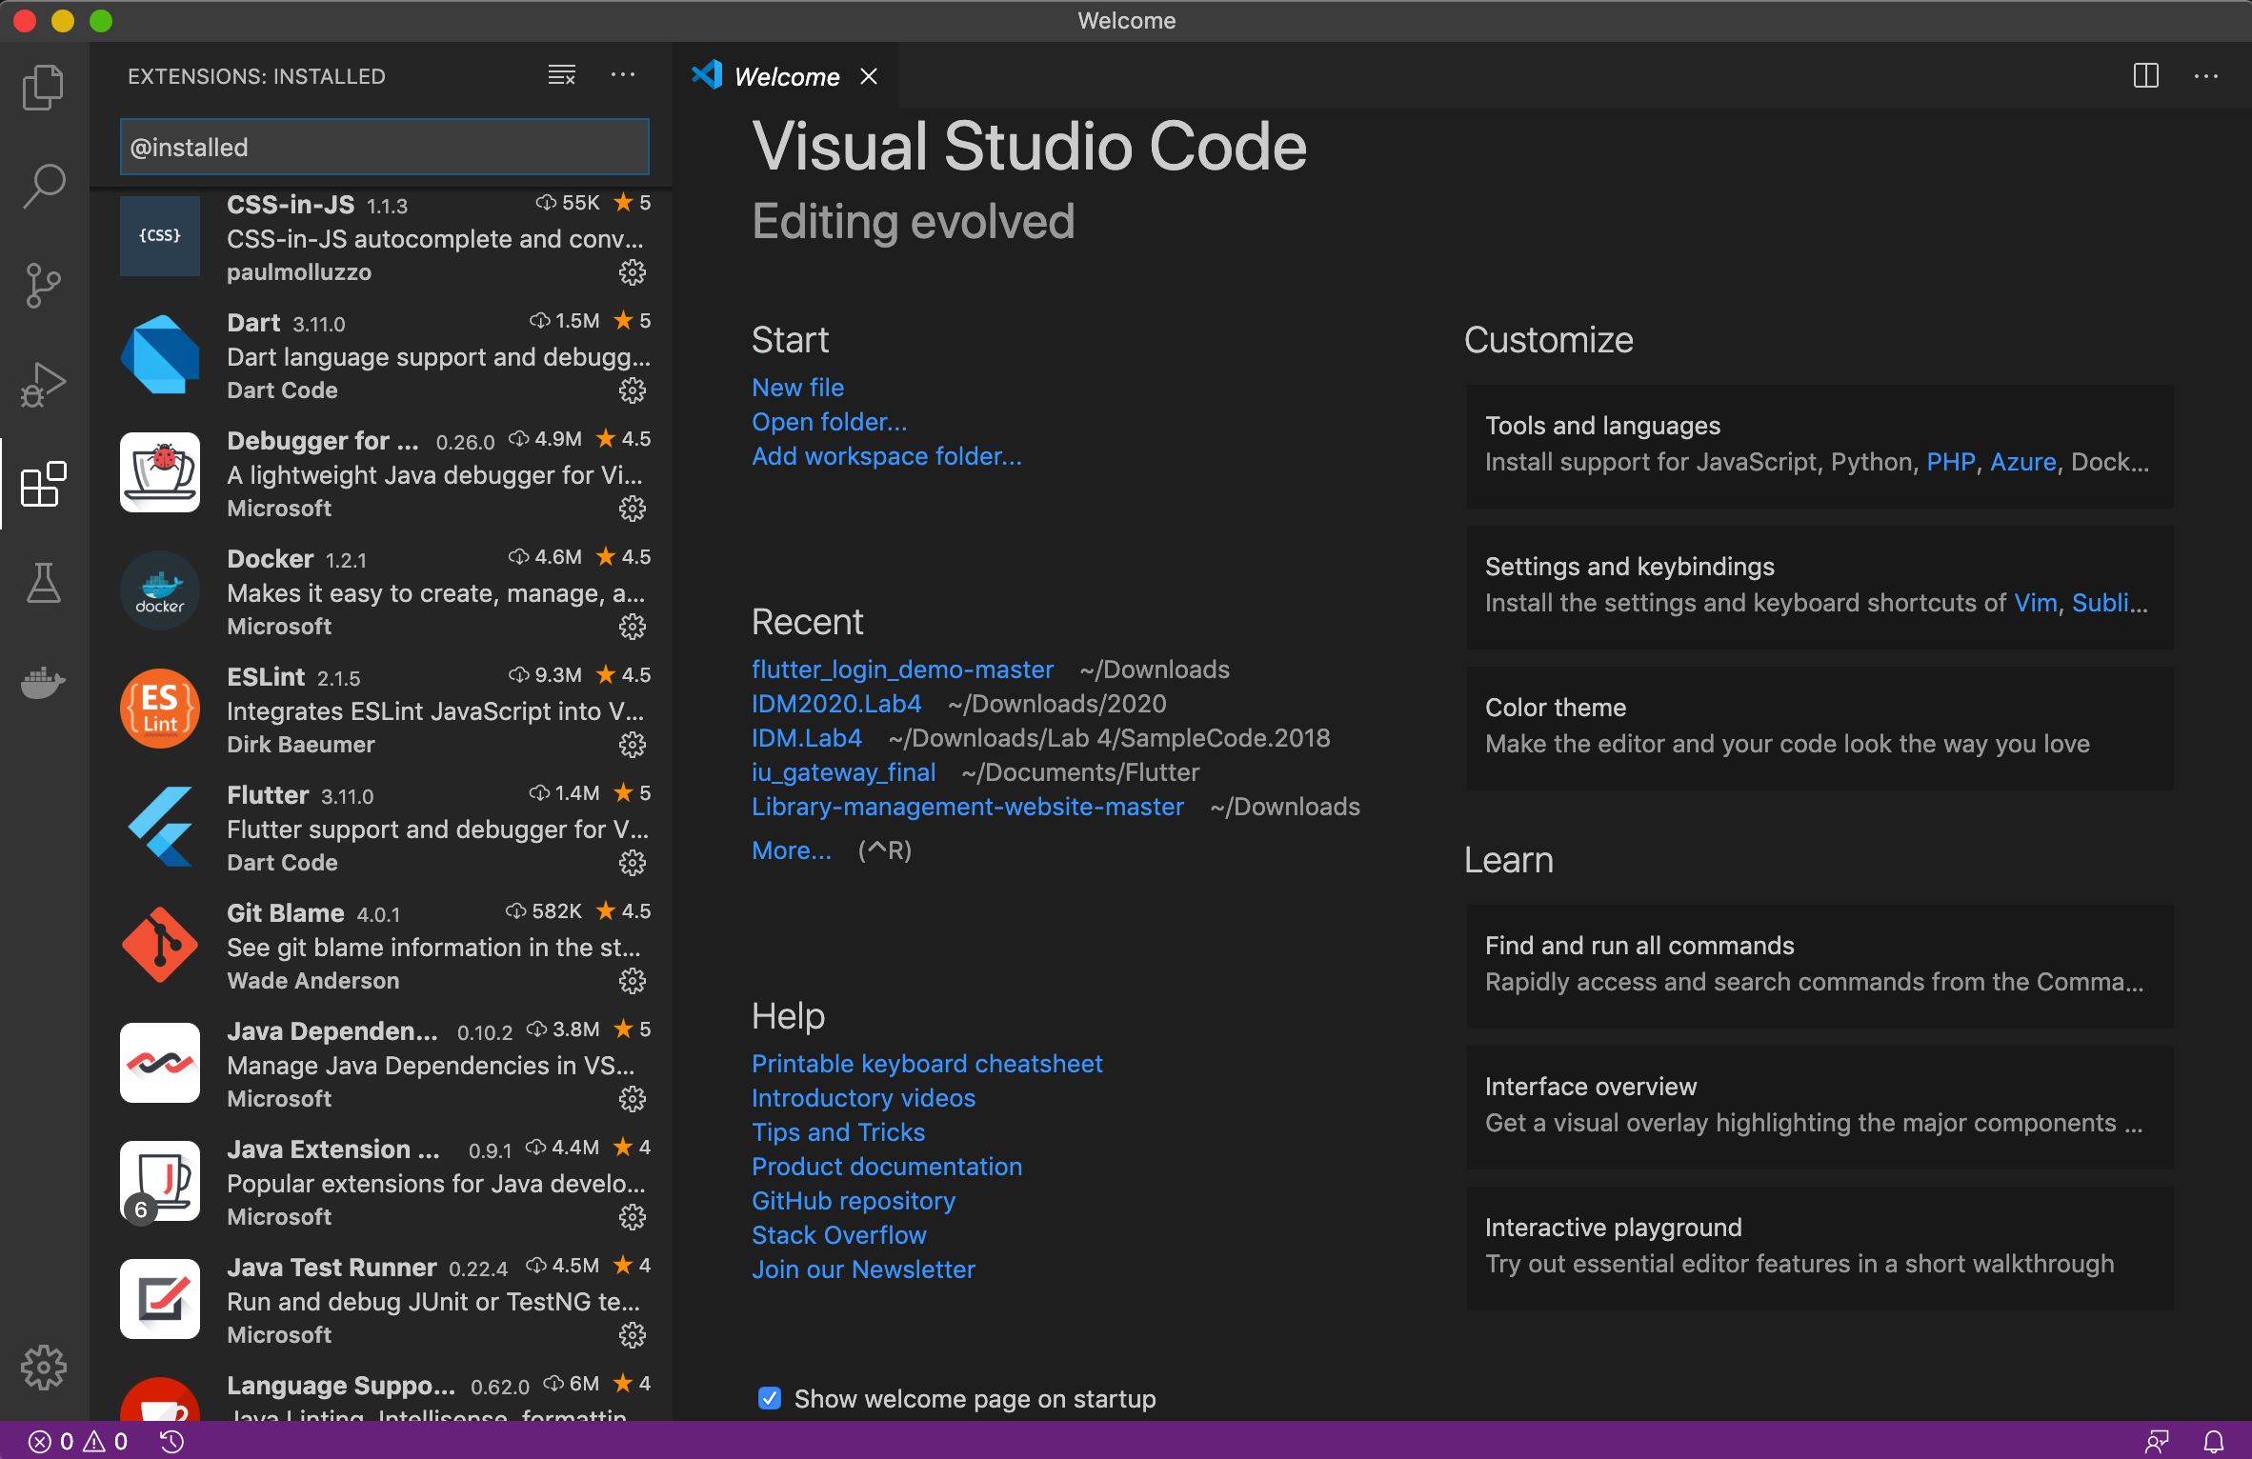

*Figure 14: Visual Studio Code with Flutter support plug-ins installed*

1. Both Android Studio and VSCode are equipped with built-in device simulators. This feature will help developers to test run their apps and both IDE support the very powerful feature of Flutter, which is Hot Reload.

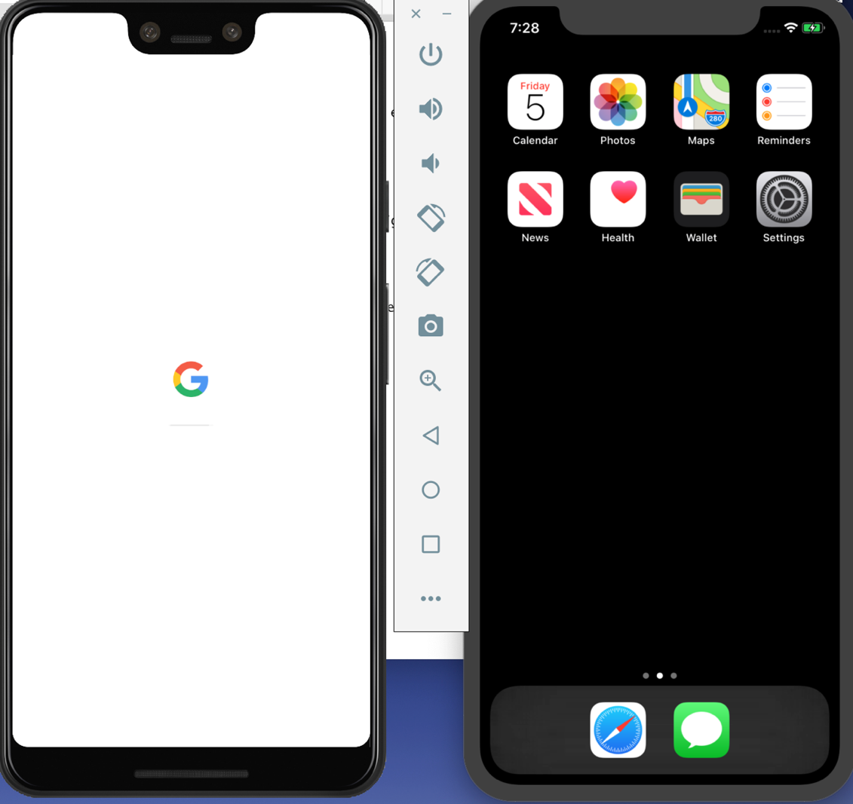

*Figure 15: Android (Pixel 3XL) and iOS (iPhone 11) simulators*

1. With Flutter installed, IDEs installed and virtual devices set up, we can now check the working status and issues of Flutter on our machine using the command: ***flutter doctor*** in Terminal.

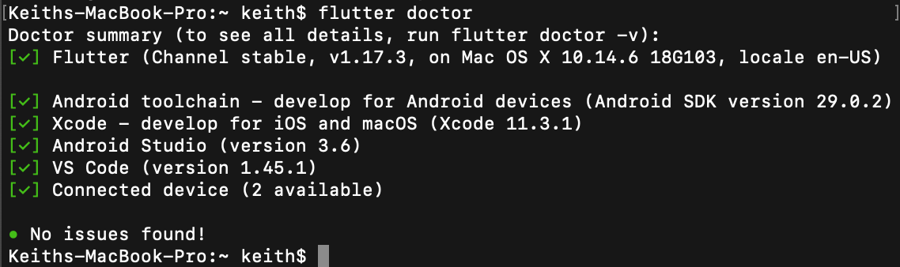

*Figure 16: Flutter status and issues check results*

***2.5.3 Setting up a Flutter app.***

In Android Studio, Flutter support is built-in, developers only need a few more plug-ins and extension to help with syntax highlight, typos highlights, and syntax error solutions. Create a Flutter app using Android Studio is fairly easy, with the following steps

1. Start Android Studio, choose “New” -> “Flutter Project”

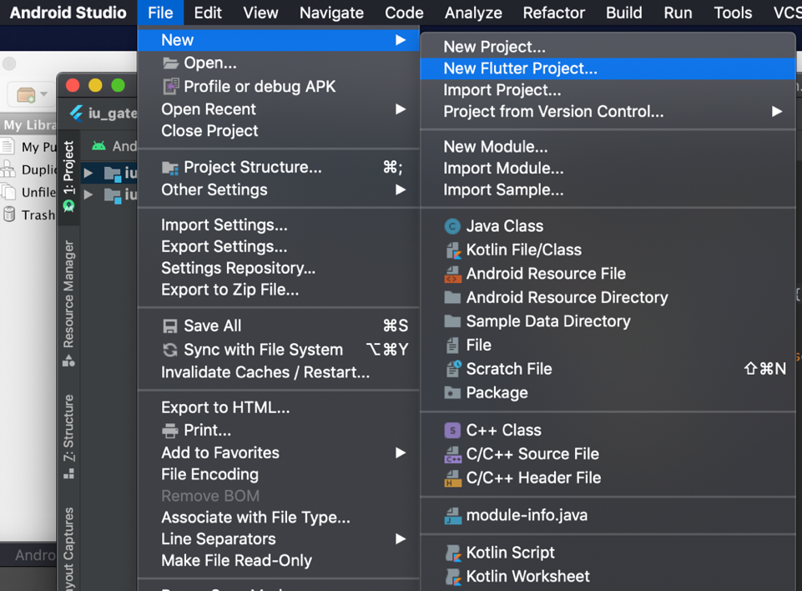

*Figure 17: Choosing a new Flutter project in Android Studio*

1. A dialog then appear, we can choose between “Fluter Application”, “Flutter Plugin,” “Flutter Package”, “Flutter Module”. Each optionn has their own purpose. For creating an app, we will choose “Flutter Application”.

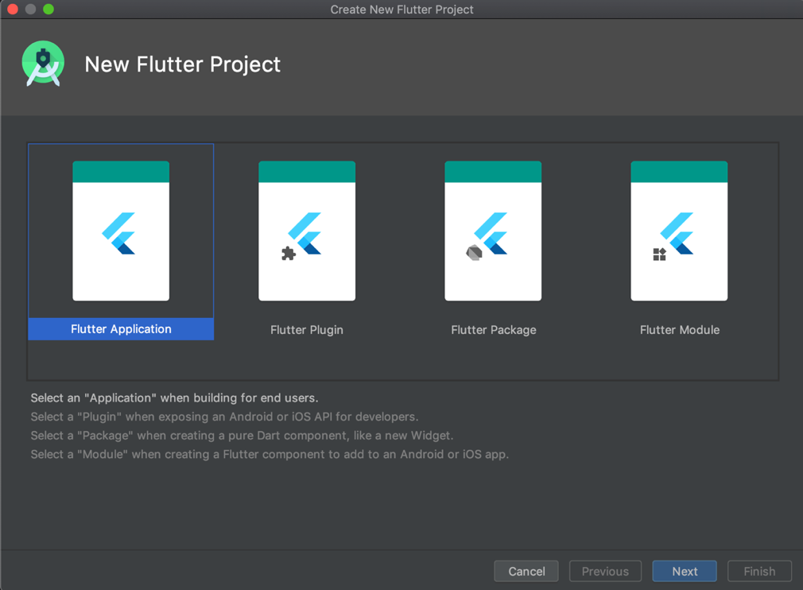

*Figure 18: Flutter project option dialog*

1. We can then set the detail information of the Flutter app with the next pop-up dialog, such as the name of the project, the SDK path, the location where the project will reside in and a brief description of the project.

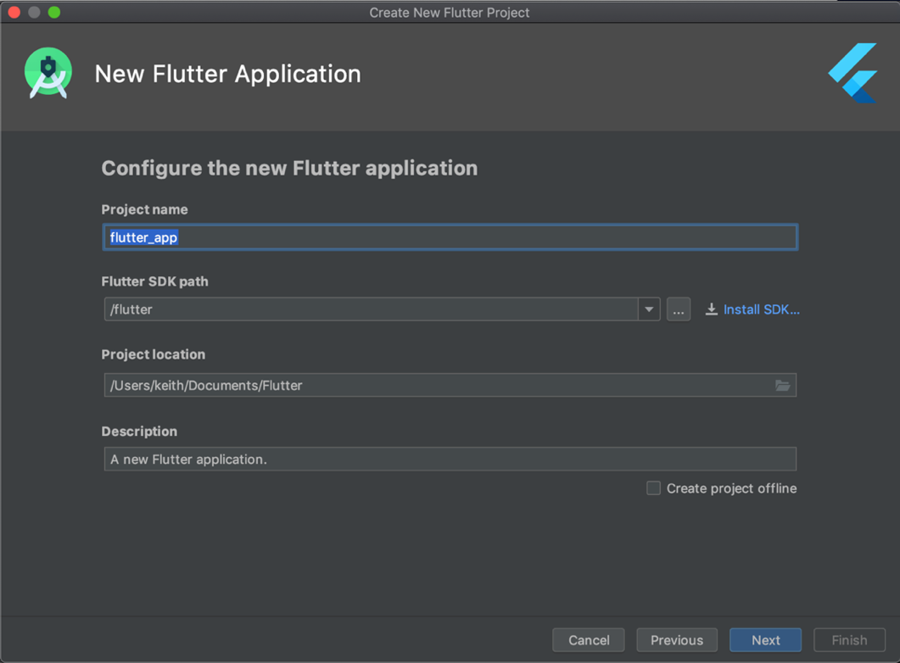

*Figure 19: Flutter project detail information dialog*

1. After we finish providing the information, Android Studio will take care of the rest of the setting up process. When done, we will be greeted with the project panel with intial boilerplate code from Flutter, the code can be run to create a simple counter application on the simulators.

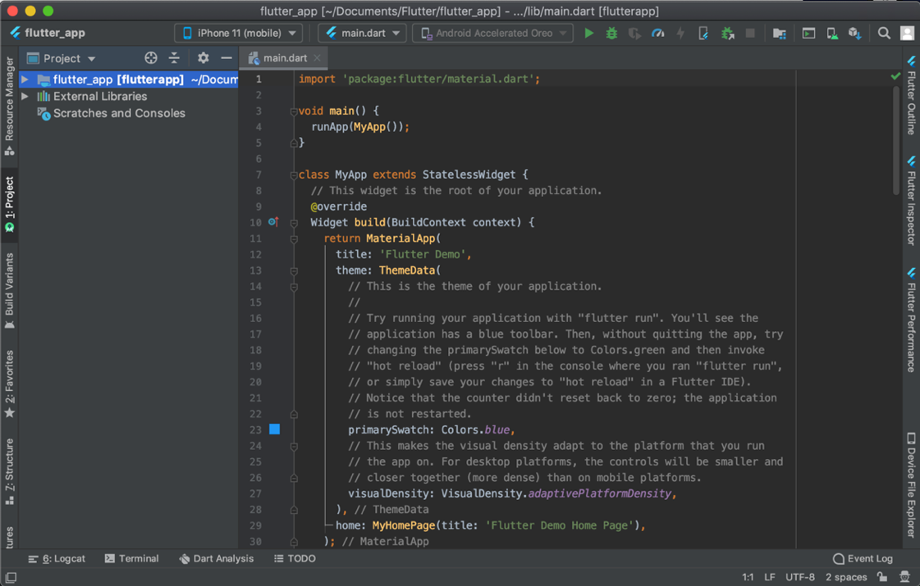

*Figure 20: Project development panel with boilerplate code*

***2.5.4 Setting up Firebase.***

Firebase itself is an online console where developers can manage projects with their connected applications (Web app, iOS apps, Android apps). To set up Firebase for a Flutter application, we first need to set up a new Firebase project on the Firebase console website.

1. Go to Firebase website and choose “Go to console”. The console interface will be shown as followed

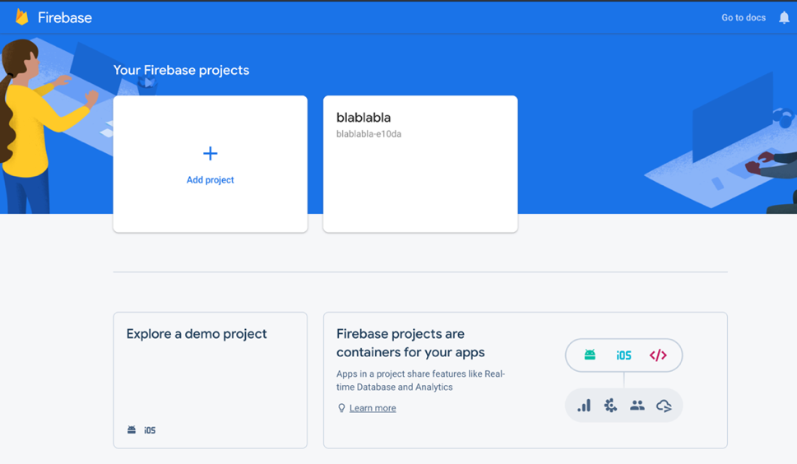

*Figure 21: Firebase console project manager interface.*

1. Choose “Add project” and provide the necessary information for the project. For the case of the application in this thesis, I have also chosen to enable Google Analytics for the project.

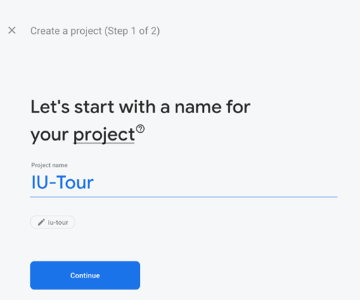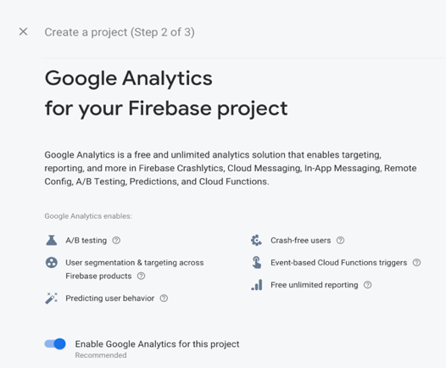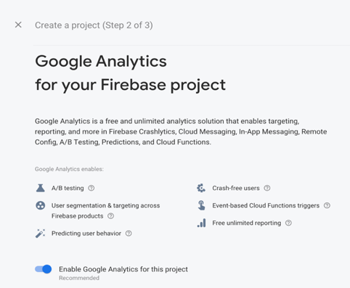

*Figure 22: Firebase project intialization steps*

1. After that, Firebase will take care of the rest of the project initialization process. When the process is done, we will be greeted with the project control panel as followed

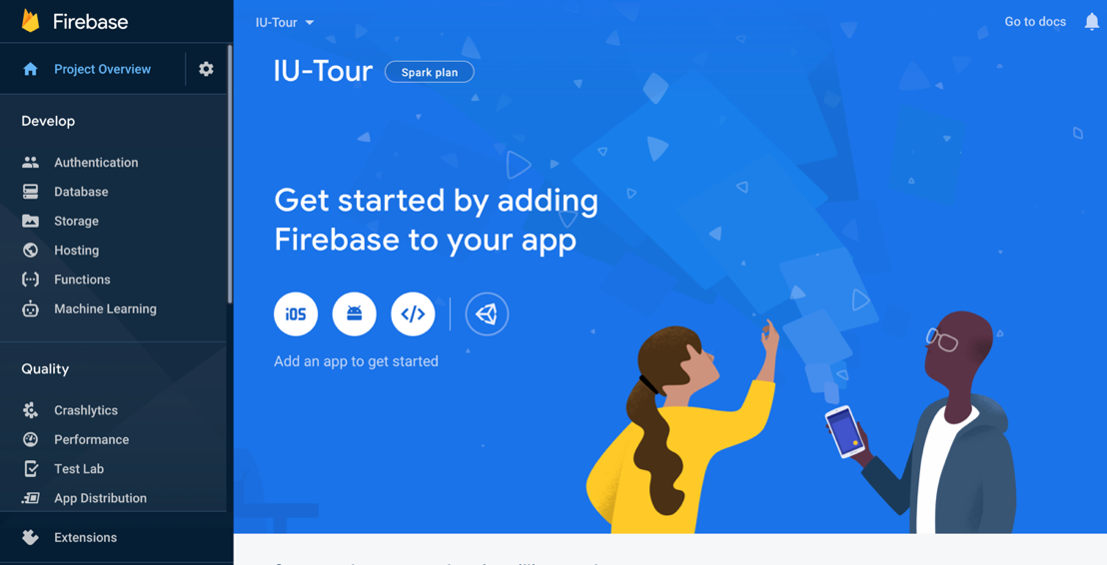

*Figure 23: Firebase project control panel*

***2.5.5 Setting up Firebase connection to mobile applications.***

Firebase supports a multitude of applications, from Web applications, to Native Android/ iOS applications, to cross-platform mobile applications. The process for setting up a connection of a mobile application to Firebase server for using Firebase functions and services is relatively the same for both Android and iOS, only difference is the add-ons file that differs according to the operating system.

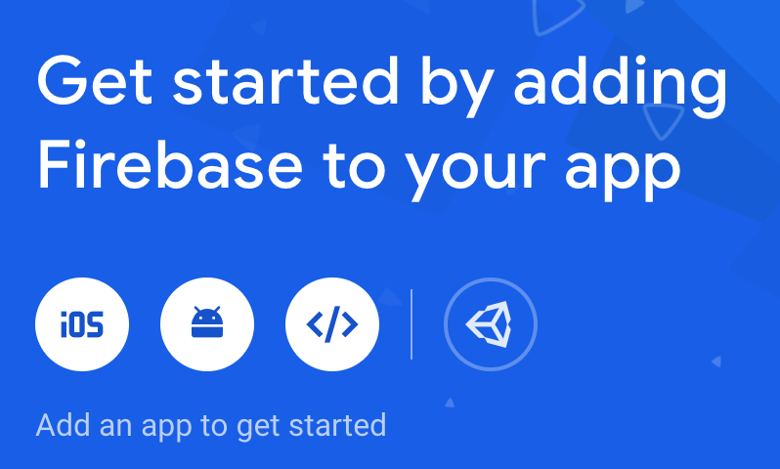

*Figure 24: Applications connection buttons*

1. For Android, choose the Android icon, we will then be led to a process of registering our Flutter (Android) apps to Firebase as followed.

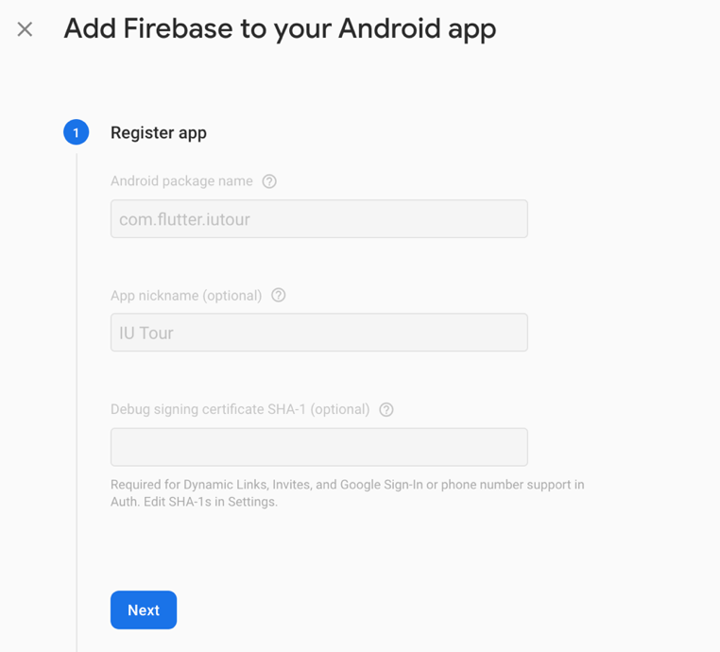

*Figure 25: Application information form (Android)*

1. After we provide the application information, Firebase will generate a unique configuration file for the application called “google-services.json”, we only need to download the file and place it in our project according to the instruction.

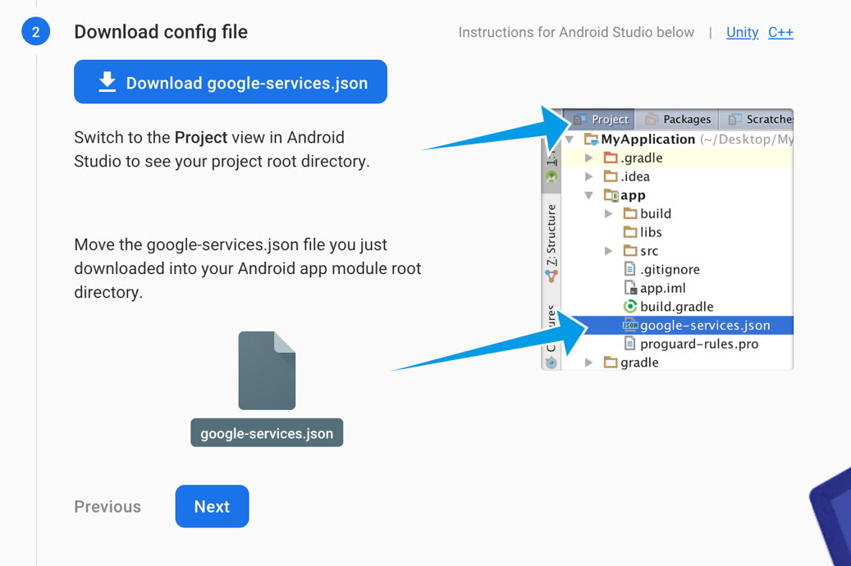

*Figure 26: Firebase Android configuration file.*

1. After putting the configuration file to our Flutter project, we then need to locate the build.gradle file and add the Firebase SDK as followed.

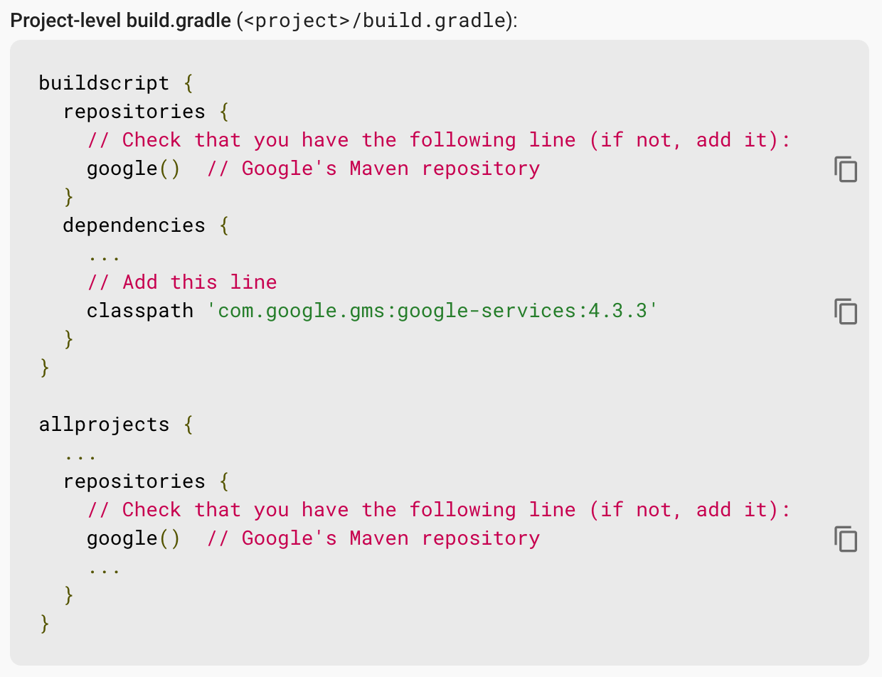

*Figure 27: Project-level build.gradle file Firebase SDK code*

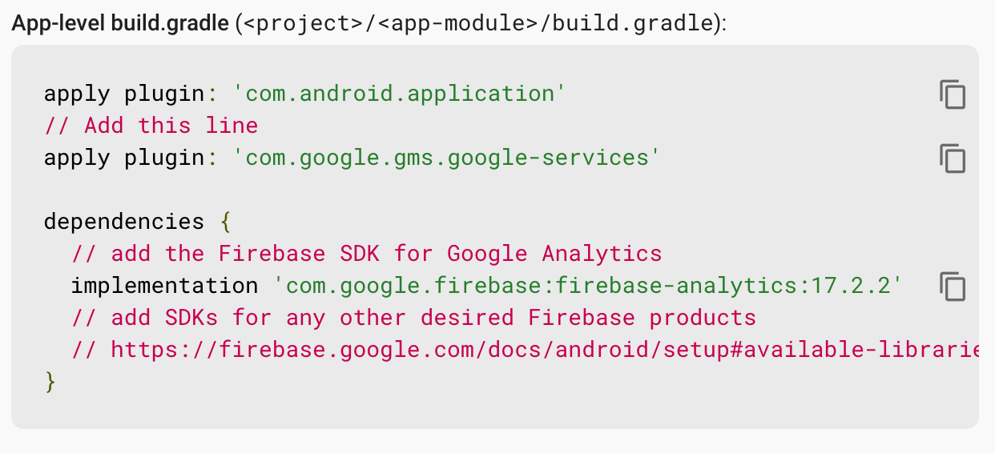

*Figure 28: App-level build.gradle Firebase SDK code*

1. After this step, the Flutter application can now connect to the Firebase console, ultilize Firebase authentication, access Firebase database. The application can be tested for feature right away in the Android simulators.
2. For iOS, repeat the first step of the registering just as we did for Android, but with iOS this time.

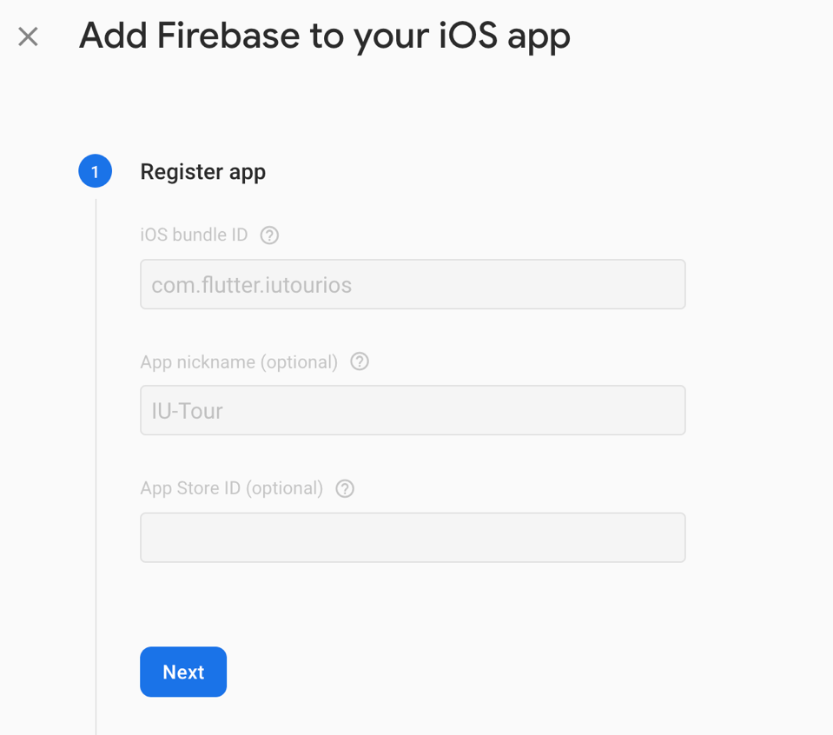

*Figure 29: Application information form (iOS)*

1. In iOS, Firebase will generate a file called “info.plist”, this is the configuration file used for iOS. This file will be put into the Flutter application via Xcode (Mac only) according to the instruction by Firebase.

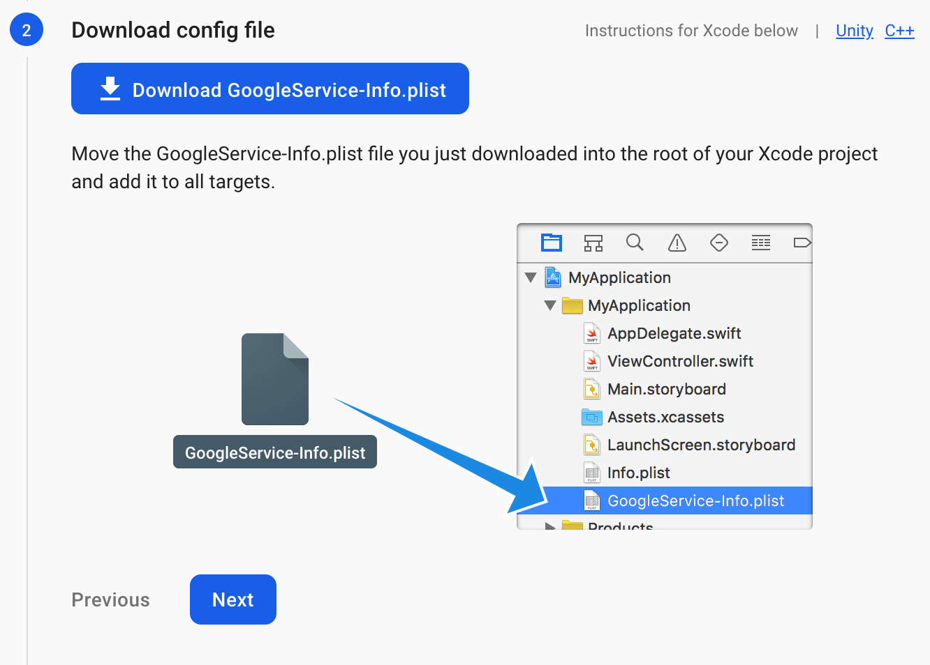

*Figure 30: Firebase iOS configuration file*

1. Since iOS relies on CocoaPod to manage dependencies, we need to add a “Podfile” to our iOS/Flutter application using the following command in the project terminal.

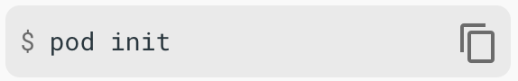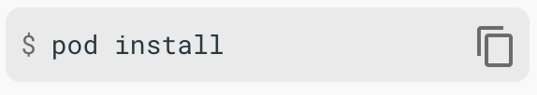

*Figure 31: Podfile initialization command*

1. The next step is only for reference, if any native iOS app to connect to Firebase, we also need to modify the “AppDelegate.swift” file to add the Firebase SDK. However, in Flutter iOS, the Firebase SDK is added via the “Podfile”, it is much easier. The code for App Delegate modification is as followed.

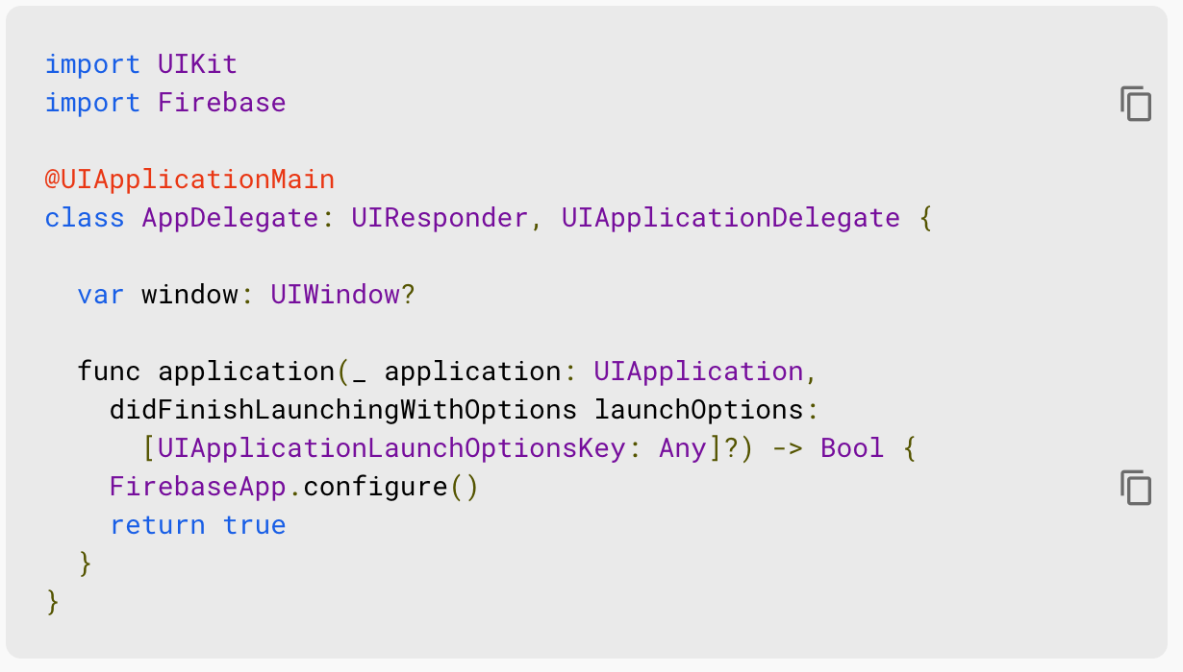

*Figure 32: AppDelegate.swift Firebase SDK code*

1. The app can now be run in the iOS simulators and can now access Firebase just as the Android app can. We can also check on the project control panel and find that there are now two apps connected to Firebase.

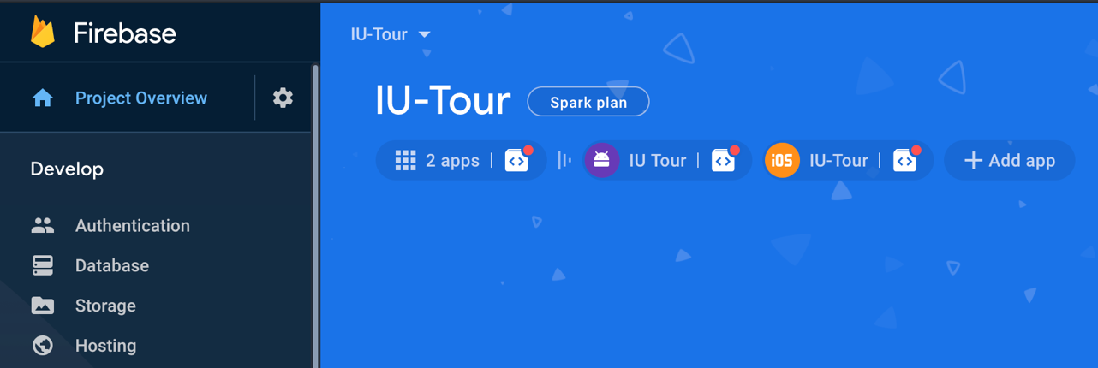

*Figure 33: Firebase control panel after app connection*

***2.5.6 Setting up Firebase features & services.***

Firebase has a wide range of features and services to help enhance the experience of a mobile application such as Authentication, Real-time Database, Cloud Firestore, Cloud Storage, Cloud Messaging, etc.

1. To set up Authentication service, from Firebase control panel, choose “Authentication”

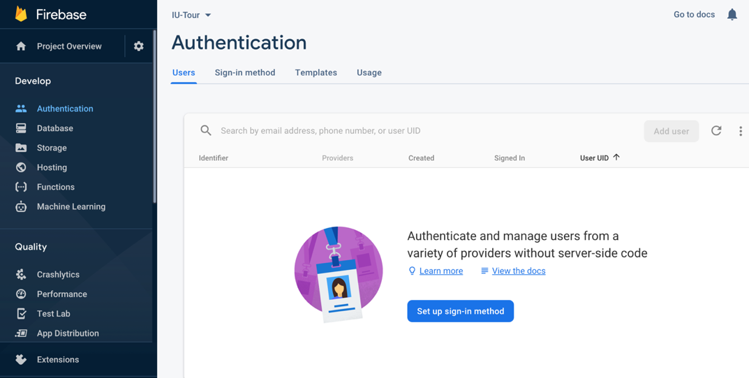

*Figure 34: Firebase authentication service panel*

1. Choose the “Sign-in method” tab from the panel, we will see a list of sign-in providers for our application.

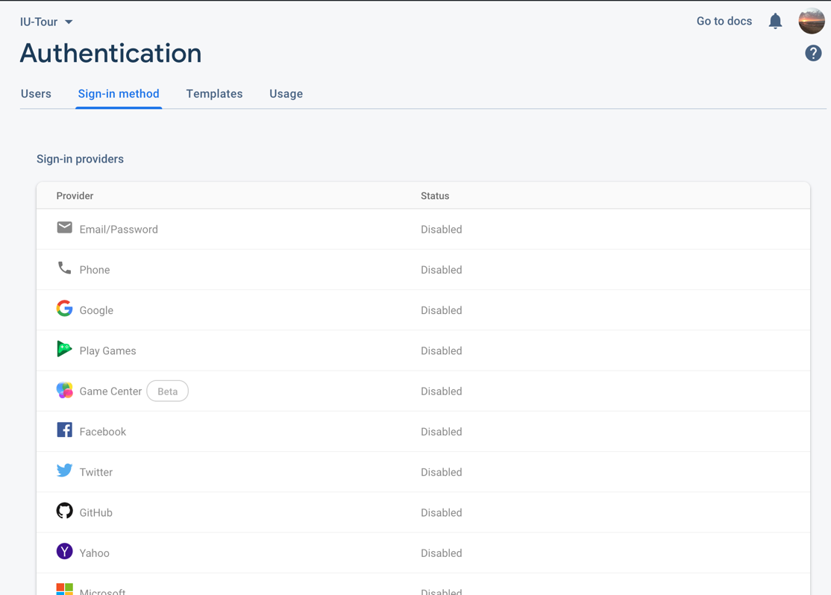

*Figure 35:Authentication sign-in providers tab*

1. After choosing a provider for the authentication, we can then return to the “Users” tab to create some users to log in to our application. Functions such as email validation, password validation, user validation will be handled by Firebase Authentication automatically

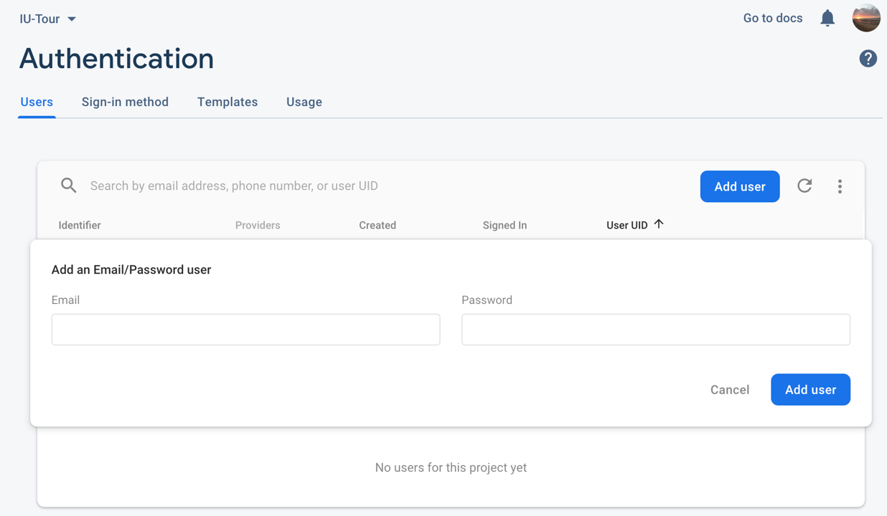

*Figure 36: Authentication users tab*

1. Firebase Authentication also provide the application with functions for many cases such as: Password reset, Email address verification, Email address change, etc. All can be found and edited in the “Templates” tab.

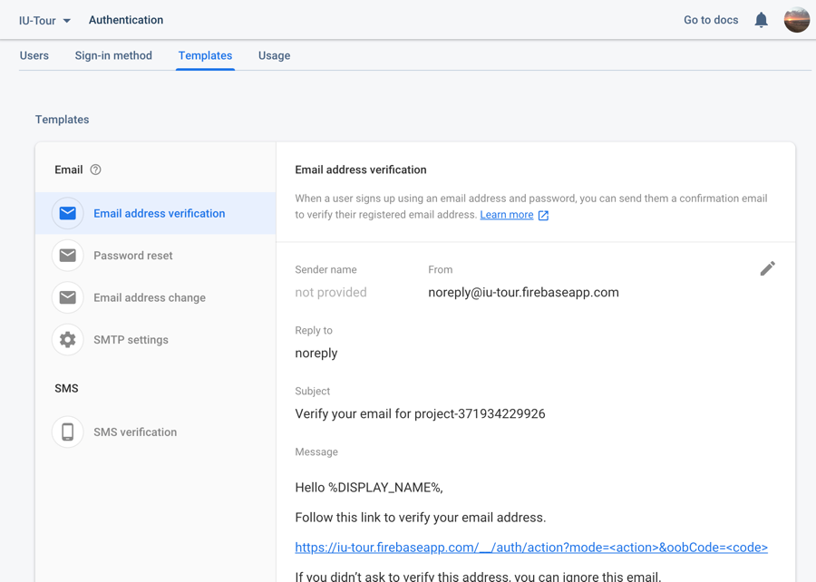

*Figure 37: Authentication functions template tab*

1. To create a database for the application on Firebase, developers can choose between Cloud Firestore or Real-time Database. Both of the database support real-time updates, queries, with Firestore being the newer feature that support more queries and is more scalable. For the application in this thesis, I will choose Cloud Firestore over Real-time Database due to the superior performance of the service.

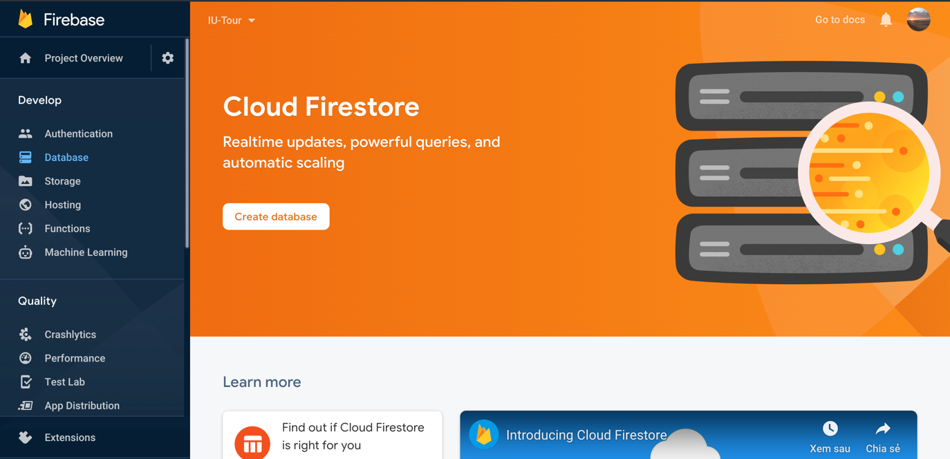

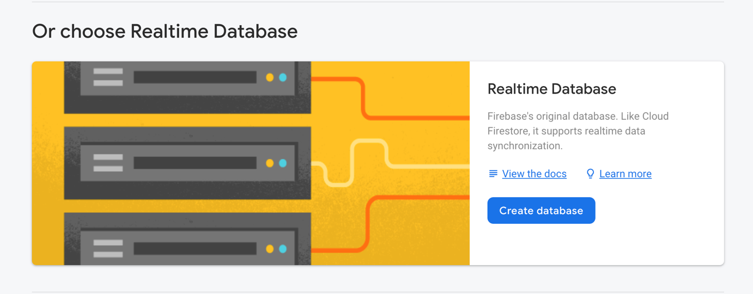

*Figure 38: Firebase Database service panel*

1. For both Cloud Firestore and Real-time Database, we only need to click on “Create Database”, Firebase will then show us the steps to set up a database for our application. The first step is to choose between *Test mode* and *Production mode*, with the only difference in their security rules.

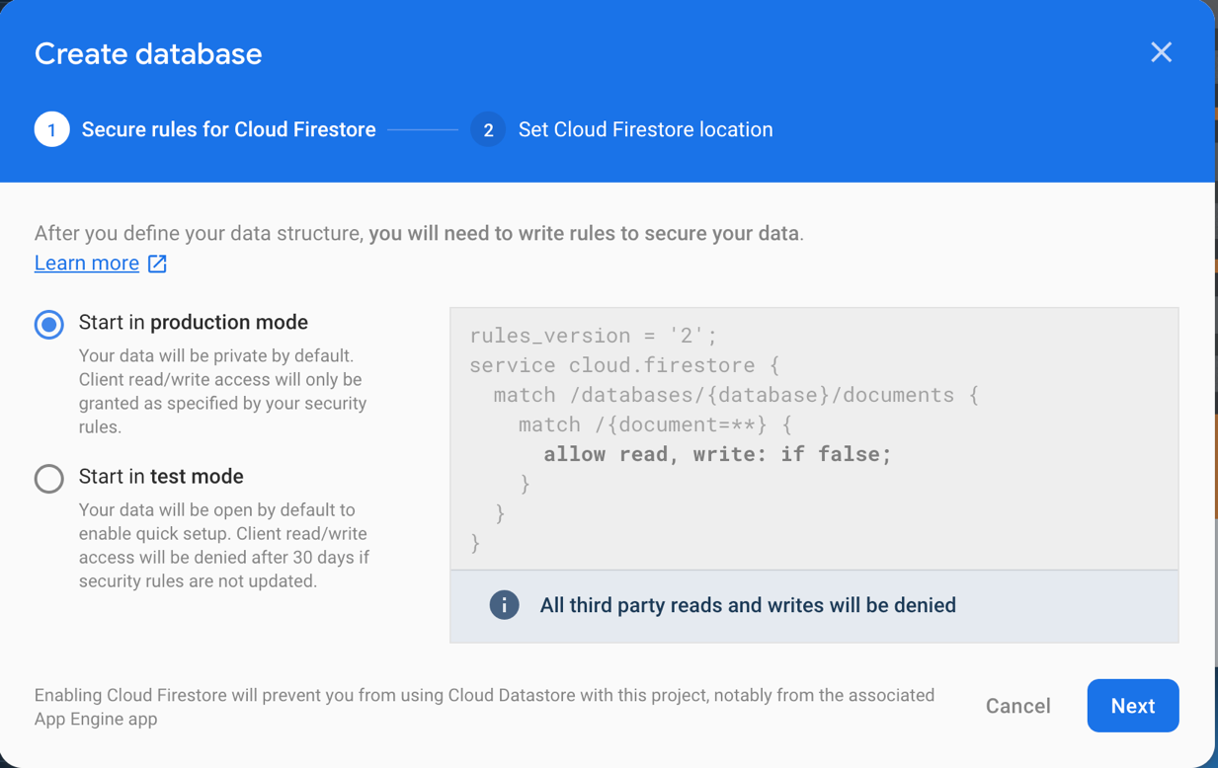

*Figure 39: Database rule mode*

1. After choosing the security mode for the database, we need to choose the server which will hold the database. There are many servers to choose, for the application in this thesis, I chose the Asia server.

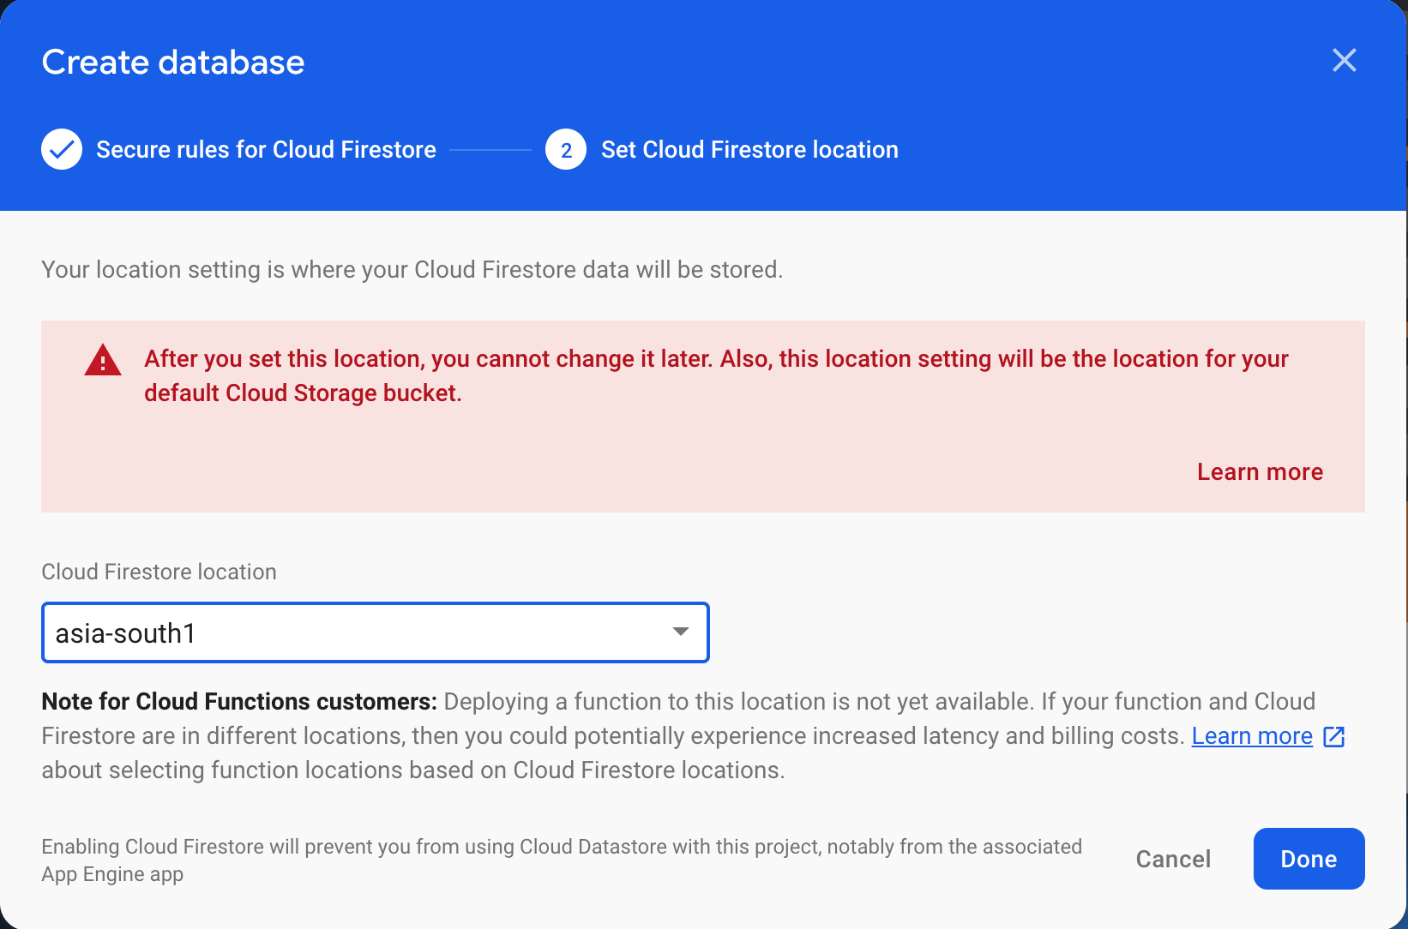

*Figure 40: Database server selection*

1. After the creation, Firebase will lead us to the panel where we can view our data, create security rules, view or create indexes for data querying and view our database usage in the main database panel. We can create collections, documents in the data tab both manually or using our mobile application via development code.

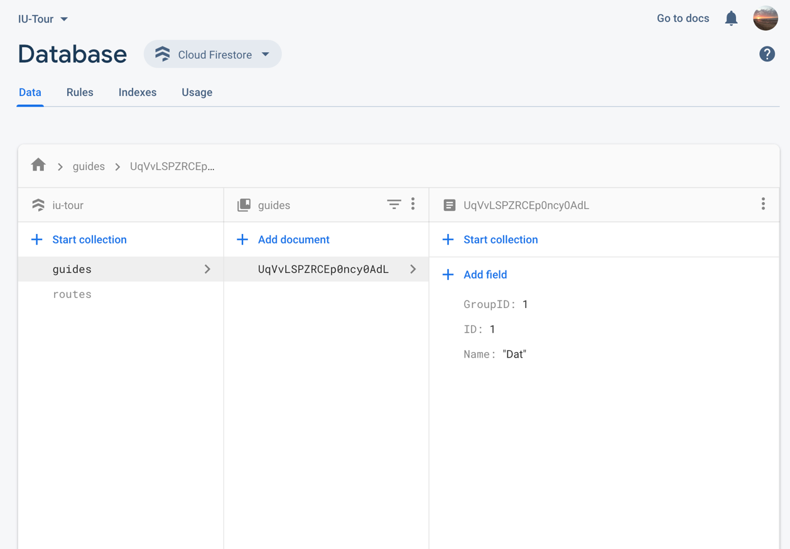

*Figure 41: Cloud Firestore database dashboard panel*

1. To add a collection of documents manually, we simply press on *Start collection*, the dialog will pop-up, we need to add a collection ID, then add a document with its ID and fields to the collection. To add more documents to a collection, we simply follow the above steps.

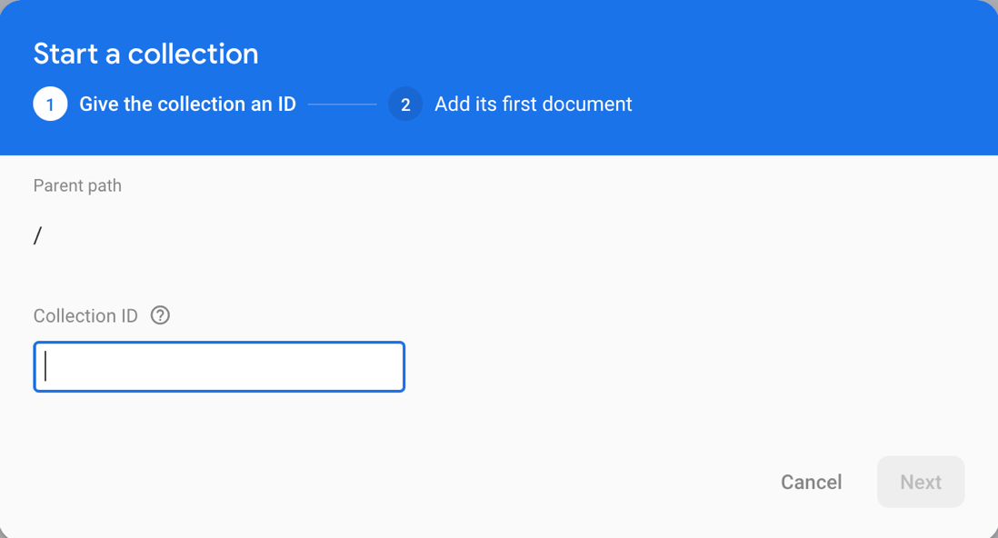

*Figure 42: Collection adding form*

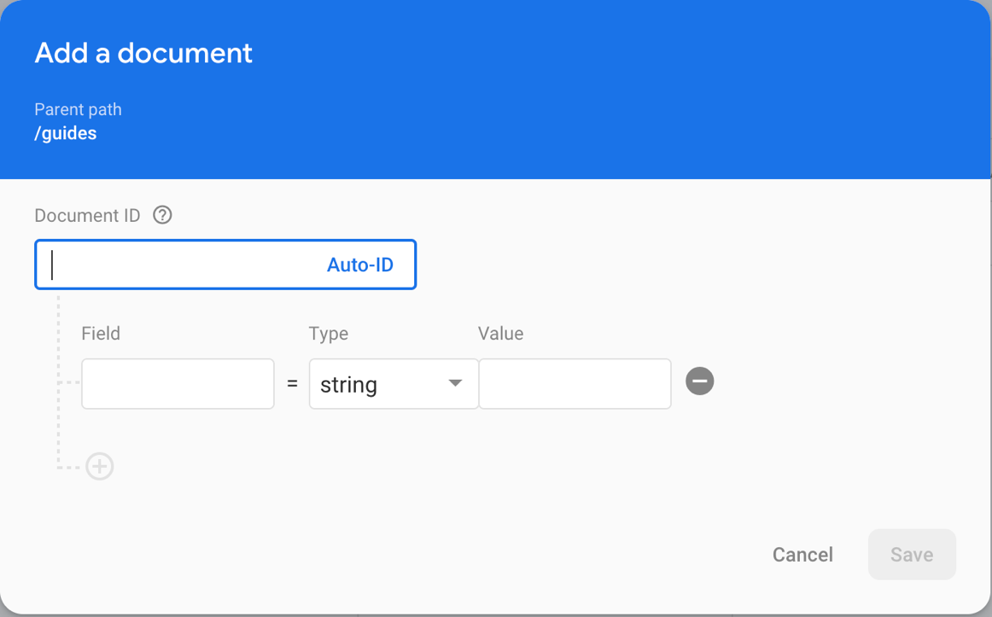

*Figure 43: Document adding form*

1. Firebase provides a method to make push notification for Flutter applications. It is called FCM (Firebase Cloud Messaging). To set up the FCM service we can do as follow

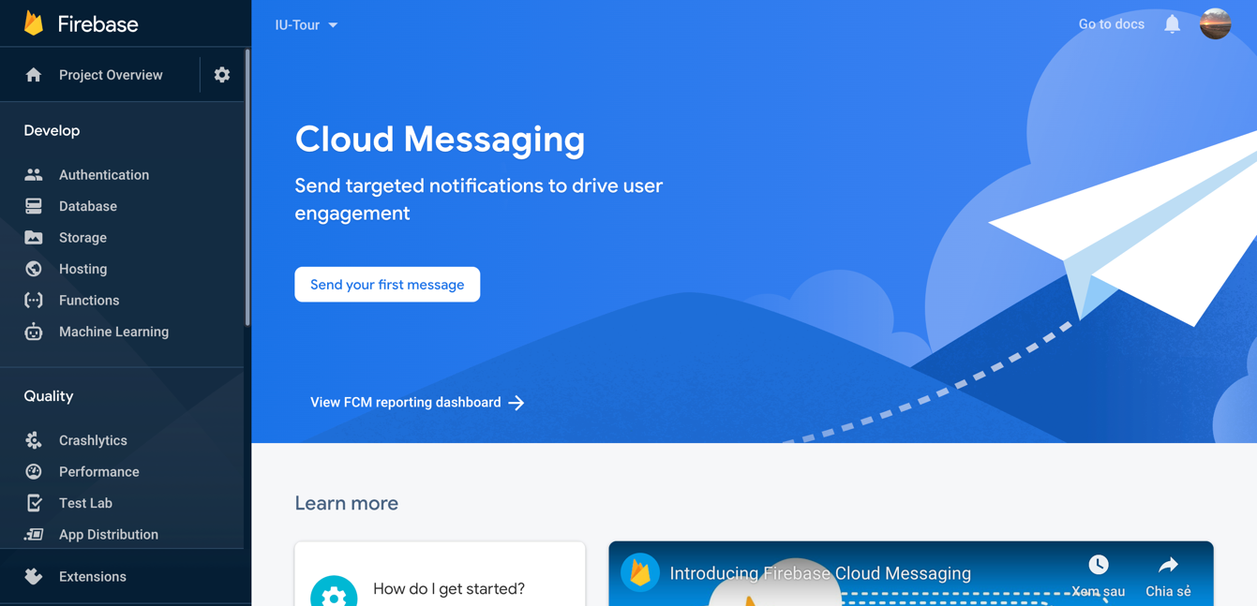

*Figure 42: Firebase Cloud Messaging panel*

1. We can choose to set up notification messages manually or set up notification via the development code in Flutter. To set up a notification and testing out the display of that notification, we first press on *Send your first message*.

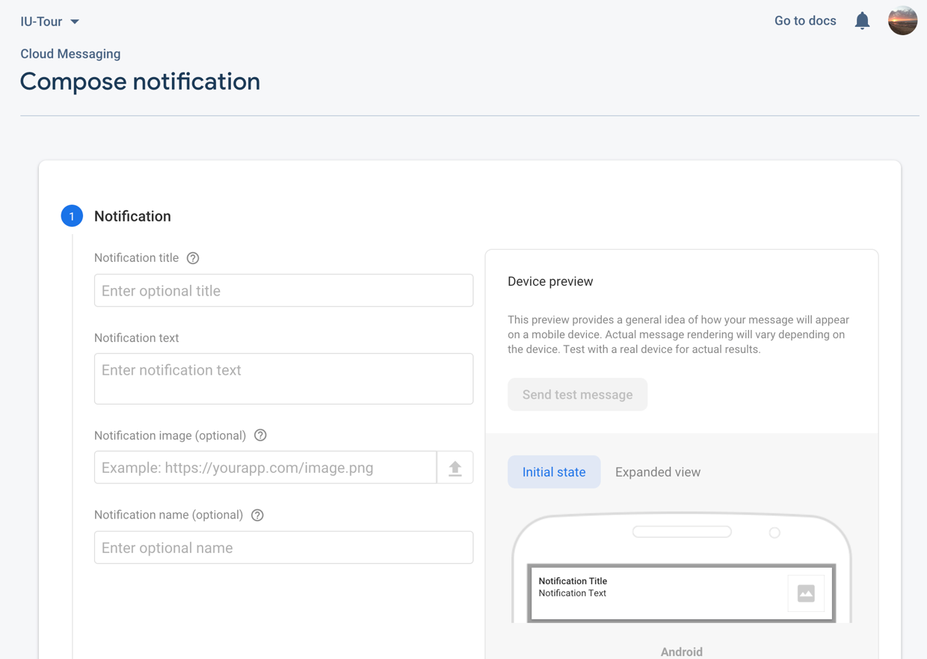

*Figure 43: Notification message composition panel*

1. We then provide details for our notification, along with the target where the notification will be sent to.

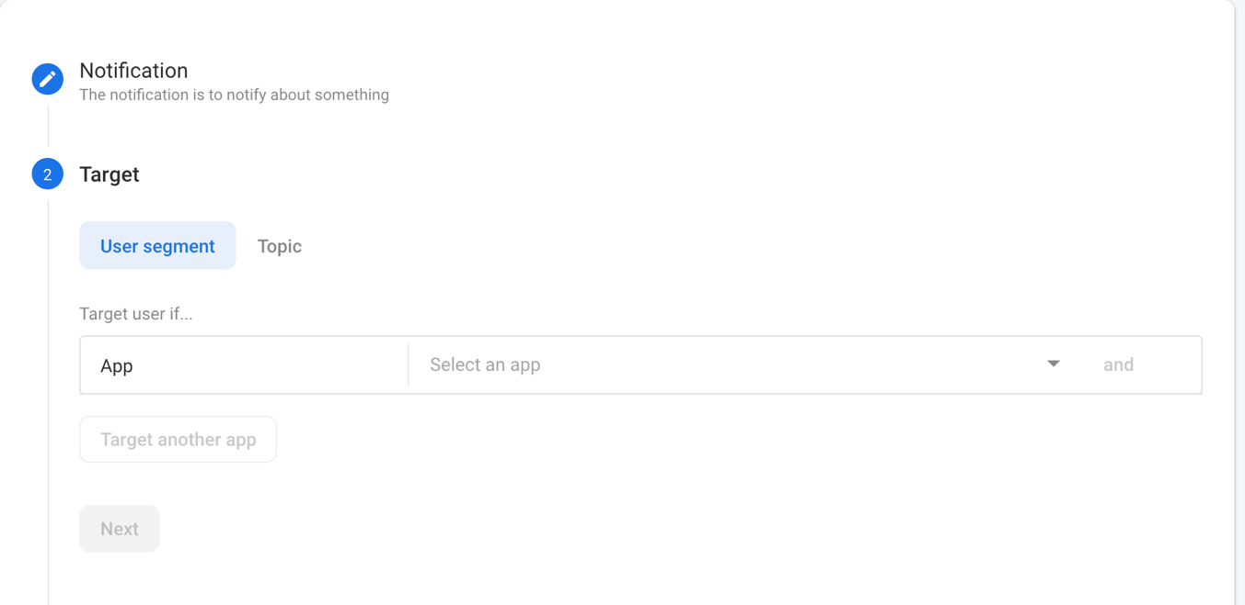

*Figure 44: Notification target setting*

1. The notification can also be schedule for when to be sent to the selected targets.

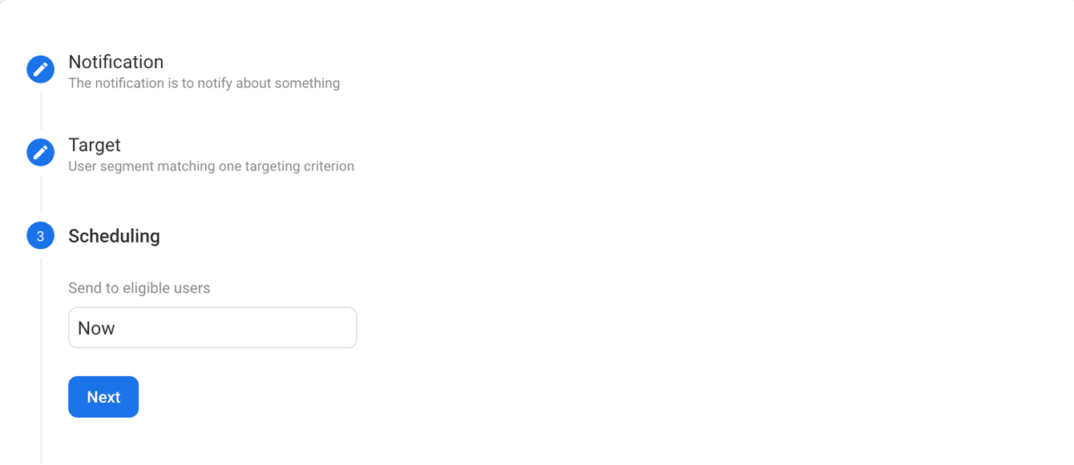

*Figure 45: Notification scheduling panel*

1. When the notification creation is completed, we can preview how the notification will appear on the devices (both Android and iOS) with the notification previewer panel

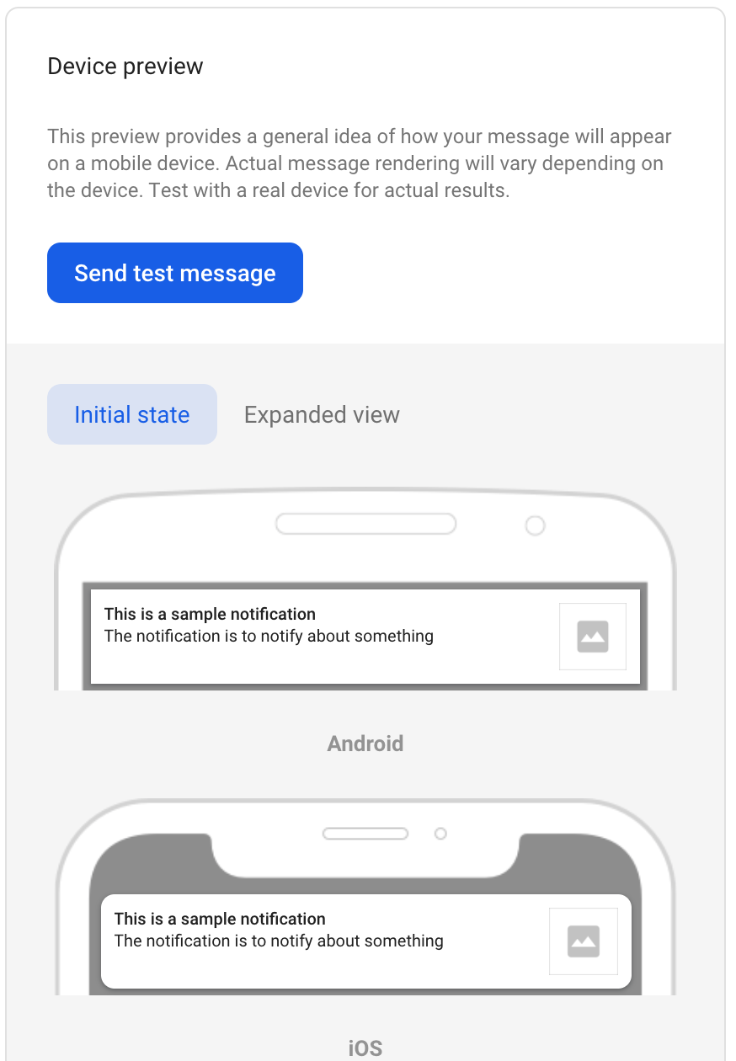

*Figure 46: Notification preview panel*

Firebase also has many more extension and features in the work in will soon be available for usage. For now, we can ultilize some useful extension that incorprorate some of the Google Cloud Platform services such as Text Translation, Shorten URL, Mailchimp Sync, Image Resizer.

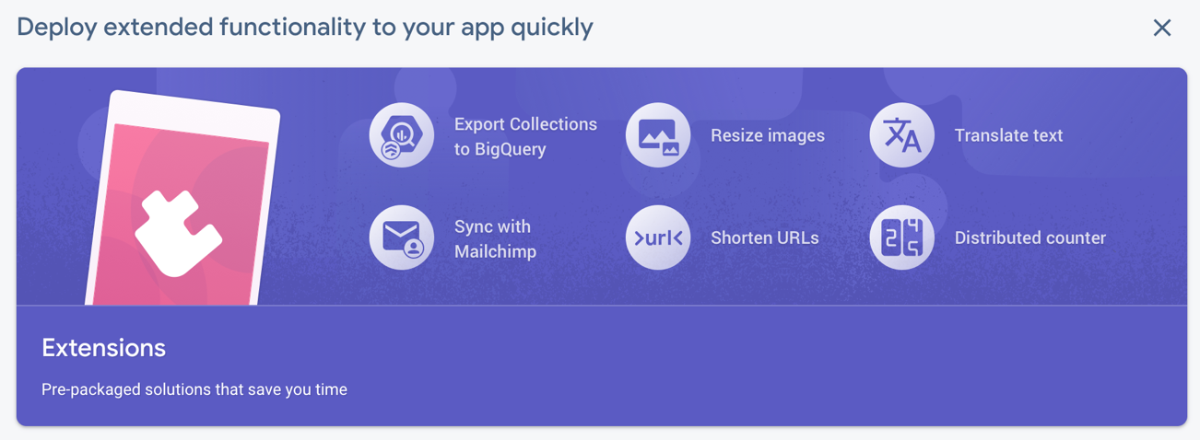

*Figure 47: Firebase extensions panel*

**CHAPTER III**

**METHODOLOGIES -**

**REQUIREMENT ANALYSIS AND DESIGN**

**3.1 USER REQUIREMENT ANALYSIS**

From the problem statement in chapter I, base on the many flaws of the current state of the program, we will now set up the user requirement analysis for the application. The role for the users in this application will be divided into two teams: Operator and Participant. The Operator team has the guides and the managers, the Participant will have the students who join into the tour. The user requirements analysis is as follow.

* As a guide: I am the most active person in the operator team. I want to view my designated plan with the checkpoints in details so I will know where to go, what to do and when to go there. I also want to see and know what group will I be leading, who is in that group. I want to be connected with everyone in the operator team as well as all the participants in my group, so that I can be updated with new information and vice versa.
* As a manager: I have the most important role in the operator team. I need to be able to make plans, edit checkpoints details and view all the plans that I have created. I want to see all groups of participant with their detail information. I want to be able to communicate with everyone, especially everyone in the operator team to make sure all the information is always up-to-date with any situation. I need to see the feedbacks, the reviews of the participant on the tour so that I can get a better understanding of their preferences and can later on improve the tour.
* As a student (participant): I want to see where I am going in details, to be able to view the checkpoints of the plan will help me locate my group better. I want to give my immediate feedback on the spot of the checkpoint. Sometimes the tour can go very quickly, I want a way which I can view more information of a specific checkpoint on the plan. I want to have a way to contact my guide that is fast and easy in case I got lost during the tour.

**3.2 SYSTEM DESIGN**

Base on the user requirement analysis, I now will give the system design for the application.

***3.2.1 Use Case Diagram***

The use case diagram from the given user requirement that shows the funtions of the application can be designed as follow.

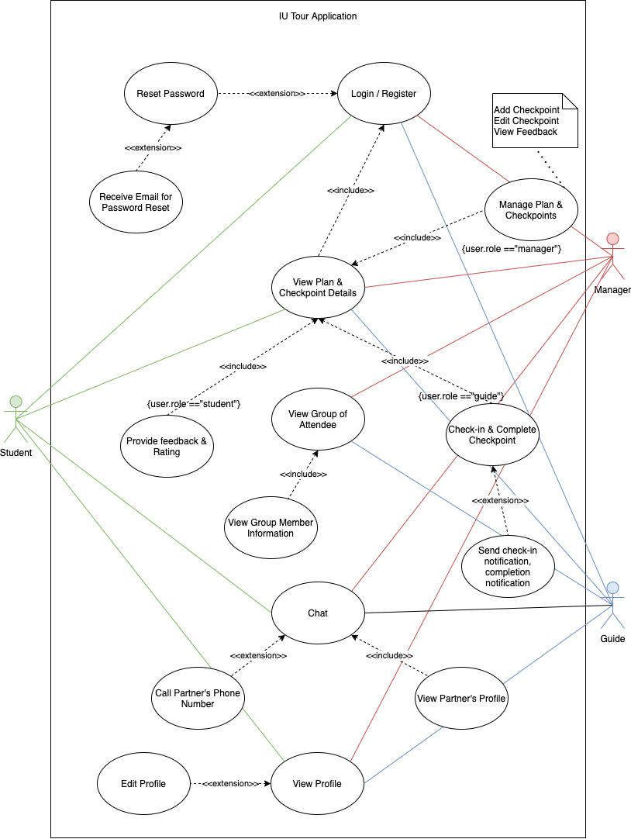

*Figure 48: Use Case Diagram*

**Diagram explanation (Figure 48):**

From the designed use case diagram, the functions for each user role in the IU Tour application can be clearly listed out to satisfy the many user requirements.

*All users:*

_Login to their own accounts, in case they forgot their password, they will be able to reset their password via an email sent by the system.

_Chat and communicate with each other via the chat panel.

_Users will be identified using their own profile which they can edit to ensure individuality.

*For the managers:*

_After login successful, the managers can now view all the created plan, with the checkpoints in details.

_Managers can also manage the checkpoints in the plans, they can add new checkpoints, edit the existing checkpoints, all changes will be updated in real-time.

_Managers can view the feedbacks and rating of the checkpoints that was provided by the student who went on the tour to assess the performance of the plan.

_Managers can view all the groups of student who attended the tour, with their members in fullest details.

_Managers will receive check-in notifications, completion notifications and SOS notifications from the guides.

*For the guides:*

_After login successful, guides can view their very own designated plan, with the checkpoints to complete in details.

_Guides can check in to a certain checkpoint, which will send a notifications to other guides and the managers to ensure smooth flow of operation.

_Guides after completing a checkpoint will send another notification to the other guides as well as the managers for progress update.

_Guides can view their own group of students, with the ability to view the members’ information.

*For the student (participant):*

_After login successful, students can see their group plan, with the checkpoints and their details.

_In the checkpoint detail, student can give their feedback and rating for the specific checkpoint, all the rating will be calculated and sent back to the managers.

***3.2.2 Architecture Diagram***

The schematic for the operation of the applications can be illustrated using the following architecture diagram.

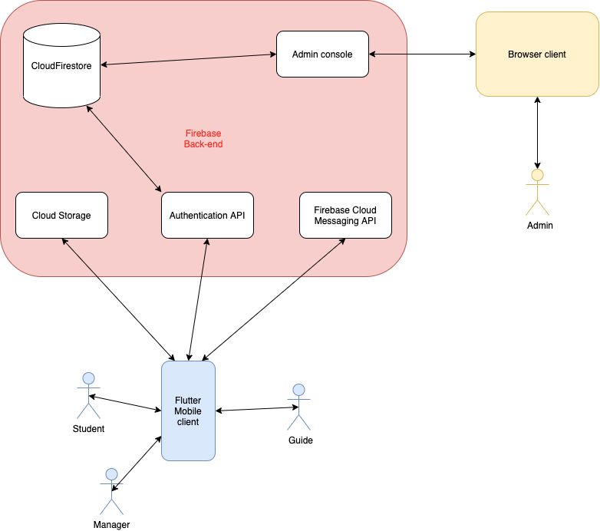

*Figure 49: Architecture diagram*

**Diagram explanation (Figure 49):**

The diagram shows the scheme of operation of the application in this thesis. There are three main components: the Flutter Mobile client, the Browser client and the Firebase Back-end.

*Flutter Mobile client:*

_Is the main application, the client that ultilize the services available from Firebase Back-end such as: Authentication, Firebase Cloud Messaging (FCM).

_Is able to read and updates the data from the database (CloudFirestore) and the Cloud Storage.

*Browser client:*

_Is the administrator of the Firebase Back-end service.

_Is able to log into the Admin Console panel on Firebase to read and update database.

_Is able to set up security rules to provide users (Flutter Mobile clients) with their own rights.

_Is the one to set up the Firebase Back-end services such as Authentication, FCM and database.

*Firebase Back-end:*

_Is the main back-end service of the application.

_Is set up and managed by the admin using the Browser client.

_Is the provider of the many services for the Flutter Mobile clients such as: Authentication, FCM, database (CloudFirestore, Cloud Storage).

***3.2.3 Sequence Diagram***

The sequence diagrams for the many functions of the application shall be illustrated as follow.

1. **Login:**

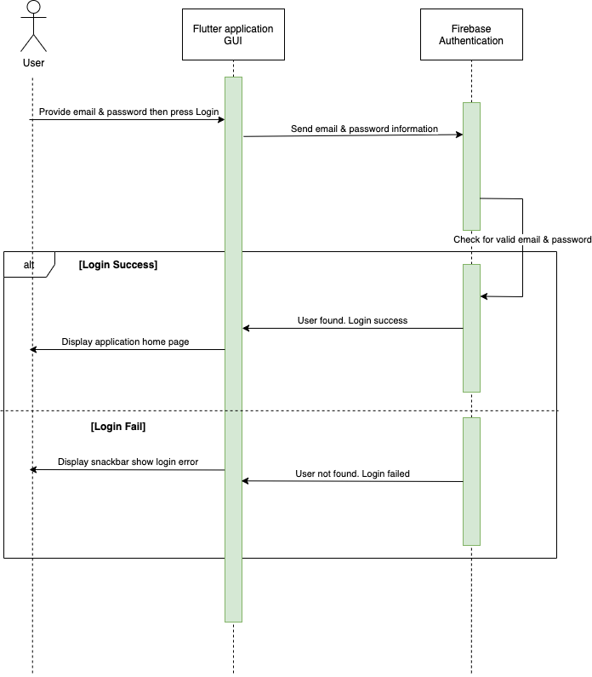

*Figure 50: Login sequence diagram*

**Diagram explanation (Figure 50):**

The sequence diagram shows that when the user provide the application with their email and password to the login form and then press on “Login”. The email and password will then be sent to the Firebase back-end service. Firebase will have the email and password to match up with the existing accounts on the Authentication service. If the email and password is valid, then Firebase will send the signal to the application. The Flutter application will then redirect the user to the home page UI. In the case of mismatch between the provided credentials and the ones on the Authentication data, Firebase will send another type of signal to the application. This time the app will show an error message to the user interface prompting the user to check the credentials again.

1. **Register**

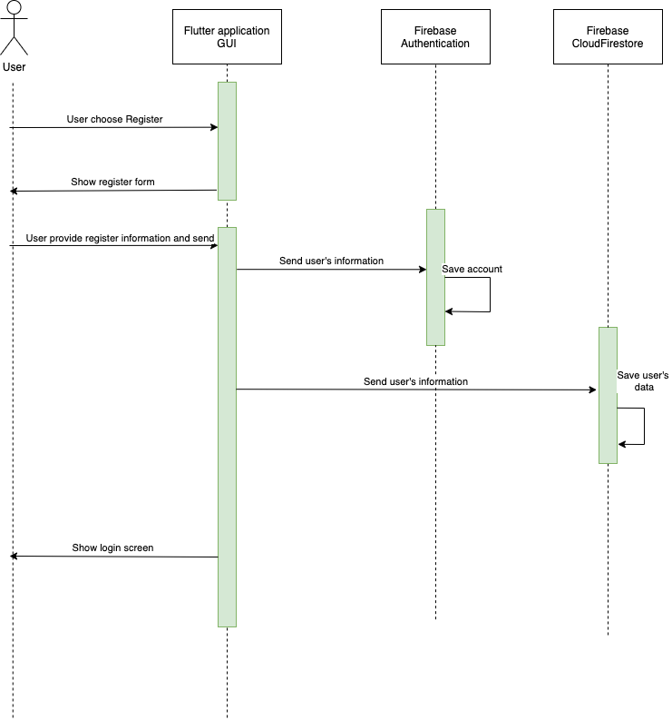

*Figure 51: Register sequence diagram*

**Diagram explanation (Figure 51):**

The sequence diagram shows that when the user wants to create an account, they can click on the “Register” button, which will then redirect them to the register form UI. The user can then provide their information to register for a new account, then press “Register”. The information will then be send to Firebase Authentication service with the flag of signing up a new user, Firebase will then handle the information such as email, password and create a new authentication user in the database. Along with that, a collection with the name “users” will be updated with a new document that is the new user account in the Cloud Firestore database. After the register process is successfully completed, the Flutter UI will redirect the user back to the Login form, user can now login to their own registered account.

1. **Forgot password**

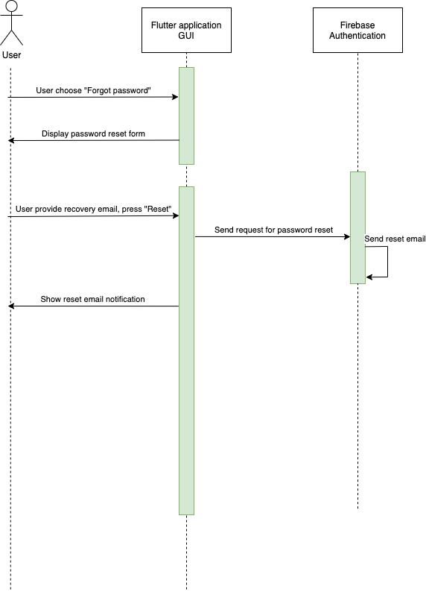

*Figure 52: Forgot password sequence diagram*

**Diagram explanation (Figure 52):**

The sequence diagram shows when the user wants to reset their password in case they forgot it. User will press on the “Forgot password” button, which will then redirect them to the email recovery form, after that they can provide the email to receive the reset message and press “Reset”. The request for password reset will be sent to the Firebase Authentication service, which will handle the request by sending the pre-defined reset email template to the recovery email. The device will then display a new email notification, user can follow the instruction and change their password.

1. **View trip plan, checkpoint details and checkpoint feedback (Manager)**

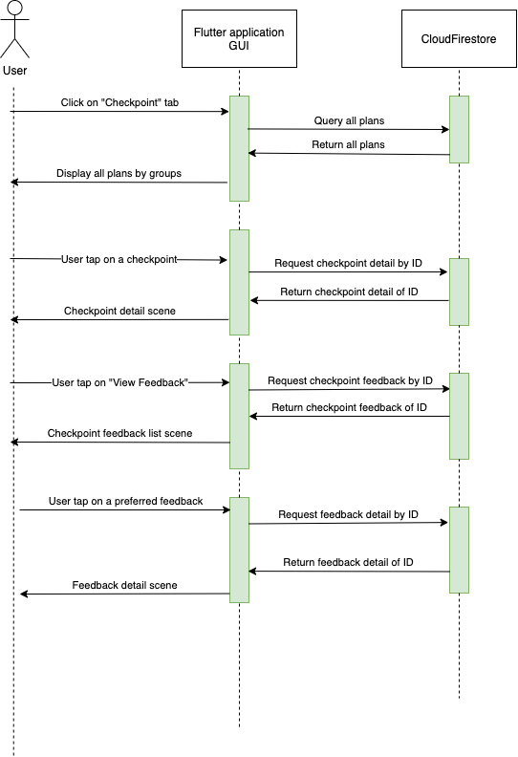

*Figure 53: Manager view plan, checkpoint and feedback sequence diagram*

**Diagram explanation (Figure 53):**

The sequence diagram shows the process of viewing the plans, the checkpoints and the feedbacks of the checkpoint. This sequence applies only to the role of manager. The manager after login successfully, can choose to view the checkpoints. Here, the application will send a request to Firestore, querying all the checkpoints available and then display them back on the app in a form of many grouped lists, grouped by the group number. When manager tap on a certain checkpoint, the application will again send a request to Firestore to get the checkpoint details, the return results is the checkpoint detail scene. In the checkpoint detail scene, there is an option for manager to view the feedbacks provided for that specific checkpoint. The process for viewing the feedback is relatively the same for viewing the plan

1. **View trip plan, checkpoint details and update notification (Guide)**

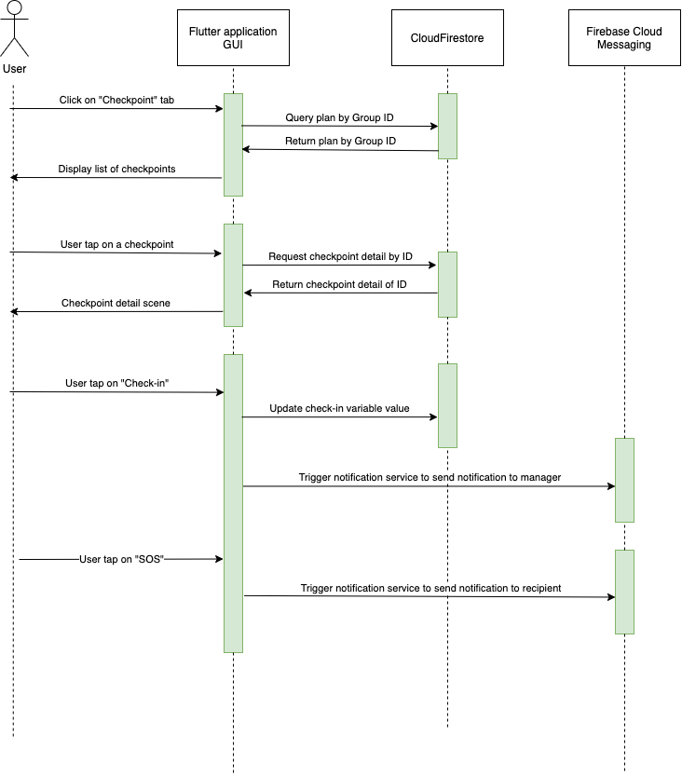

*Figure 54: Guide view plan, checkpoint details and send notification sequence diagram*

**Diagram explanation (Figure 54):**

The sequence diagram shows when a guide choose to view his or her designated plan. When the guide tap on “View Checkpoint”, instead of having all the groups, only the group that the guide is leading will be shown, then the guide can tap into a certain checkpoint to view its details. In the checkpoint detail scene, guide can now tap on “Check-in” to send a notification to others that they have checked-in to a checkpoint, to monitor the flow of operation. In case there is an SOS, guide can send a notification to other via the “SOS” button.

1. **View plan, checkpoint and provide feedback (Participant)**

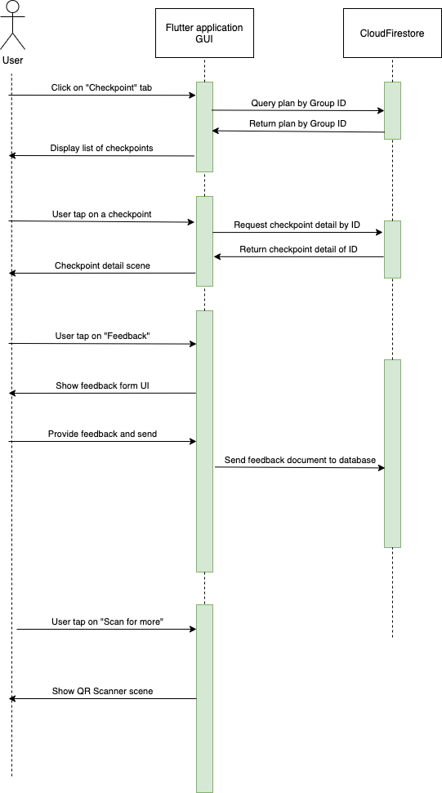

*Figure 55: Participant view plan, checkpoints and provide feedback sequence diagram*

**Diagram explanation (Figure 55):**

The sequence diagram shows the process for viewing the plan, checkpoints of a participant. When participant tap on “Checkpoint”, the checkpoints of the group that the participant is in will be shown. They can tap on a certain checkpoint to view its detail so as to be able to get to that checkpoint and to keep track of where they are in case they got lost. In the checkpoint detail scene, participant can provide a feedback, review that checkpoint on the spot via a button. Also in that scene, there is a button for a QR scanner to get them further information.

1. **Add and edit checkpoint (Manager)**

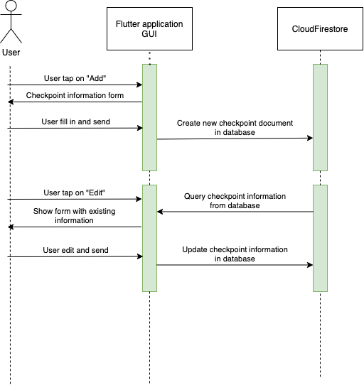

*Figure 56: Manager add and edit checkpoint sequence diagram*

**Diagram explanation (Figure 56):**

The sequence diagram shows the process of the manager adding and editing a checkpoint. When manager is in the checkpoint list scene, manager can add a new checkpoint by pressing “Add”, the display will show a form for manager to fill in to create a new checkpoint. After filling in and clicking “Save”, a new document will be added to the database of checkpoints. When manager is in the checkpoint detail scene, the button will show “Edit”, when pressed the display will show the form again, this time however it will be filled with existing information of the checkpoint. After manager finish editing and press “Save, the document in the database will be updated with the new information, the display will also show a newly updated checkpoint details scene.

1. **Viewing groups of attendees (Manager)**

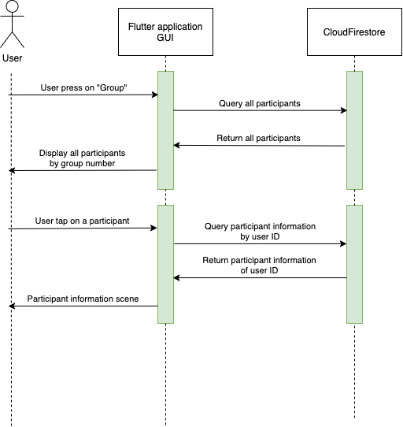

*Figure 57: Manager viewing groups of attendee sequence diagram*

**Diagram explanation (Figure 57):**

The sequence diagram shows the process of view the groups of attendees (participants) of manager. Manager when click on “Groups” will be able to view all participants queried from CloudFirestore and show in a form of grouped lists, grouped by the group number. When manager tap on a certain participant, the information queried from Firestore will then be shown to manager via the participant information scene.

1. **View groups of attendee (Guide)**

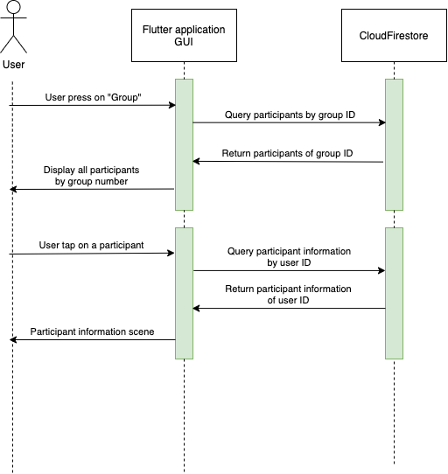

*Figure 58: Guide viewing groups of attendee sequence diagram*

**Diagram explanation (Figure 58):**

The sequence diagram shows the process of viewing groups of participants for guide. When click on “Group”, instead of having to see all participants available, the guides now only see the participants of their designated group, queried from Firestore. When guide wants to see more details about a participant, they can click on the participant and the information of that participant will be queried from Firestore, then it will be displayed on to the participant information scene for the guide to see.

1. **Chat (All users)**

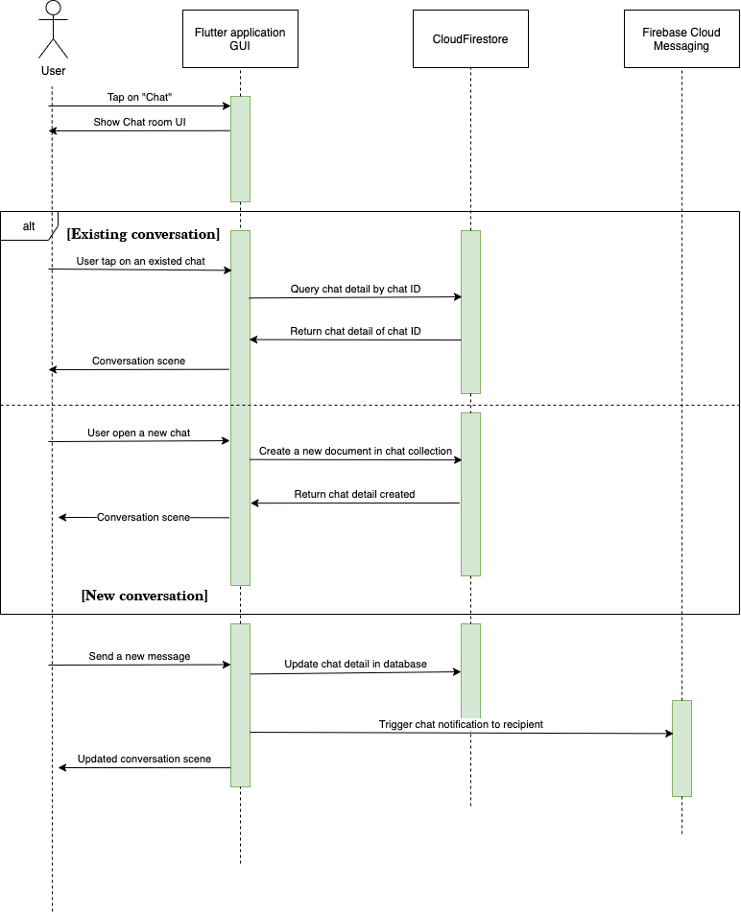

*Figure 59: Chat sequence diagram*

**Diagram explanation (Figure 59):**

The sequence diagram shows the process of the chat function. When a user click on “Chat” they will be redirect to a chat panel. In here they have two options, to open a new conversation, which will create a new chat document on Firestore database, then every new message in that conversation will be updated to the document on Firestore. In case of opening an existing conversation, the conversation will be queried from Firestore and will be updated as any new messages are made to that conversation. Also, when sending a message, the application will also trigger FCM to send a new message notification to the recipient.

1. **View and edit profile (All users)**

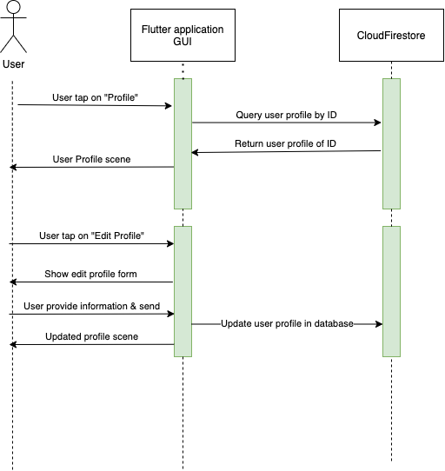

*Figure 60: View and edit profile sequence diagram*

**Diagram explanation (Figure 60):**

The sequence diagram show the process of viewing and editing user profile for all users. When user click on the “Profile” button, the display will show the profile queried by user ID from Firestore on to the screen. If a user wants to change their profile information, they can press on “Edit”, the display will show an information form with the information filled with the ones queried from Firestore. After the user finishing editing and hit send, the information will then be sent back and updated on the document on Firestore. The display will then show an updated profile scene.

**3.3 DATABASE DESIGN**

***3.3.1 Entity Relationship Diagram***

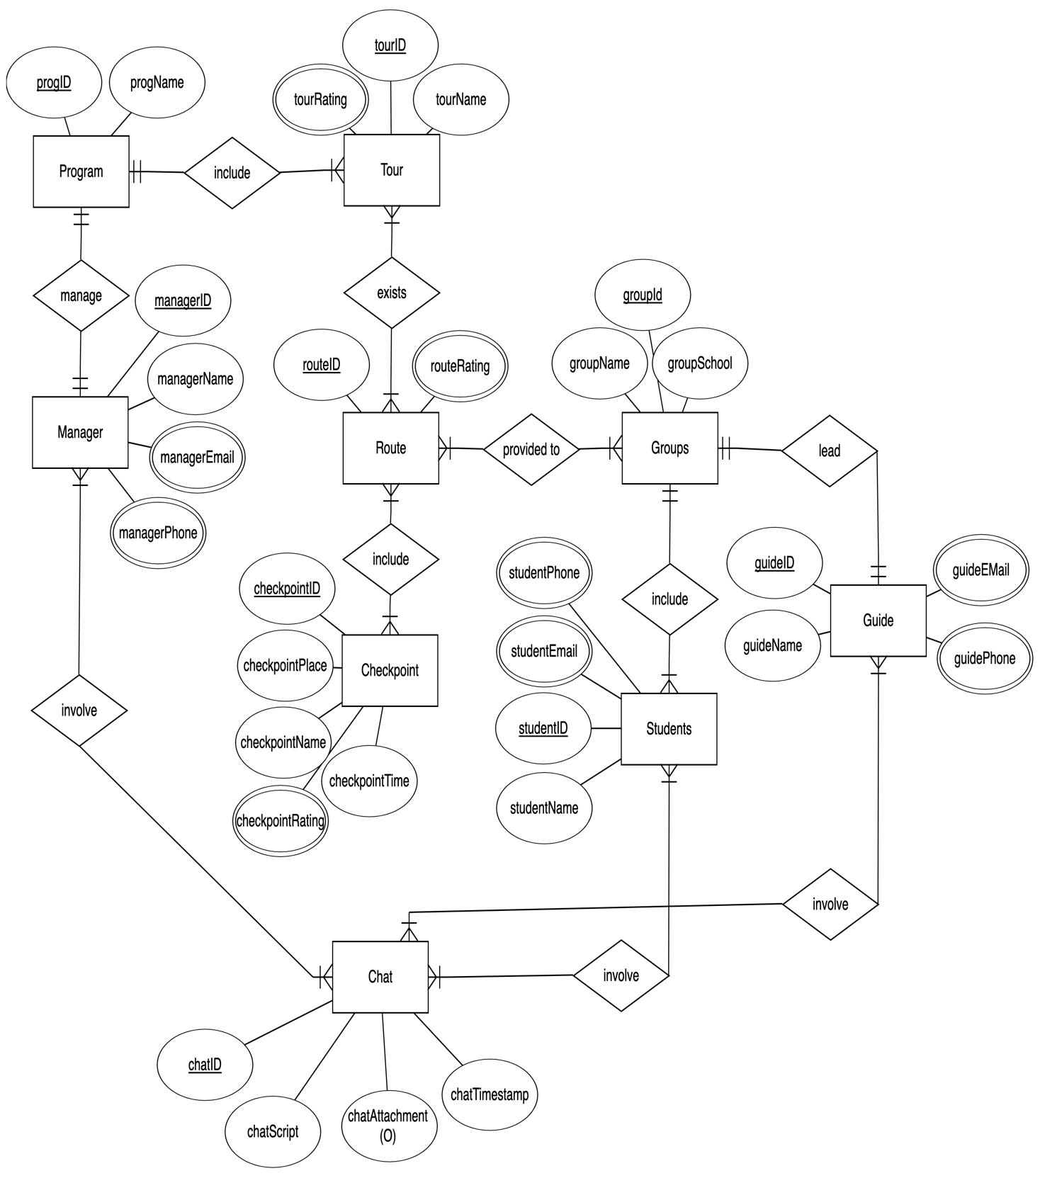

*Figure 61: IU Tour entity relationship diagram*

**Diagram explanation (Figure 61):**

The entity relationship diagram shows how the database was designed for the use of NoSQL database on CloudFirestore. We have the following

_Program: we can have one or more program running concurrently, each program will include one or more tours and all is managed by manager. (ProgramID, progName). However in this thesis, I focused mainly on one tour that is the IU Campus tour.

_Tour is included in program (with tourID, tourName, tourRating), includes many routes (routeID, routeName, routeRating).

_Route is provided to Groups (groupID, groupName, groupSchool) that are led by Guide (guideID, guideName, guideEmail, guidePhone)

_Route also has many Checkpoint (checkpointID, checkpointName, checkpointPlace, checkpointTime, checkpointRating) that Guide, Manager and Student can see

_Groups are led by Guides and is consisted of many Students (studentID, studentName, studentEmail, studentPhone).

_Chat (chatID, chatScript, chatAttachment, chatTimestamp) will be involved by all users available in the application.

**3.4 USER INTERFACE DESIGN**

***3.4.1 Manager user interface design***

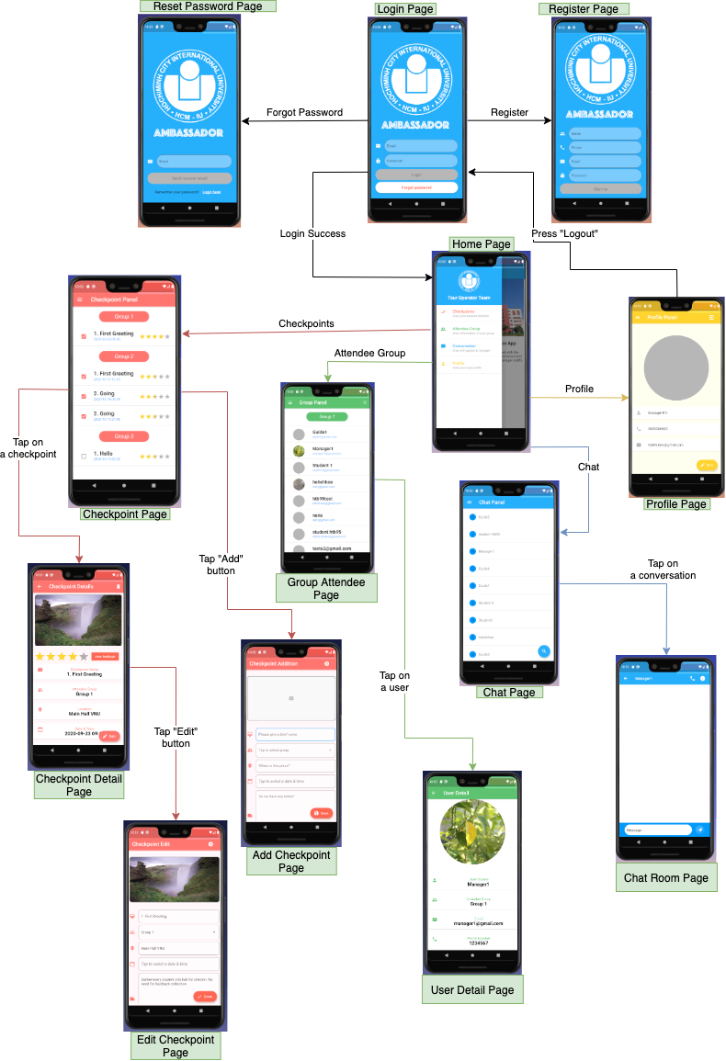

*Figure 62: Manager role user interface flow scheme diagram*

**Diagram explanation (Figure 62):**

The scheme diagram shows the flow of user interface for the role of manager in the application. We can see that the manager after logging in can view the home page and navigate to other pages via the drawer navigator on the left.

_In the checkpoint panel, manager can view all checkpoints of all groups, right from this scene, manager can add a new checkpoint. Manager can tap to view the details of the checkpoint and in this scene, they can edit the details to their liking, view the overall rating as well as view the detailed feedback of participants.

_In the attendee group panel, manager can view all groups with their members in the form of many lists. Manager can tap on a member to view the details of that member.

_In the chat panel, manager can see all users, and can chat with any user that they like. In the chat room scene, manager can call the other user directly using phone number.

_In the profile panel, manager can view and then edit their profile to their liking and they can log out of the app from this scene.

***3.4.2 Guide user interface design***

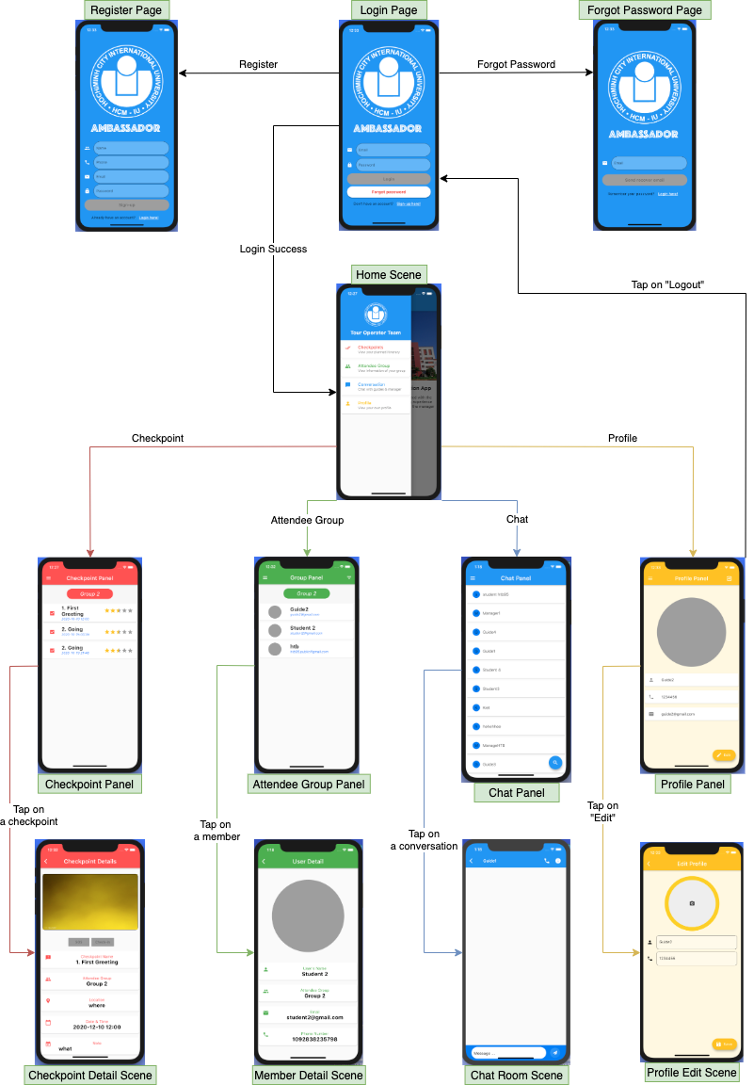

*Figure 63: Guide role user interface flow scheme diagram*

**Diagram explanation (Figure 63):**

The scheme diagram shows the flow of user interfaces for the role of guide in the application. After logging in successfully, the guide will see the same home screen and can navigate through the pages via the drawer navigator on the left. We can see that the guide and manager share the same user interface throughout most of the pages. However, there are some differences.

_In the checkpoint panel, the guides can see only the designated checkpoints that they were assigned to, not all checkpoints of all groups. Guides can not add new checkpoints from this scene. Guides can tap to view the checkpoint details, in this scene, guides have the option to check-in into the checkpoint, complete the checkpoint and send SOS signals, guides can not edit the checkpoint details.

_ In the attendee group panel, the guides can only view the members of their provided group. Guides can view the details of their members by tapping on them.

_ Chat panel is the same as of managers’ chat panel.

_ Profile panel is the same as of managers’ profile panel.

***3.4.3 Participant user interface design***

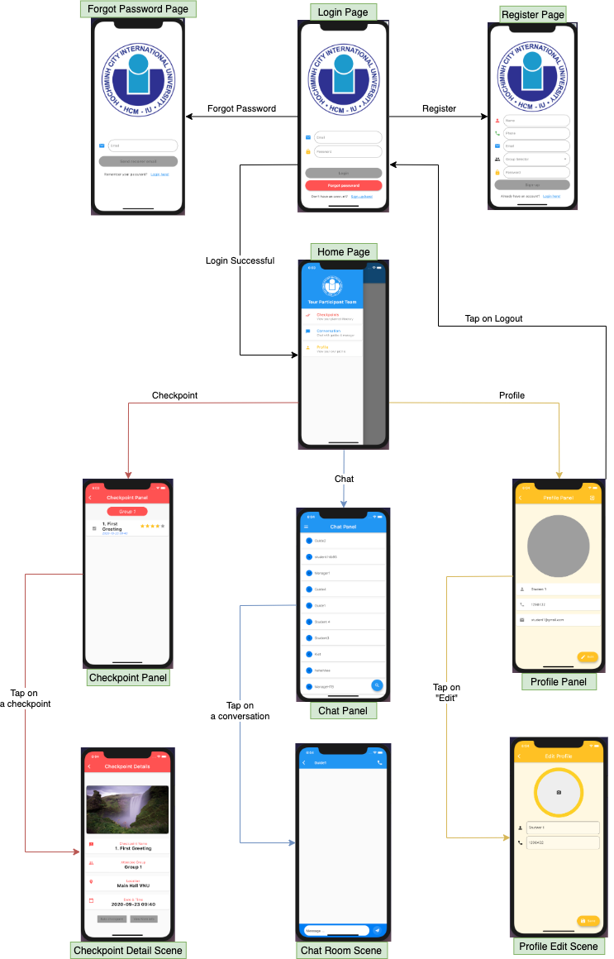

*Figure 64: Participant role user interface flow scheme diagram*

**Diagram explanation (Figure 64):**

The scheme diagram shows the flow of user interfaces for the role of participants in the application. After logging into the app successfully, the participants are greeted with a welcome scene. Both the login design and the welcome scene are different from the manager or guide in order to distinguish between the two teams. The participant can also navigate through the pages using the drawer navigator.

_In the checkpoint panel, participants can view all the checkpoints provided to their groups, participants can not add new checkpoint. To view the details of the checkpoint, participant can tap on them, in this scene, participants have the option to provide feedback and rating to that checkpoint, also there is the button to open the QR scanner to scan for more in-depth information that participants need.

_There is no attendee group panel for participants as this is a management and operating level panel.

_ Chat and Profile panel is the same as of guides and managers.

**CHAPTER IV**

**IMPLEMENTATIONS AND RESULTS**

**4.1 IMPLEMENTATIONS**

***4.1.1 Setting up database***

First of the implementation is to set up the database which will hold the many collections of application data. We need to set up the online database (CloudFirestore) on Firebase according to the steps provided in chapter 2. After the initial setting for the online database, we then need to implement the model of the data in the Flutter application. The implementation for the data in the app is as follow

**1. Users**

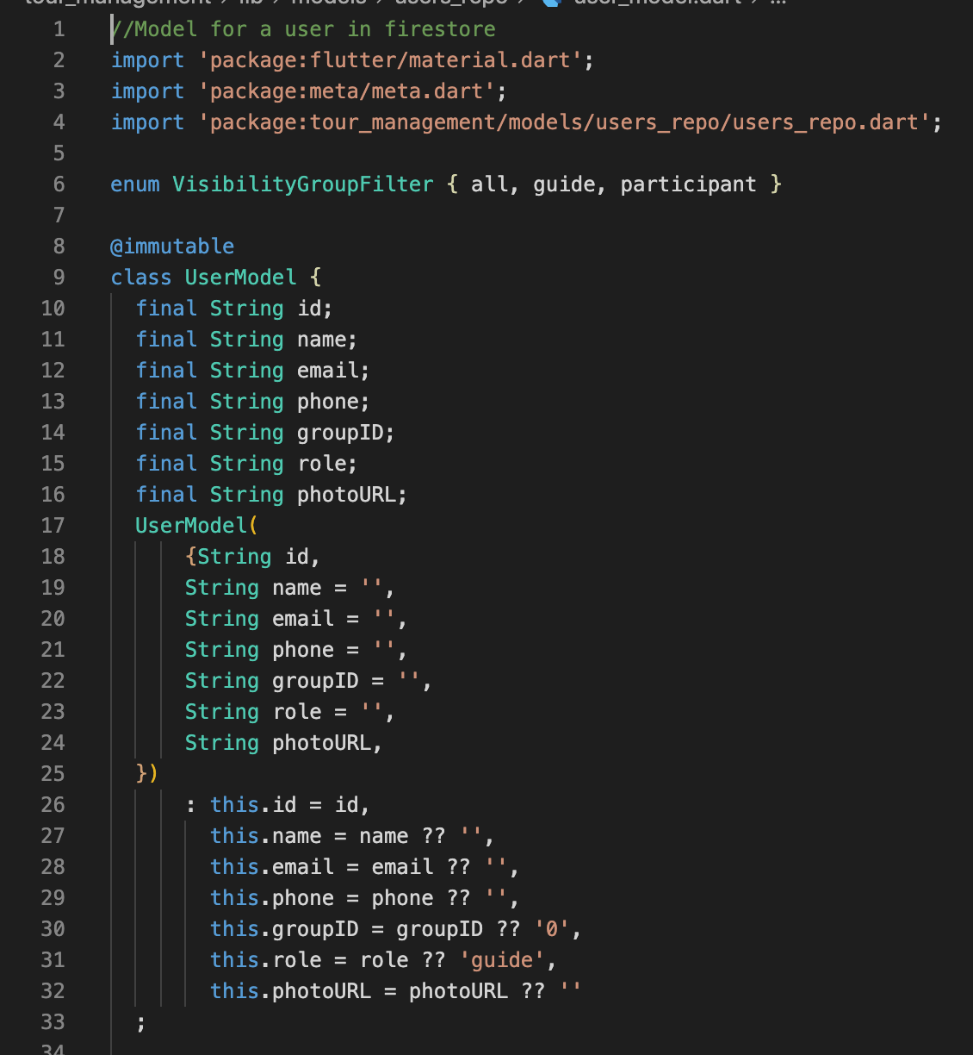

*Figure 65: user_model.dart*

The ***user_model.dart*** file will be the model for the user data to be stored on Firestore. Each users will follow the same model. Each user will have an ID, a name, an email, a phone number, a groupID, a role and a photoURL for the profile image. Figure 65 shows the initial part of the ***user_model.dart*** file, which involves the intialization of the constructor for the model of users.

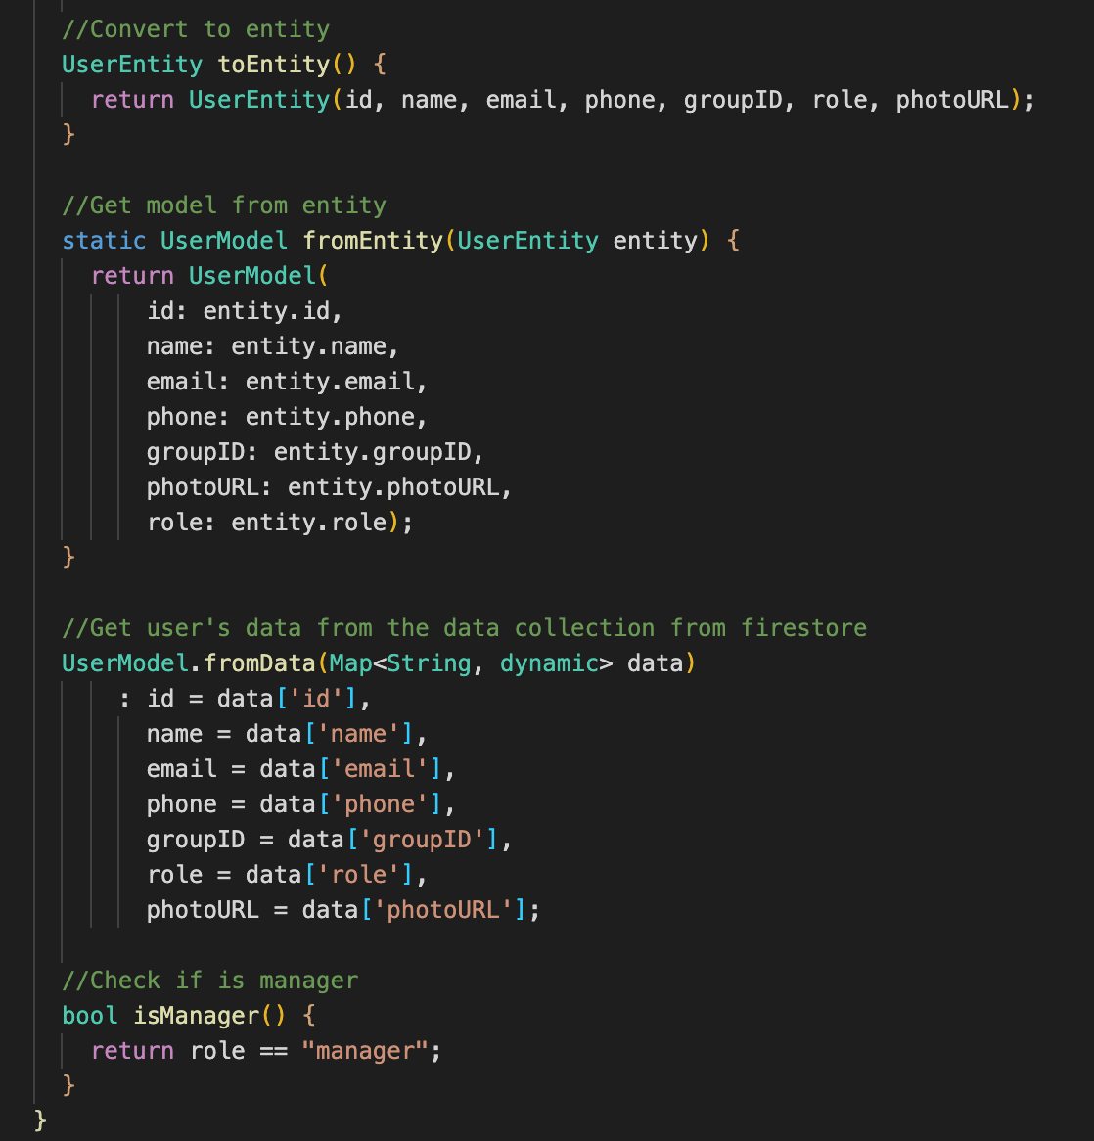

*Figure 66: user_model.dart functions*

Figure 66 shows the functions implemented in the ***user_model.dart*** file. We have the function to turn the user model into an entity, which can be referenced later to get information for the profile page of the application. On the other hand we also have the functions to retrieve the user model back from either the entity created or retrieve it from the Firestore collection. Lastly, a function to check if the role of the user is manager or not. This function is to help the app to distinguish between users, checking by their role to give the users their designated views and UIs.

Next we have the ***user_entity.dart***, to manage the user model turned entities. In this file, we will import the use of CloudFirestore, and we will store the entities created to the Firestore collection.

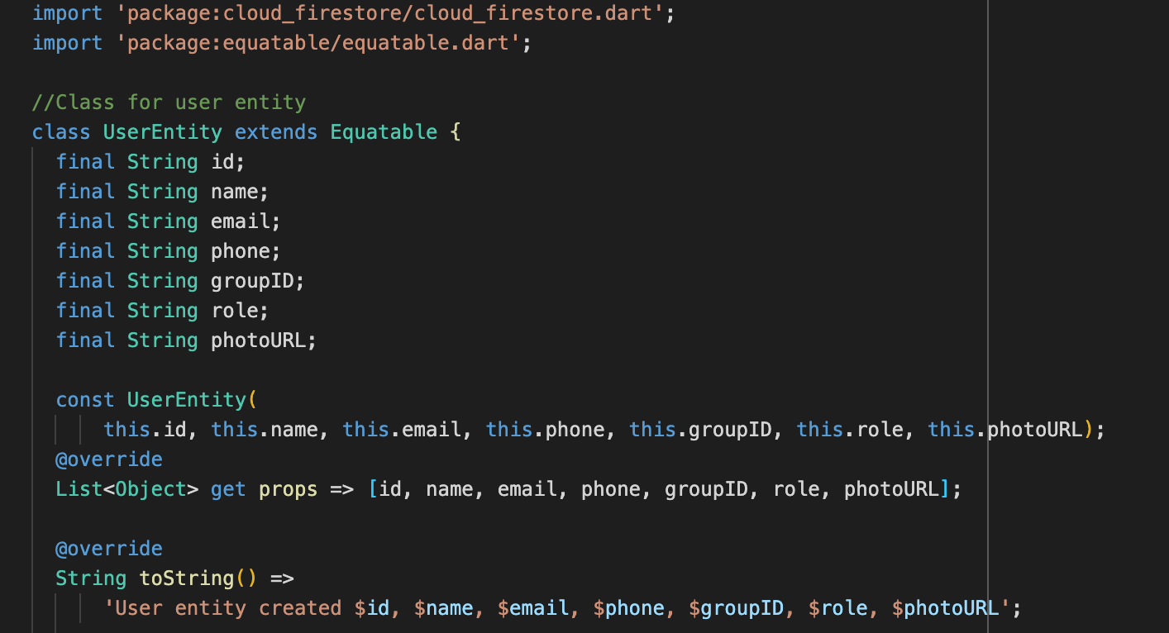

*Figure 67: user_entity.dart*

The UserEntity class share the same fields as UserModel class and there is a function to get the field properties from the UserModel class.

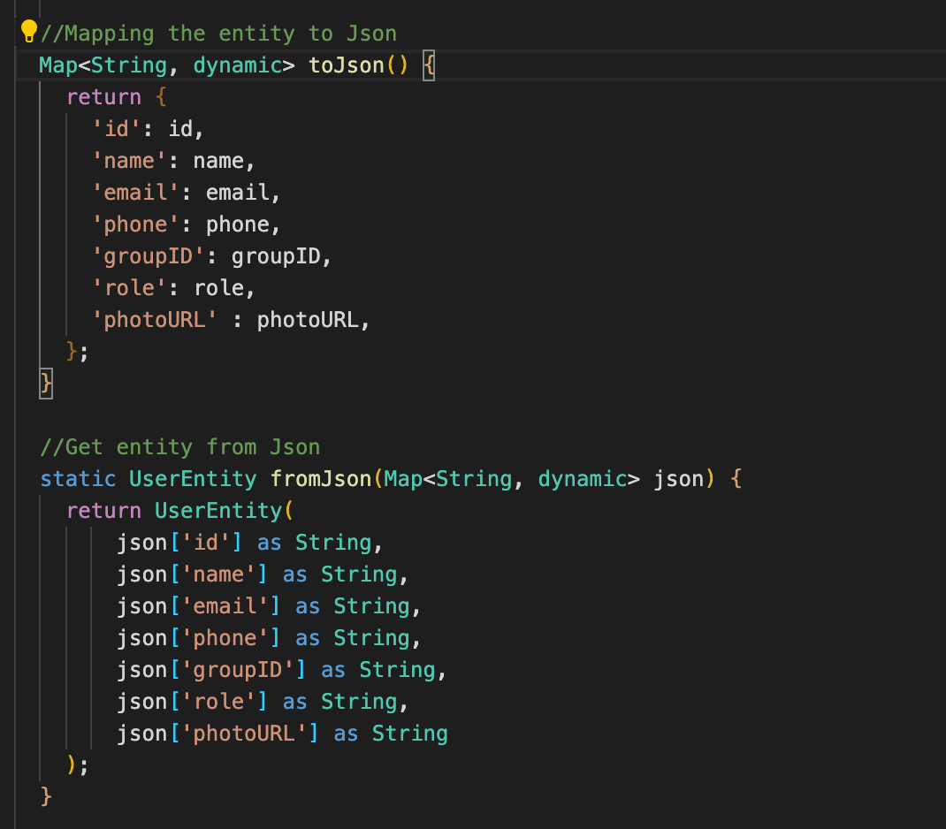

*Figure 68: user_entity.dart Json functions*

Since Firestore send and receive and save its documents in the form of JSONs, Figure 68 shows the UserEntity class implemented the functions for creating JSONs from user entities and vice versa, to send and receive data from Firestore.

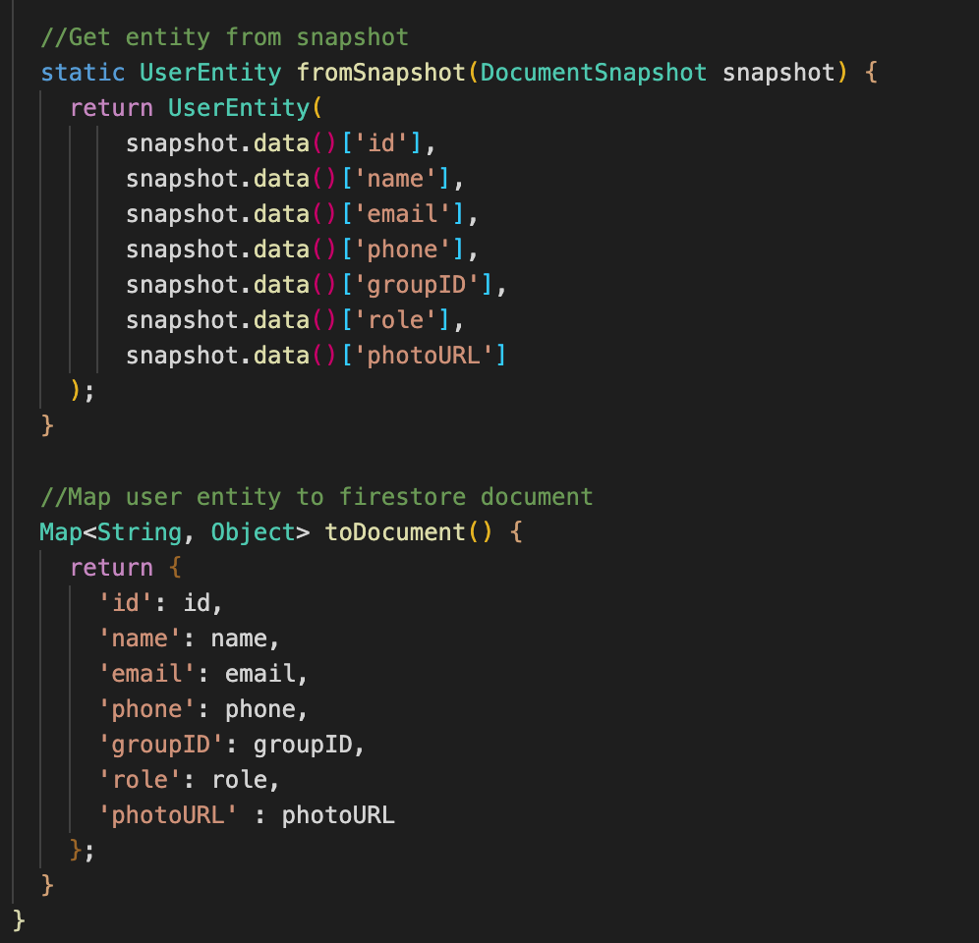

*Figure 69: user_entity.dart Firestore function*

Figure 69 shows the functions of the UserEntity class that are related to Firestore. We have the function to get the user entity from the document snapshot on Firestore and the option to map the user entity on to a document which can then be send to Firestore.

**2. Checkpoints**

The checkpoints models and enity for the application also follows the same structure and methods as of the user model and user entity. We provide two classes, one for CheckpointModel and a class for CheckpointEntity. The checkpoint repository will be encapsulated within a Flutter package, the reason for keeping checkpoints in a packages is the ease of transfer of the package from the operator team to the code of the participant team, this can reduce code re-writing. To create a new Flutter package, we can follow the steps provided in chapter 2.

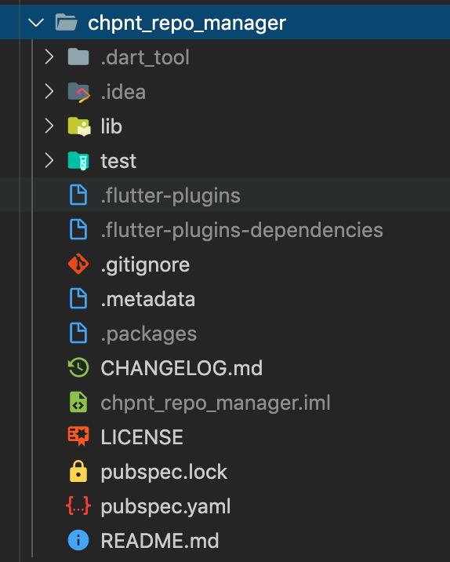

*Figure 70: checkpoint repository Flutter package*

The CheckpointModel class will be responsible for the data model that each checkpoint will follow. Each checkpoint will have an ID, a name, a location, a time and date, a note, a complete status, a check-in status. The complete status is to make sure when the manager follow up on the plan, they sees that the guides are completing their tasks, and the check-in status is to make sure the progress of the tour is continuously updated.

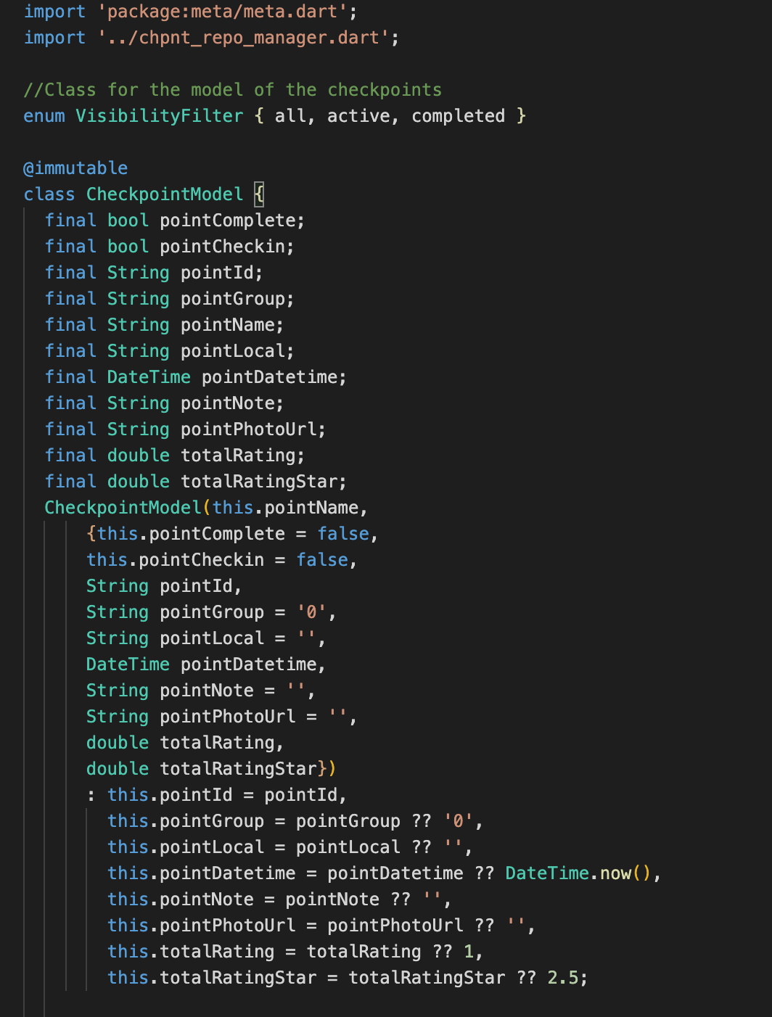

*Figure 71: checkpoint_model.dart*

CheckpointModel also follow the same methods that of UserModel, the class will have a function to create an entity from the model and get the model from a collected entity. The CheckpointModel class also has another function that is ***copyWith***, the function will be used to update the checkpoint documents if there are any changes.

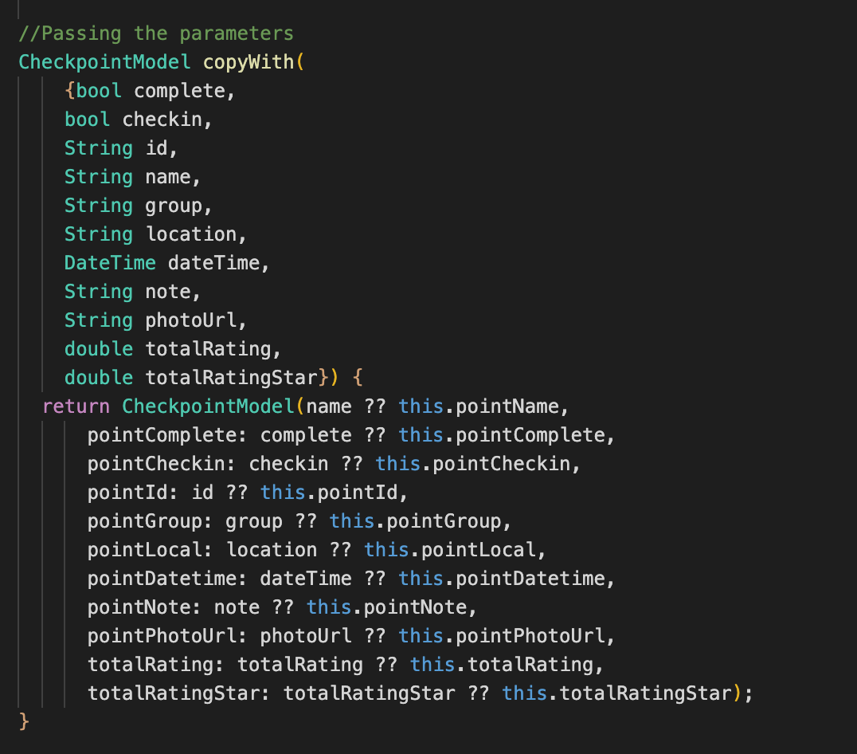

*Figure 72: checkpoint_model.dart copyWith function*

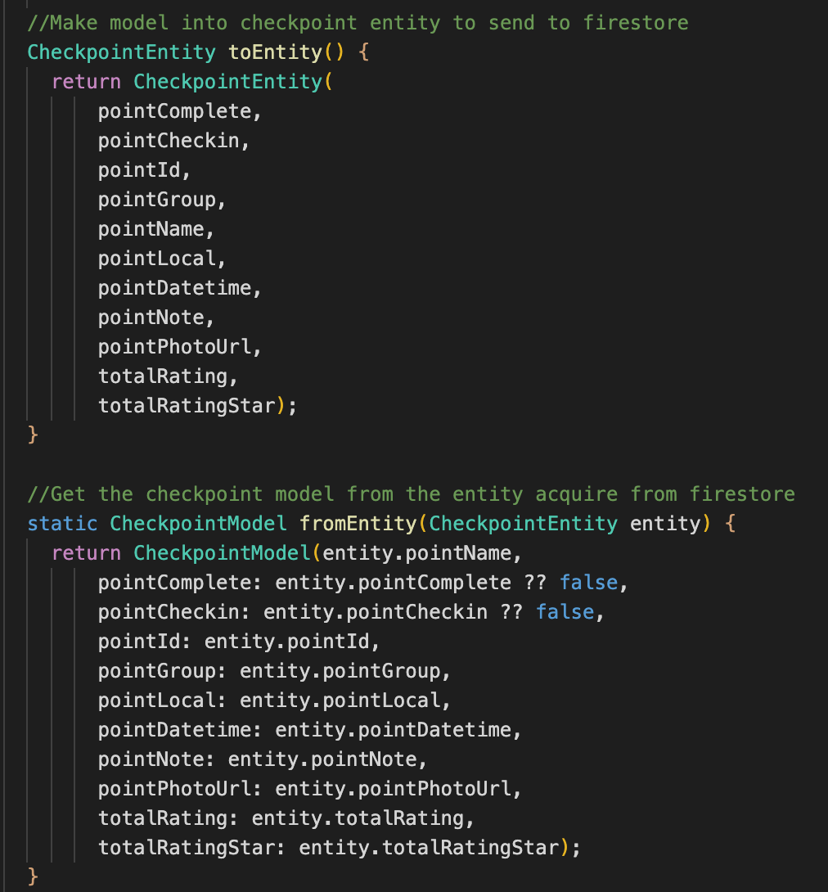

*Figure 73: checkpoint_model.dart fromEntity and toEntity function*

The CheckpointEntity class follows the same structure of UserEntity, entities are created and then sent to Firestore as a document to be stored online and entities can be retrieved from Firestore. Checkpoints are also handled by Firestore in the manner of handling JSONs, therefore, there will also be functions to get checkpoints from JSONs and vice versa.

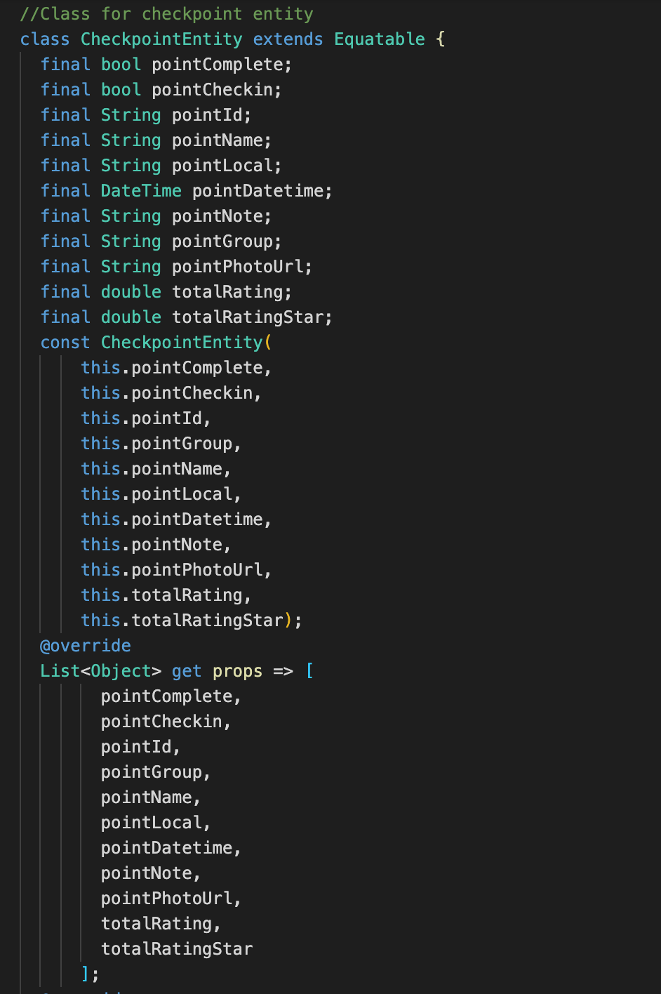

*Figure 74: checkpoint_entity.dart*

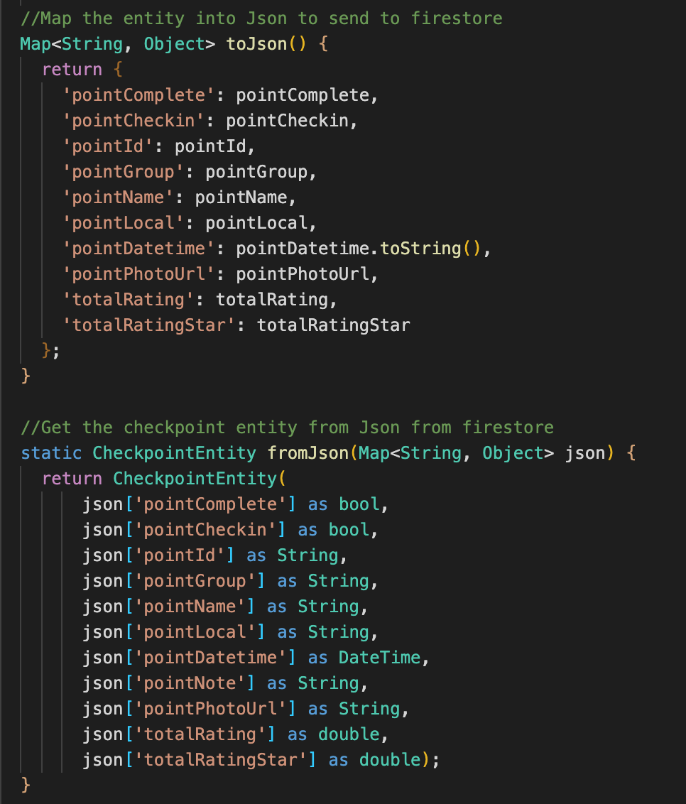

*Figure 75: checkpoint_entity.dart JSON related functions*

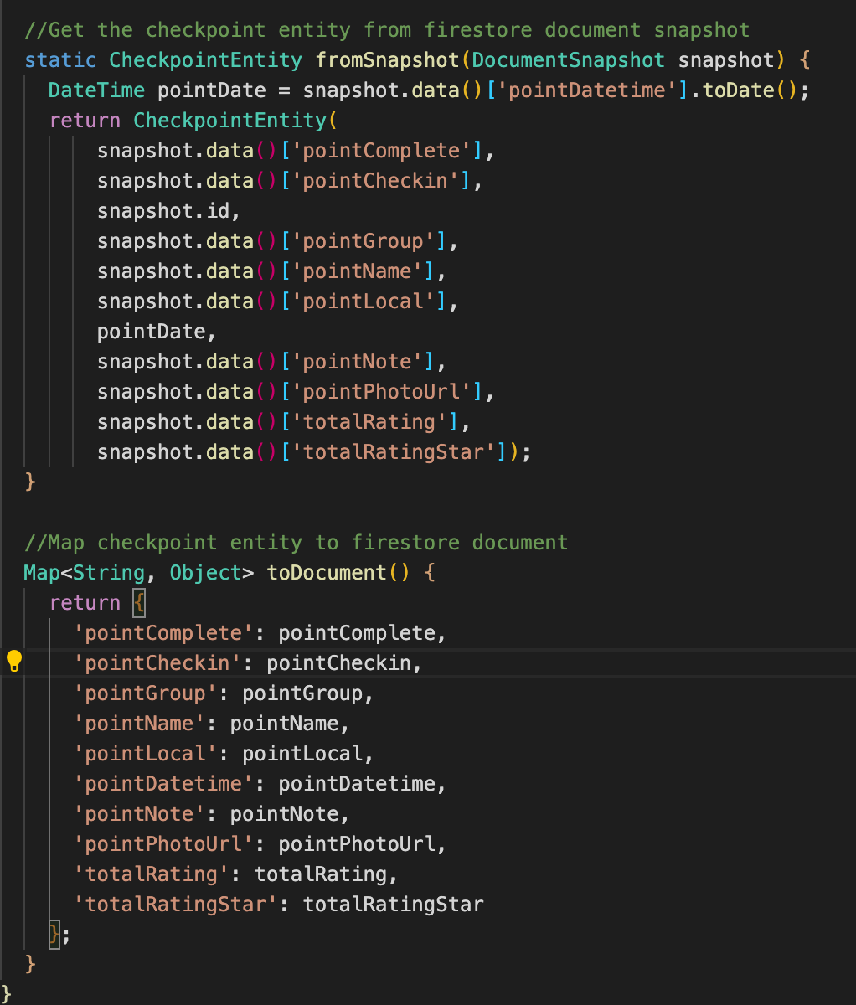

*Figure 76: checkpoint_entity.dart Firestore related functions*

**3. Firestore**

With the model and entity now set up, we now need the classes to help the app connect to Firebase and send the users as well as the checkpoints to the Firestore collections. We will have to separate class, one for handling the users data to send to Firebase and one to handle sending the checkpoint data to Firebase, each will belong to its respective side.

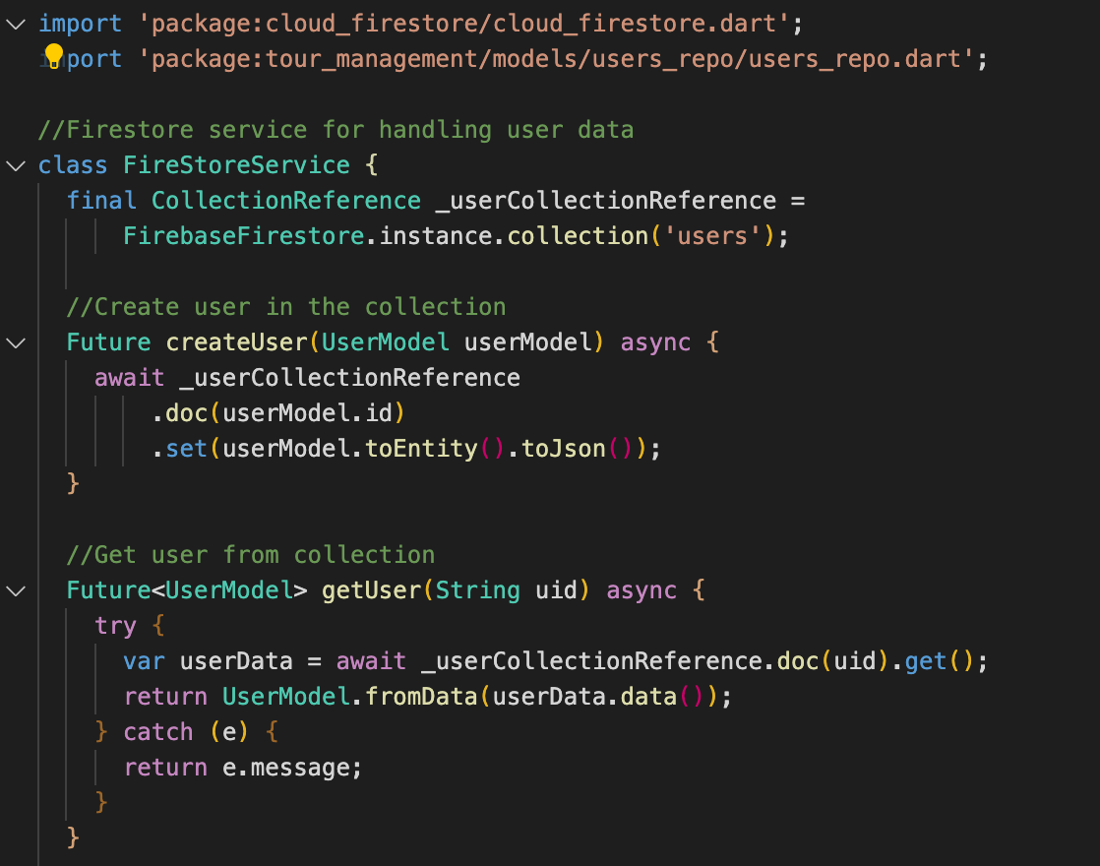

*Figure 77: Users firestore functions class*

Figure 77 shows the class that handle the Firestore functions for adding and getting the users from the online Firebase database. We create a new collection called “**users**” to hold the many user documents. Next we have a function called ***createUser*** that set a new JSON document created from the UserEntity to the online collection and give each one a new ID. The next function called ***getUser*** is used to get the user documents from the online collection, the result from this function will be converted into the UserModel.

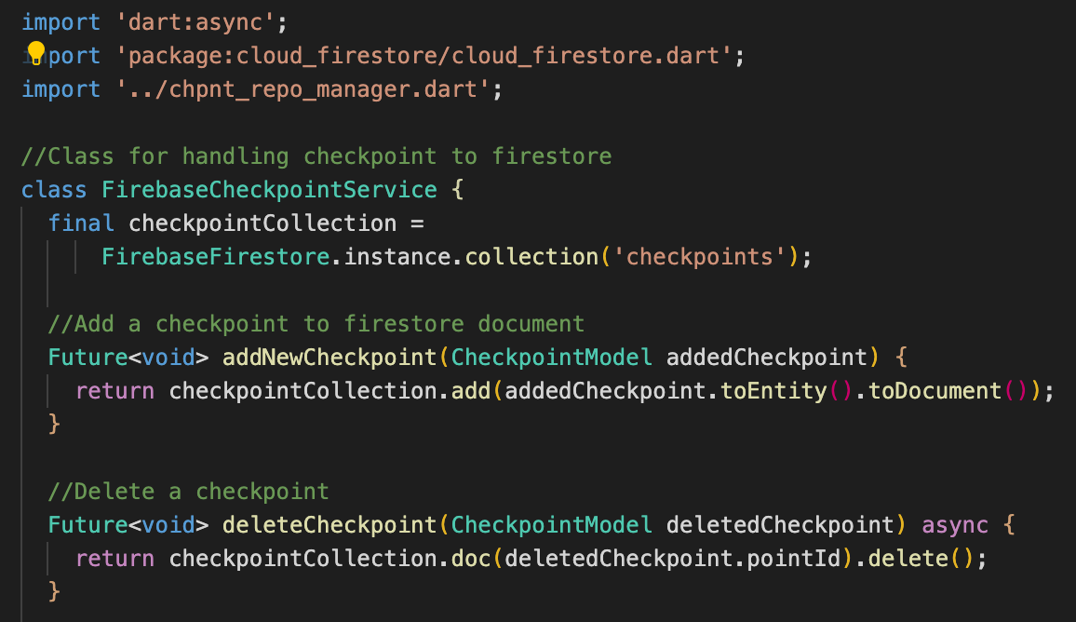

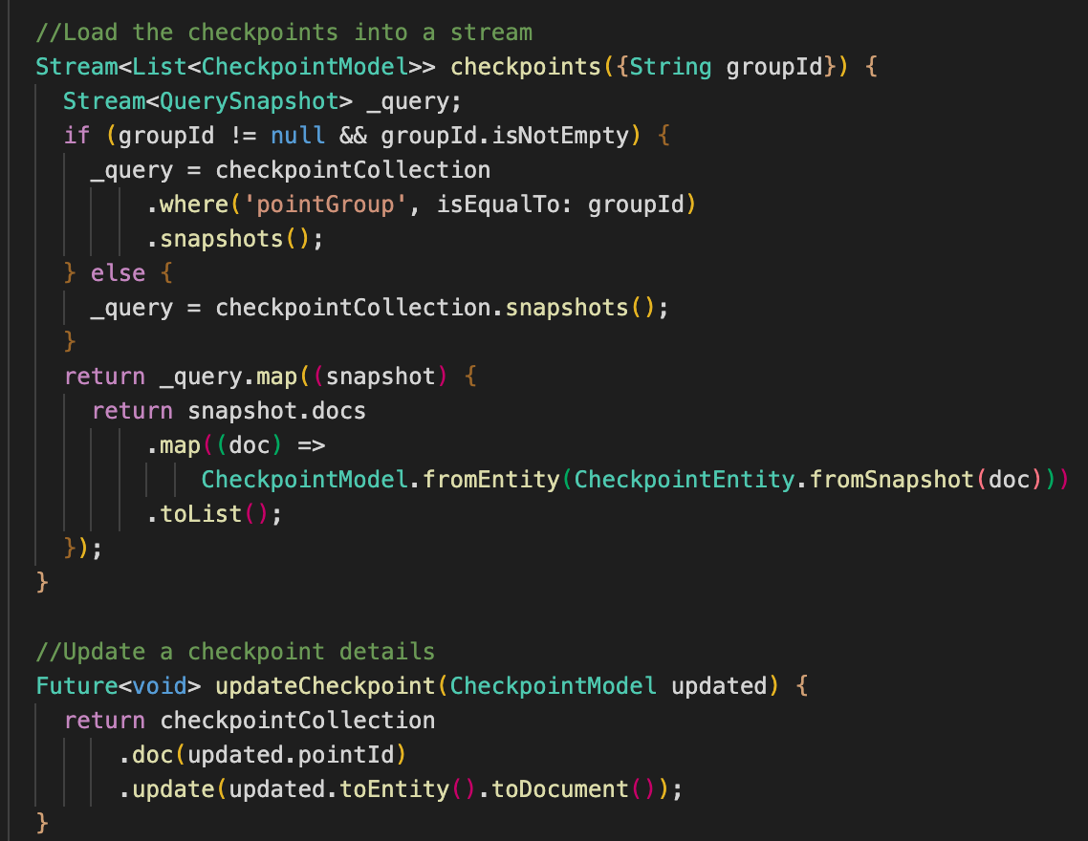

*Figure 78 & 79: Checkpoints Firestore function class*

Figure 78 and 79 shows the class that handle the Firestore functions of the Checkpoints. The class will create a new collection called “**checkpoints**” on Firestore. Along with that are the functions to add the checkpoints to the collections called ***addCheckpoint***. Since manager can edit and delete the checkpoints from the online collection, we need to implement two functions to enable that to the application. The function ***deleteCheckpoint*** will get the checkpoint by the ID and delete it from the collection. The function ***updateCheckpoint*** will find the checkpoint with the ID and then update it with the newly updated checkpoint, writing the updated ones to the existing ID, overwriting the old one.

***4.1.2 Implementing login and authentication services***

In order to implement the Login, Register and Forgot Password feature of the application, we need to follow two steps. The first and formost is to set up Authentication services on Firebase, which can be done via the instruction in chapter 2. As stated in chapter 2, Firebase has a collection of templates for the many functions relating to authentication that can be set up quite easily. Next is to set up the Dart classes to connect to the Firebase service and provide function for the application.

The logical functions for the features will be enclosed in ***firebase_services.dart***. The class FirebaseService here will provide many functions such as ***signInWithEmailPassword***, ***signUpNewUser***, ***resetPassword*** and ***signOutUser***. The class is shown as followed.

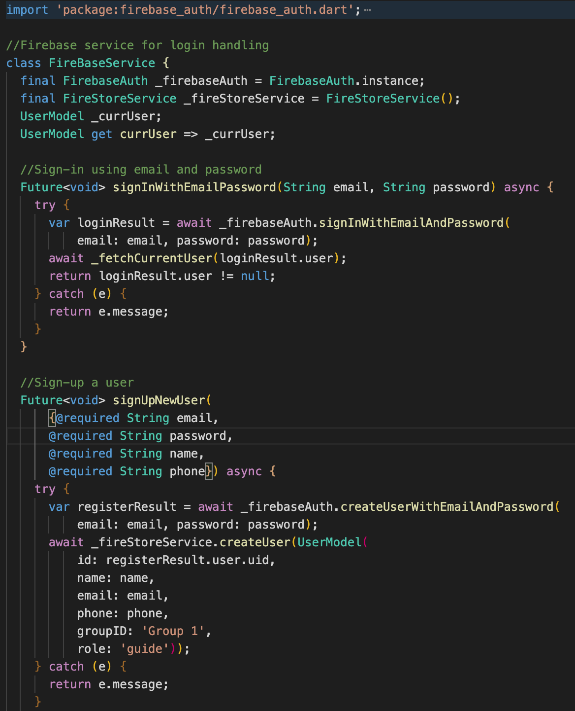

*Figure 80: firebase_service.dart*

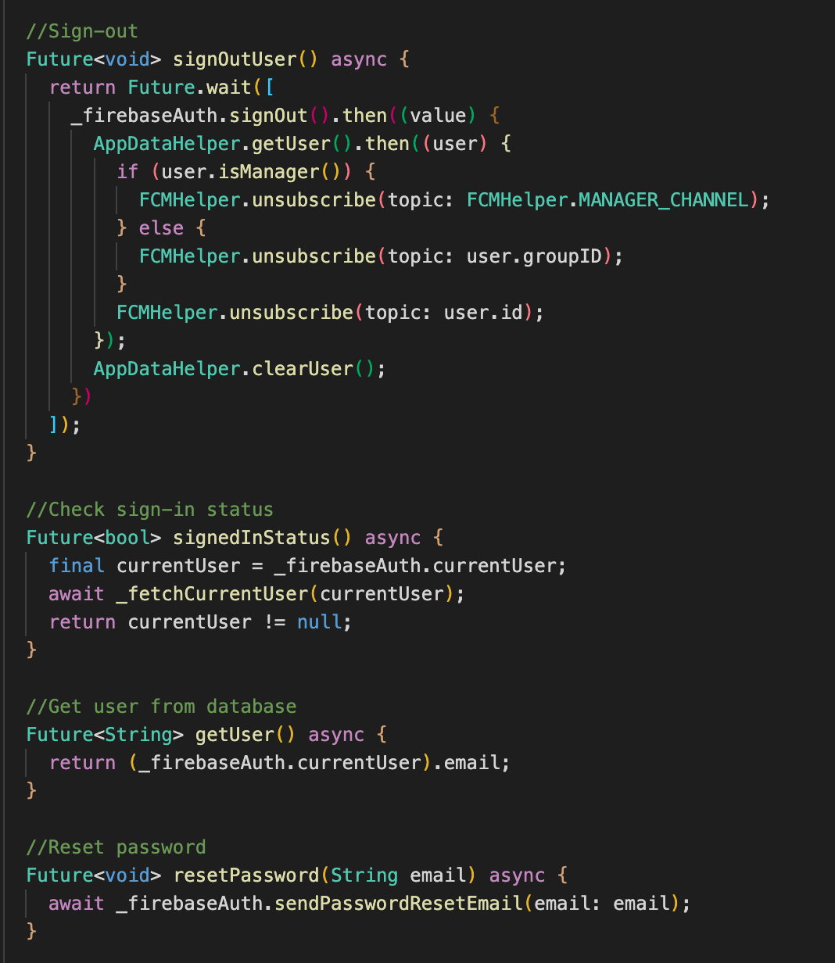

*Figure 81: firebase_service.dart functions*

The class has an import of ***package:firebase_auth/firebase_auth.dart***, this is the import to use the provided function for login, register and password reset from Firebase Authentication service. The function ***signInWithEmailPassword*** will take in the value of email and password, then pass the values on to the function of ***signInWithEmailAndPassword*** that was predefined in the ***firebase_auth*** library. The same applies for the function ***signUpNewUser*** that uses the function ***createUserWithEmailAndPassword*** from Firebase to create a new user in the Authentication method collection of user. Moreover, this function also implement the code to add the newly registered user to the ***“users”*** collection on Firestore for later reference. The application also has the feature of resetting the forgotten password of their accounts, this function is called ***resetPassword*** that will implement the ***sendPasswordResetEmail*** function provided by Firebase.

***4.1.3 Implementing state management***

To help the application with state management, there are quite a few Dart libraries that can be used such as Provider or BLoC. For the case of the application in this thesis, we will be using BLoC, more specifically ***flutter_bloc***. The bloc library will enable the business logic in the application, the logic will require a state and the event that would happen in that specific state. In order to organize the application documents, we will put the blocs into an organized folder called ***“controllers”*** which will house the many blocs for many features of the applications such as login, authentication, checkpoints management, chat, etc. All blocs in this folder follow the same principle of having a class for states, a class for events and a class for bloc that map the events to their states.

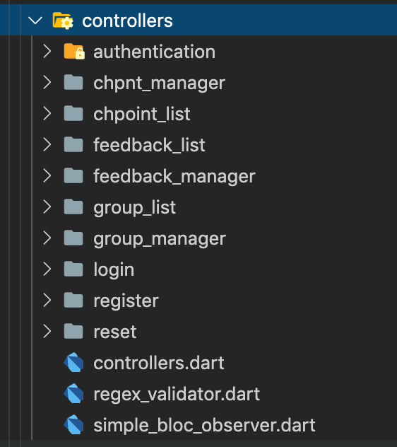

*Figure 82: Application controllers folder*

To illustrate the way that ***flutter_bloc*** provide state management to the application. We can take in the authentication bloc as an example that other blocs will follow. In the authentication bloc, we will have three files, that is the ***auth_state.dart***, ***auth_event.dart*** and ***auth_bloc.dart***. The class AuthState will define the many states that authenticating to an app should have while AuthEvent will provide the events that would happen during a certain state in the authentication process. Finally, the AuthBloc class will provide a business logic controller to the states and events, mapping them together thus providing the app with state management for the authentication aspect of the app.

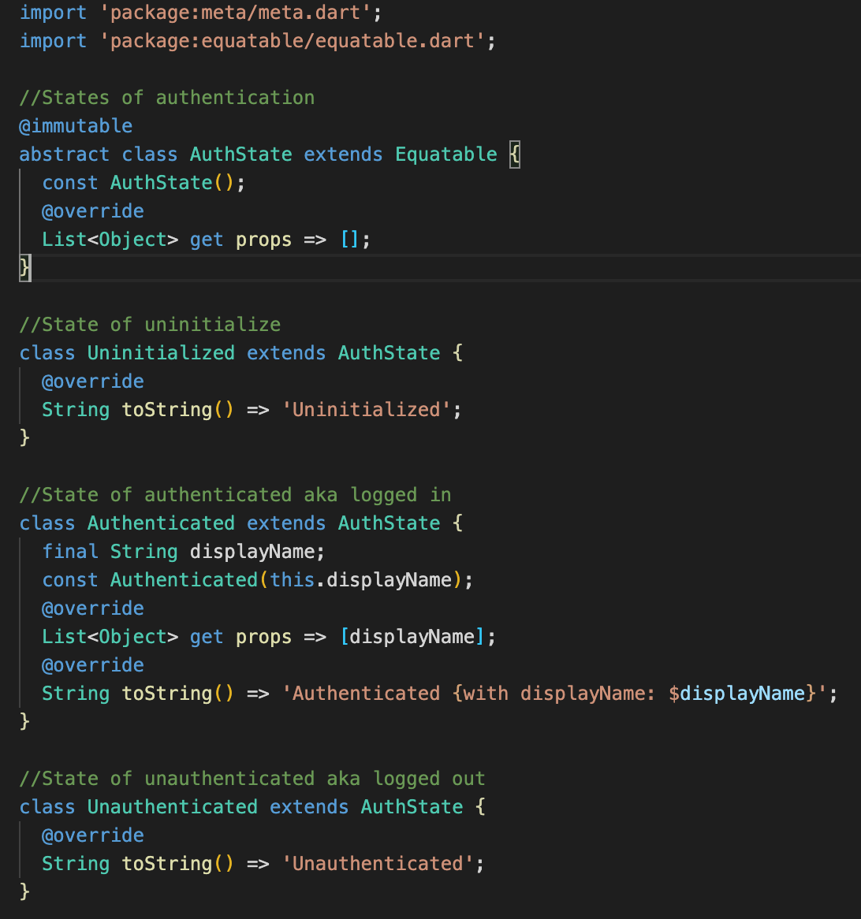

*Figure 83: auth_state.dart*

Figure 83 shows the AuthState class, which defines the three states of authentication. We have the ***Uninitialized*** state, which is the very first state of the application, on the first launch without previous login. Next is the state of ***Authenticated***, the state when the authentication is successful and user is logged in. Last one is the state of ***Unauthenticated***, this will be the state when the user logged out of their account. The purpose of having the state management is that to keep the user’s login state, so that they don’t have to try to login again on app re-launch.

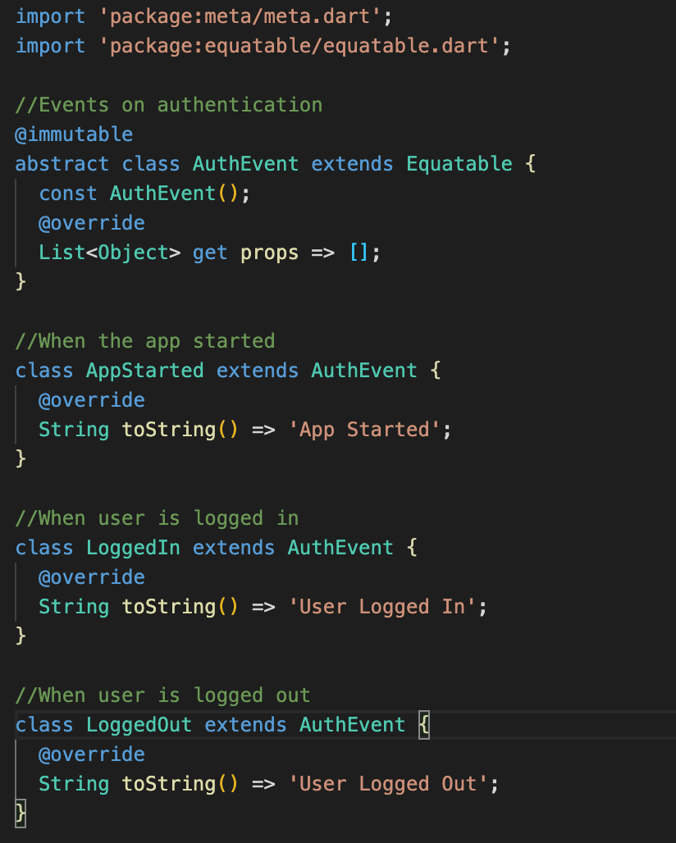

*Figure 84: auth_event.dart*

Figure 84 shows the class AuthEvent class, this class defines the events of the Authentication process. We have the event for ***AppStarted***, this applies for when we first launch the app. Next is with user logged in to application successfully, the event is called ***LoggedIn***. Lastly, the event on user logged out from their account will be called ***LoggedOut***. These events defined here will be mapped to the defined states provided by the class ***AuthState***, the mapping will be implemented in the business logic controller class called ***AuthBloc***.

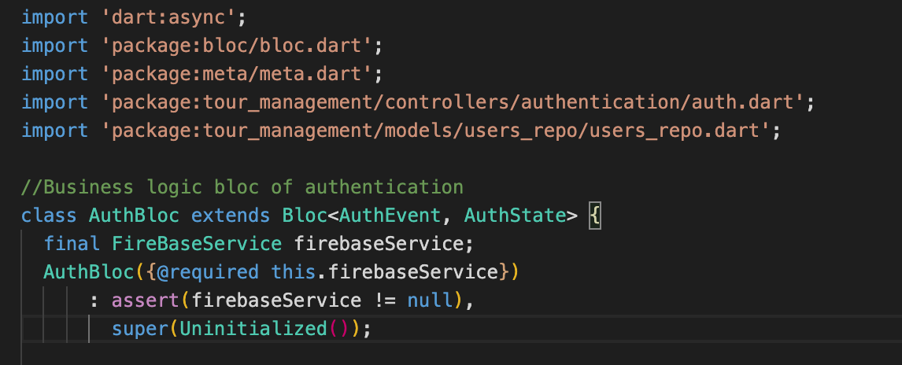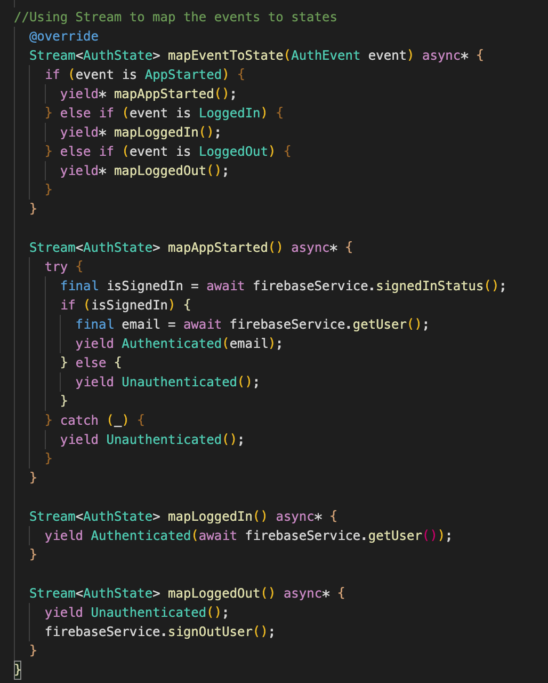

*Figure 85 & 86: auth_bloc.dart functions*

Figure 85 and 86 shows the AuthBloc class, here we see the import of ***package:bloc/bloc.dart*** in order to user flutter_bloc. The class also initialize an instance of the FirebaseService class, to get connected to the Authentication service of Firebase. We have the function of ***mapEventToState***, this function as its name suggests will map the events to is respective states, we will map the three pre-defined events to their states. On *AppStarted*, the application sign-in status will be checked, to yield the state of *Authenticated* or *Unauthenticated* respectively to the results. On *LoggedIn*, the yield state is *Authenticated* and the user information will be fetch. On *LoggedOut*, it will yield state of *Unauthenticated* and will trigger Firebase instance to signout the user.

***4.1.4 Implementing checkpoints management logic***

Checkpoint will be divided into two blocs, one is for checkpoint management and one is for checkpoint list control. We will first implement the checkpoint management bloc, this bloc is for getting the checkpoints from Firebase ***“checkpoint”*** collection and mapping them to the many states of the application.

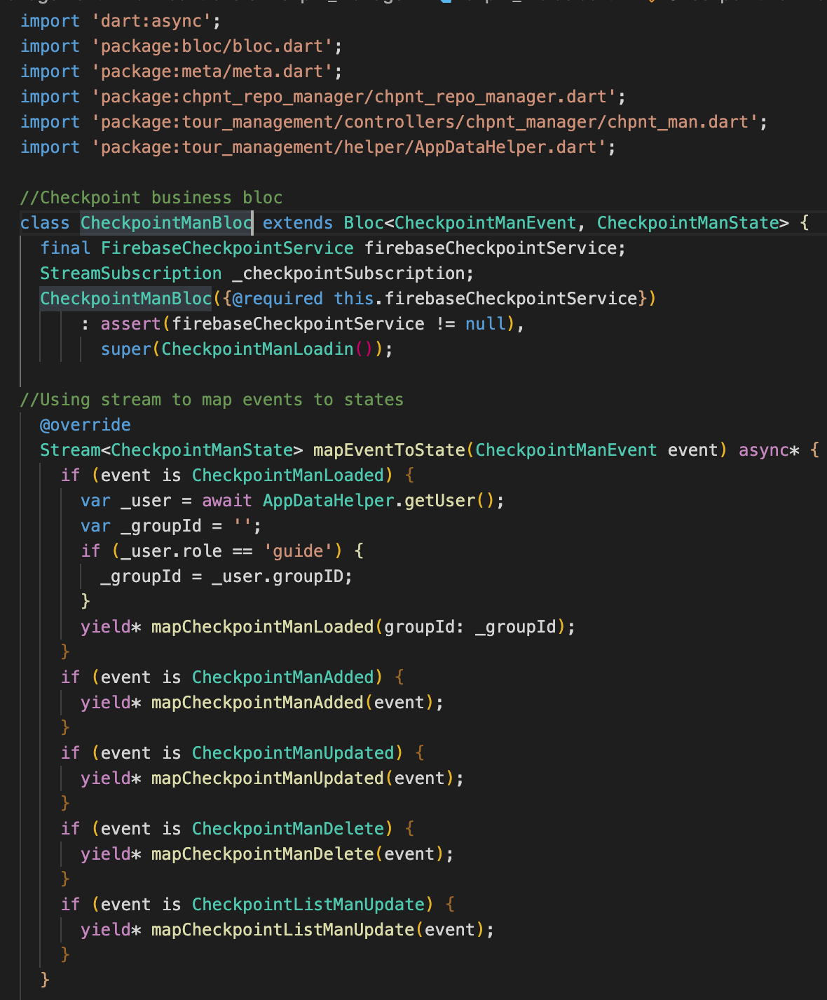

*Figure 87: checkpoint_mbloc.dart*

As we can see from Figure 87, we have a call for the instance of FirebaseCheckpointService to get the checkpoints from Firebase collection. In the function ***mapEventToState***, on CheckpointManLoaded we will check for the user’s information, more specifically the role of the users, if the user is the manager, then all checkpoints will be fetched and if the role is guide then only the checkpoints related to the group will be fetched. We also have functions to help the manager control and manage the checkpoints in this bloc such as ***mapCheckpointManAdded***, ***mapCheckpointListManUpdate***, ***mapCheckpointManUpdated***, ***mapCheckpointManDelete*** that uses the functions pre-defined in the Checkpoint Firestore class. The function ***mapCheckpointListManUpdate*** is used for updating the list of checkpoints on any new updates such as adding new checkpoints, deleting checkpoints, editing a certain checkpoint. At the very end of the class, we have a ***dispose*** function, to cancel out all process related to the checkpoint management for ease of operation for the devices.

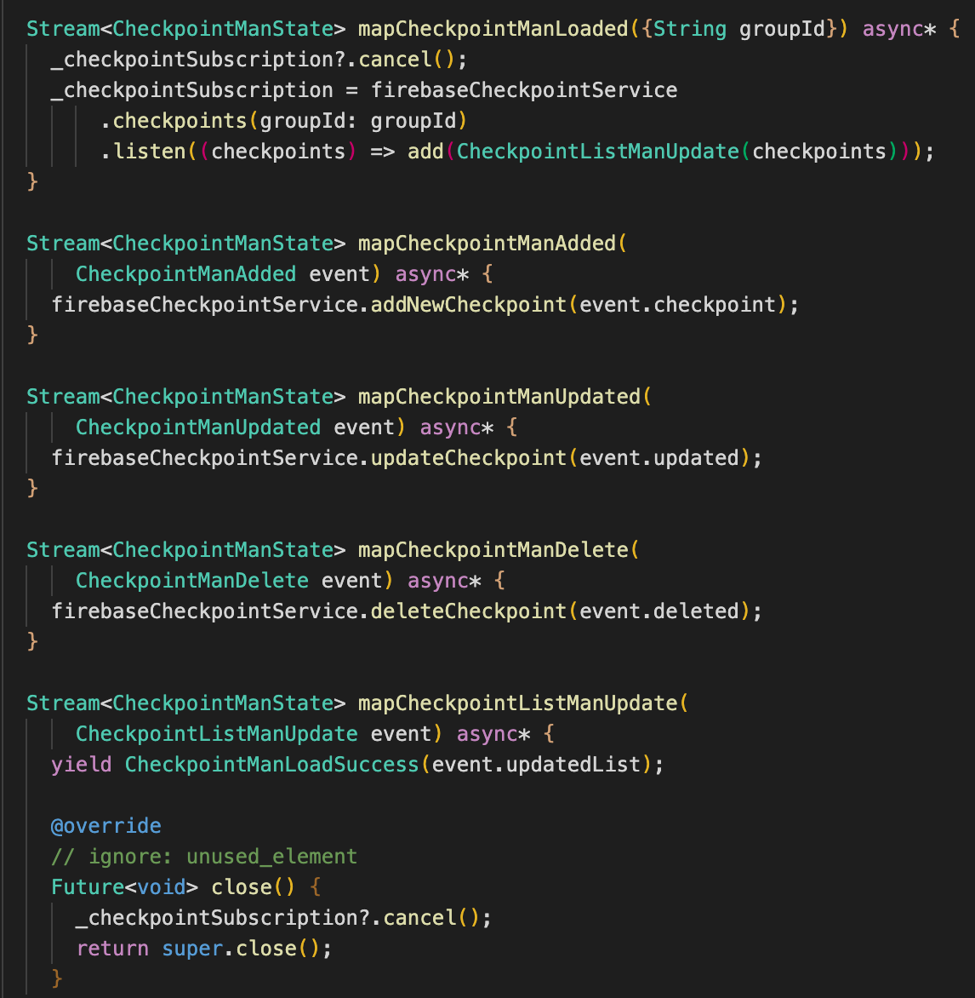

*Figure 88: checkpoint_mbloc.dart functions*

Next up is the checkpoint list, this bloc is to display the list of checkpoint after the checkpoint management bloc has finished fetching the checkpoints from the Firestore collection. In this bloc, we have a reference to ***checkpoint_mbloc.dart***, we use the bloc to listen for the state of the app, if the checkpoints are fetched successfully, then the list will load, if not then there will be a loading icon in place. In the ***mapEventToState***, we find that if the event is *CheckpointListUpdated*, meaning there has been a change in checkpoints, this will trigger a reload for the list of checkpoints.

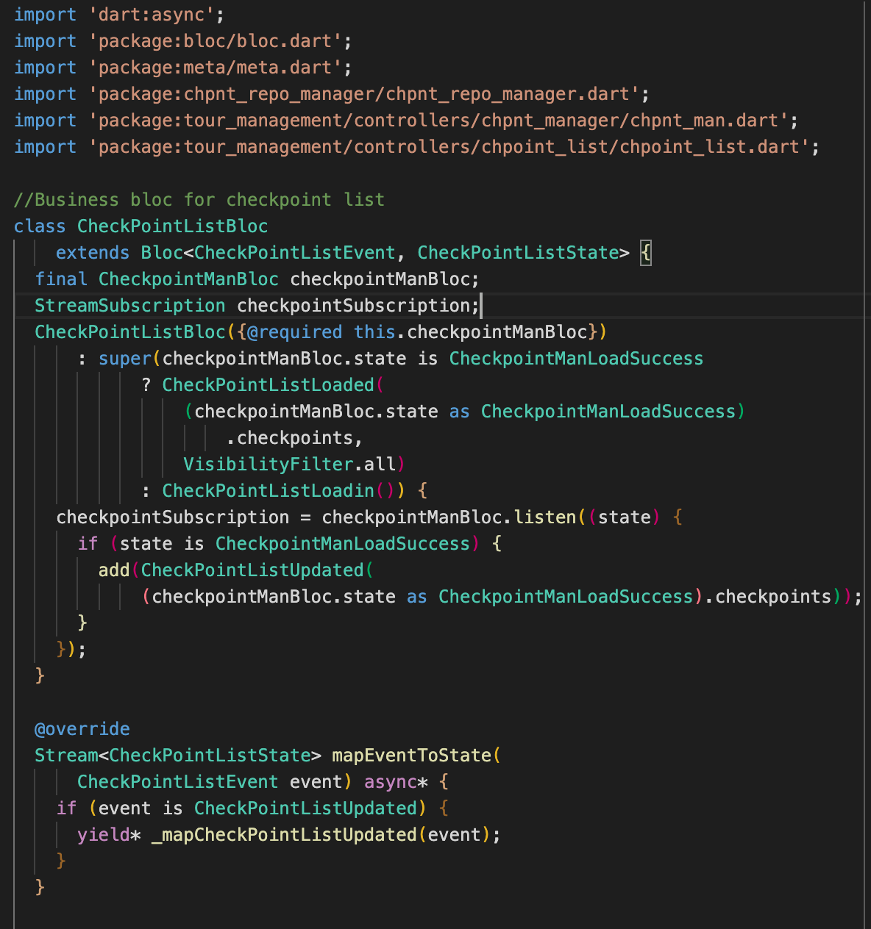

*Figure 89: checkpoint_list_bloc.dart*

***4.1.5 Implementing attendee groups management logic***

Following the same rule as of checkpoints, attendee groups in the application will also be divided into two blocs, one for fetching the groups from Firestore and one for displaying the groups on the application. The bloc for fetching the groups from Firestore will be called ***group_man_bloc***, this bloc follows the same rules as ***checkpoint_mbloc*** but instead of fetching checkpoints, this bloc will fetch the users from the ***“users”*** collection on Firestore. The groups will be fetched differently depend on the role of the user who is using the app. If the role of the user is manager, then all users will be fetched and only the users who are in the same group as the guide for guide users. Again, this user role check will be implemented in the ***mapEventToState*** function to yield the ***mapGroupManLoaded***, this is the state when all users are fetched from Firestore.

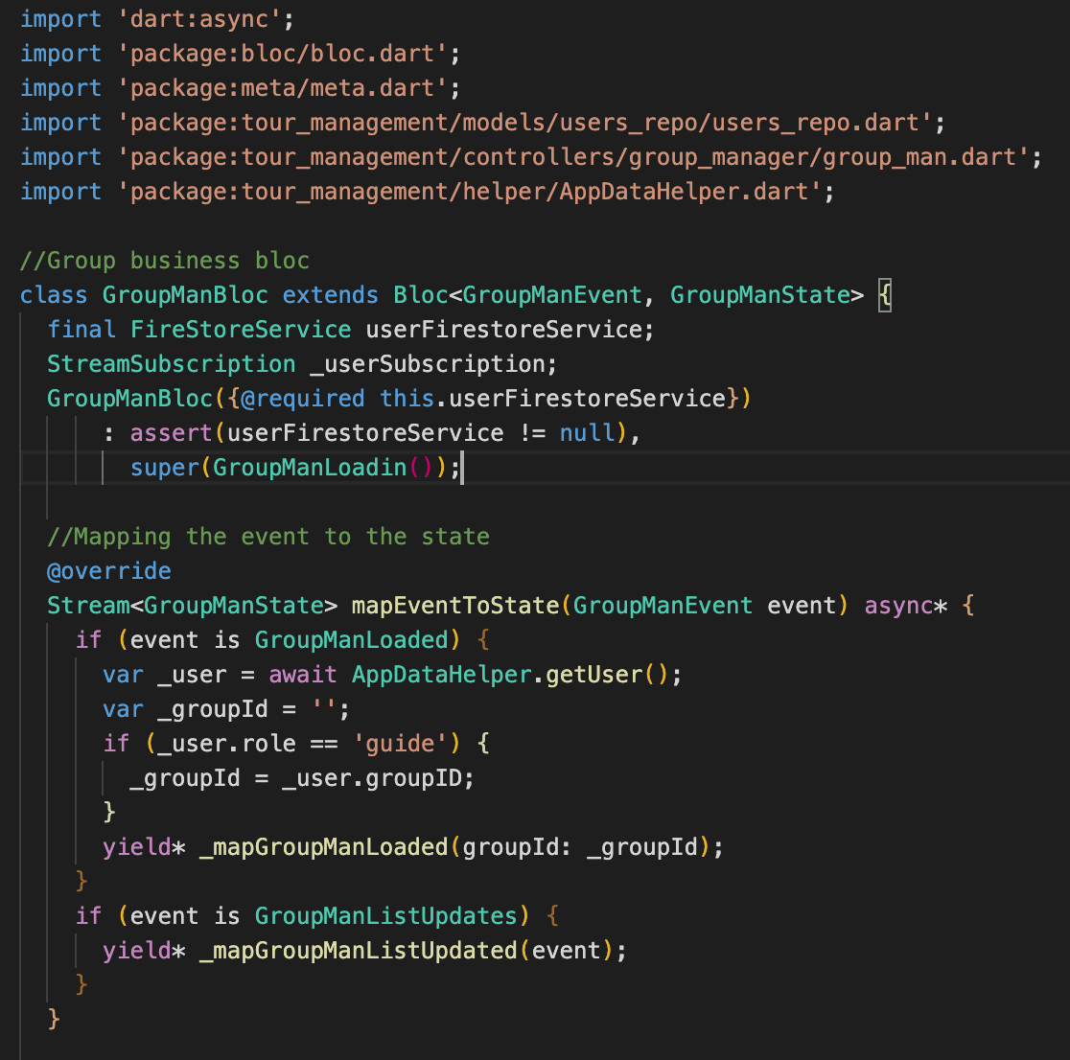

*Figure 90: group_man_bloc.dart*

The next bloc is of the ***group_list_bloc.dart***, this bloc is for displaying the list of users on to the screen. This bloc also implement the filter function, which is used to help filter out the role of users to display, we can choose to view between only guide users, participant users or manager users, this helps to reduce the amount of row needed for displaying on the application.

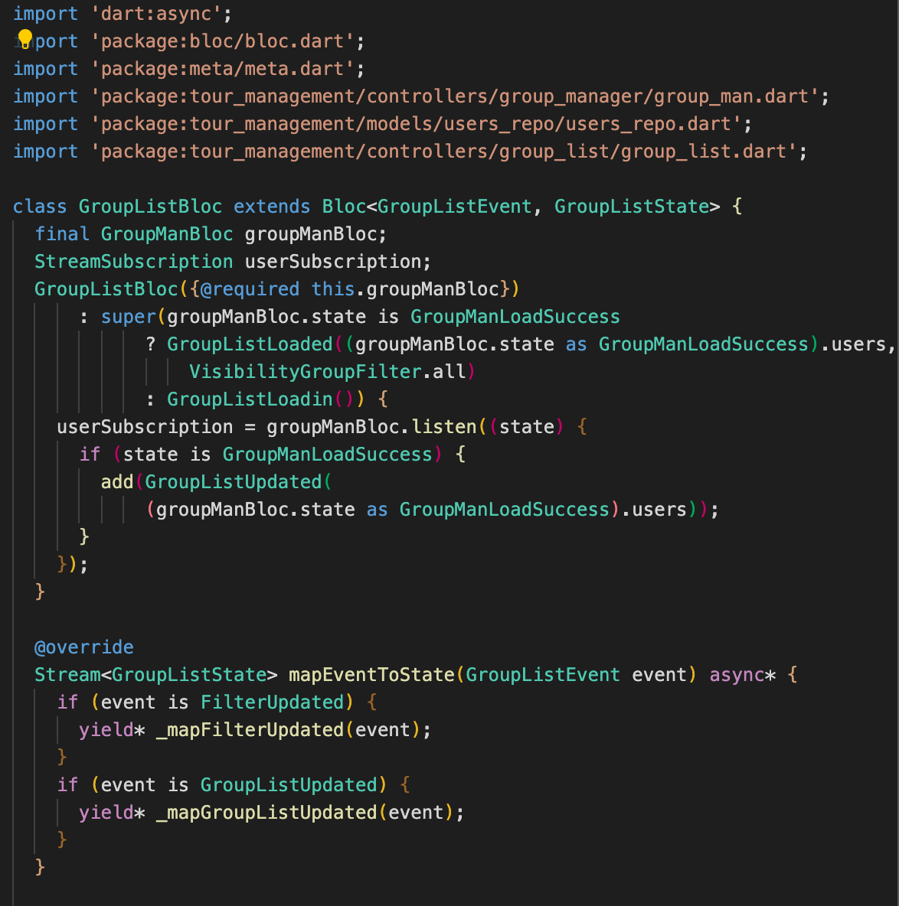

*Figure 91: group_list_bloc.dart*

The bloc relies on the controller that is ***group_man_bloc.dart***, to check if the management bloc has fetched the users, if yes then the list of users will be display. We also see two functions that is mapped to the two events of *FilterUpdated* and *GroupListUpdated*, they are ***_mapFilterUpdated*** and ***_mapGroupListUpdated***. These two functions work together in handling the list of users, on the event of a filter being chosen, the event trigger the ***_mapFilterUpdated*** function and with a new filter chosen, the list would need an update, Figure 92 will show the functions in details and show how the two functions are related.

s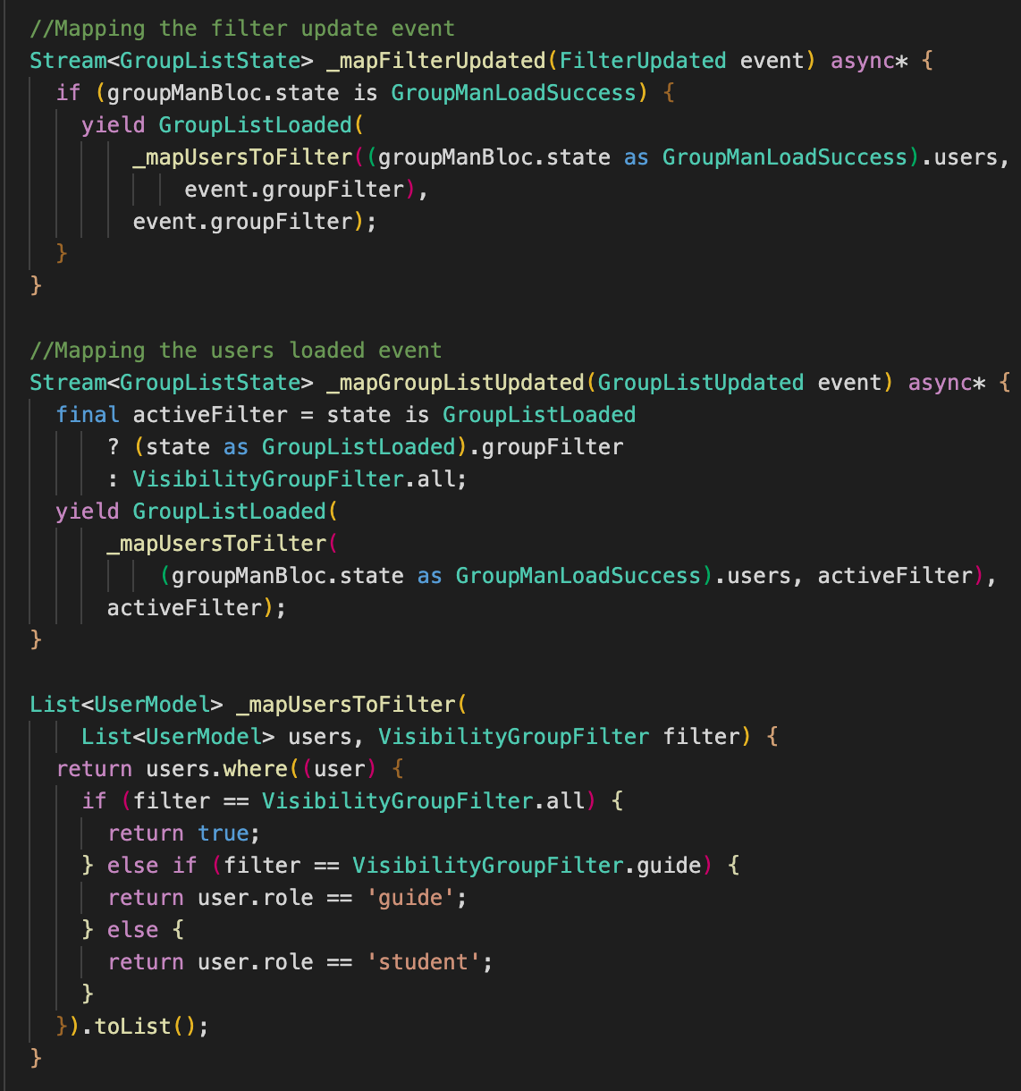

*Figure 91: group_list_bloc.dart functions*

As we can see from Figure 91, we have a function ***_mapUsersToFilter***, this is the connection between ***_mapFilterUpdated*** and ***_mapGroupListUpdated***. This function check for the selection of filter that user chose to apply to the list of users, prompting the display to show only the guides, the students or the managers. ***_mapFilterUpdated*** will check the management bloc for fetching the users, then on ***_mapGroupListUpdated*** will display the users via the filter chosen. On initial launch, the filter ***“all”*** is set as default and will show all users, on any change in the filter, the function ***_mapGroupListUpdated*** will be called to update the list accordingly.

***4.1.6 Implementing feedback viewing logic***

Feedback viewing is relatively similar to checkpoint management. The blocs are also divided into two parts, one for management and one for displaying the list on the screen. We will first target the bloc for feedback management, which will be called ***feedback_man_bloc.dart***.

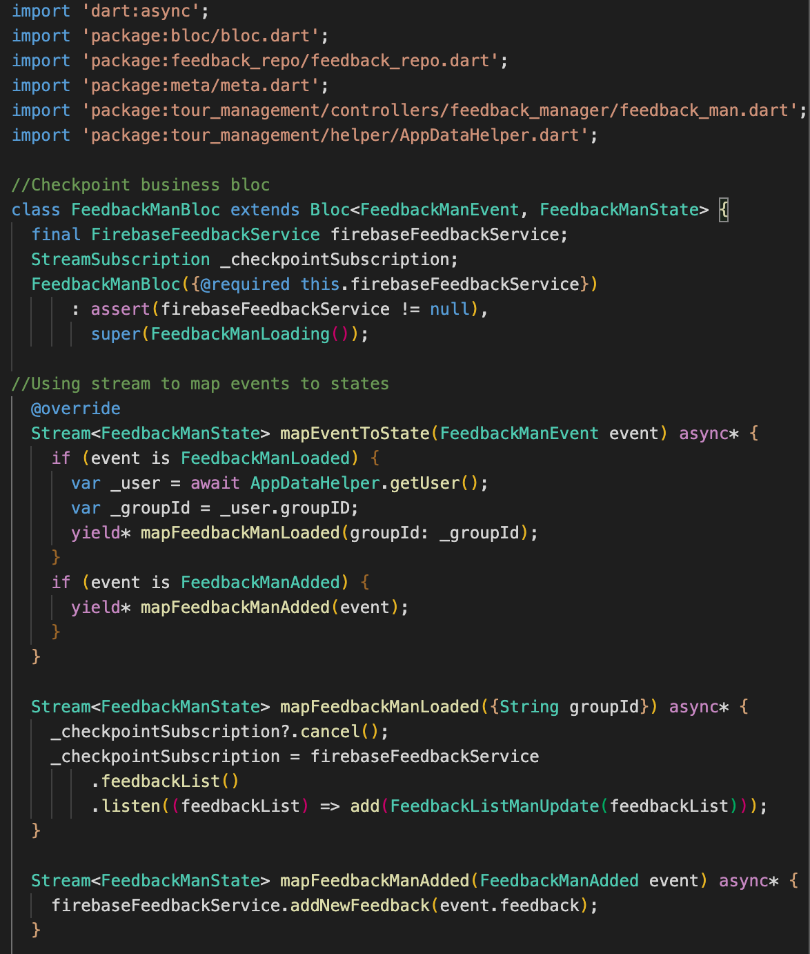

*Figure 92: feedback_man_bloc.dart*

As we can see, the feedback management bloc though similar, is very simple compared to ***checkpoint_mbloc.dart***. We only have the load feedback function on the event of fetch successful and the add function for participant to add a new feedback to the online collection. Since feedback only needs to be added, other functions such as edit, delete are not necessary therefore are not implemented in this bloc.

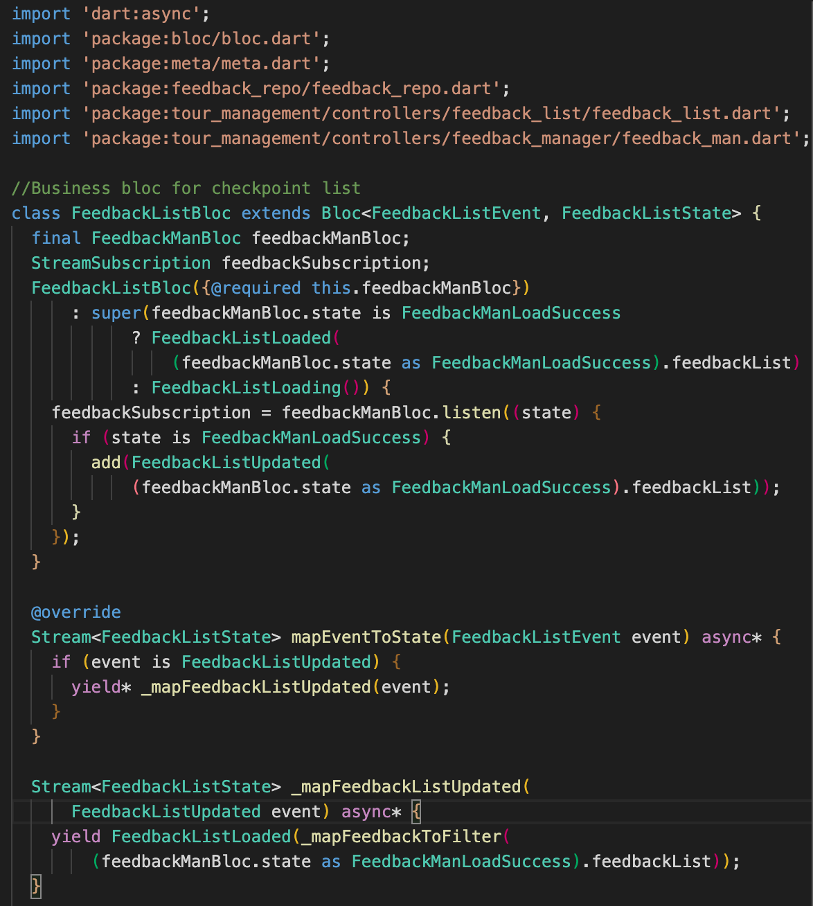

*Figure 93: feedback_list_bloc.dart*

The bloc for feedback list, similar to its management bloc, is very simple. The only function here is to load the fetched feedback onto the screen after checking for the status of feedback fetching by the management bloc. The function ***_mapFeedbackListUpdated*** follows the same principle as the mentioned list-related functions, this would update the list of feedback in the case of any new feedback was to be submitted by a participant.

***4.1.6 Implementing chat logic***

To implement chat logic, we need to implement the logic for creating chat rooms (list of conversations) and then create a chat (conversation) to the collection on Firestore as well as fetching them from Firestore to the application. The first to be implemented is ***chat_room.dart***, this class will take care of creating the chat room document to send to Firestore and when required will fetch them back to the application for display.

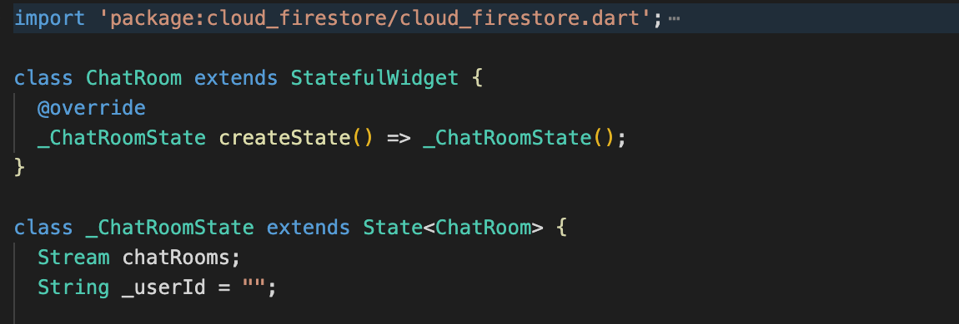

*Figure 94: chat_room.dart*

Figure 94 shows the creation of the ChatRoom class, which is a Flutter stateful widgets, meaning that this widget can have many states depending on the process of the application. We also declare a Stream for this widget to follow, which is ***chatRooms*** stream. This stateful widget itself hold a collection of smaller widgets and helper functions that provide control over chat room creation and collection.

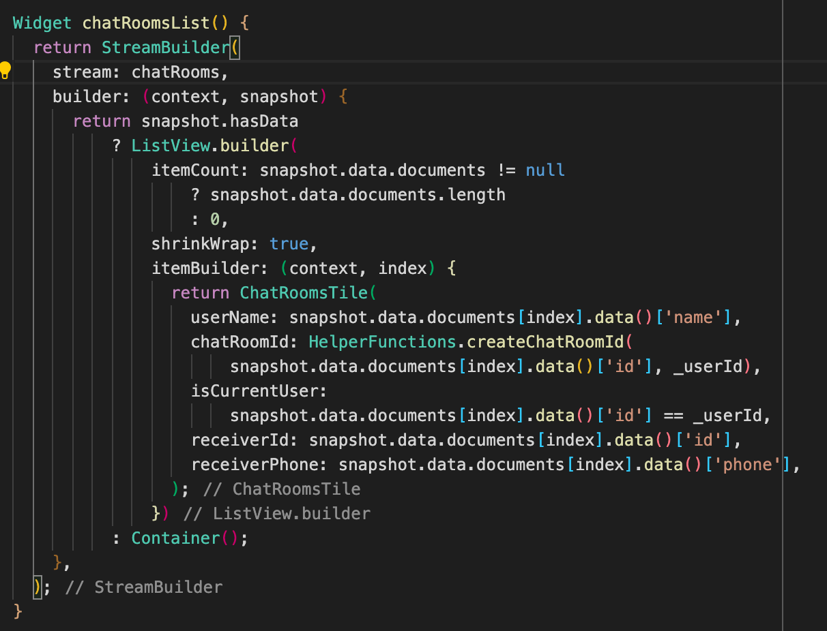

*Figure 95: chatRoomsList widget*

Figure 95 shows the ***chatRoomsList*** widget, this widget will read into the ***chatRooms*** stream for data and events. If data is available from Firestore, then the widget will create a list of chat rooms. The chat rooms to be displayed are themselves widgets that are called ***ChatRoomsTile***, which hold the information such as the name of the users, the ID of the chat and the recipient information.

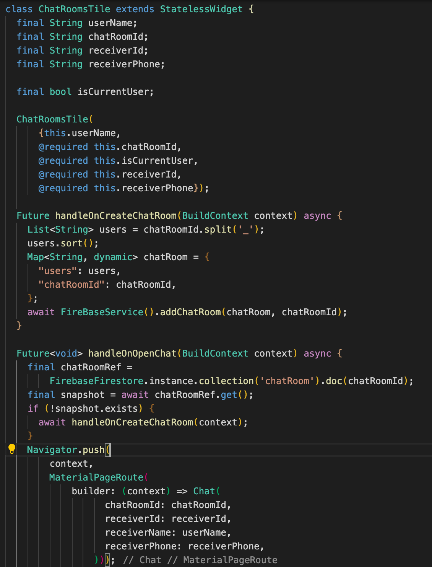

*Figure 96: ChatRoomsTile widget*

In the ***ChatRoomsTile*** widget, we find there are two helper functions. ***handleOnCreateChatRoom*** is to create a chat room of two users, with the chat room ID being the two users’ ID and the document will then be sent to Firestore for saving. ***handleOnOpenChat*** is to fetch the chat room from the collection ***“chatRoom”*** from Firestore then pushing the screen to a new screen that display the chat.

The second class to implement is the chat class. This class is for when user tap to join a chat room and start to have a conversation with the other user. A chat will be included in a chat room on the Firestore collection, with its own ID and participating users’ information collected from ***“users”*** collection on Firestore.

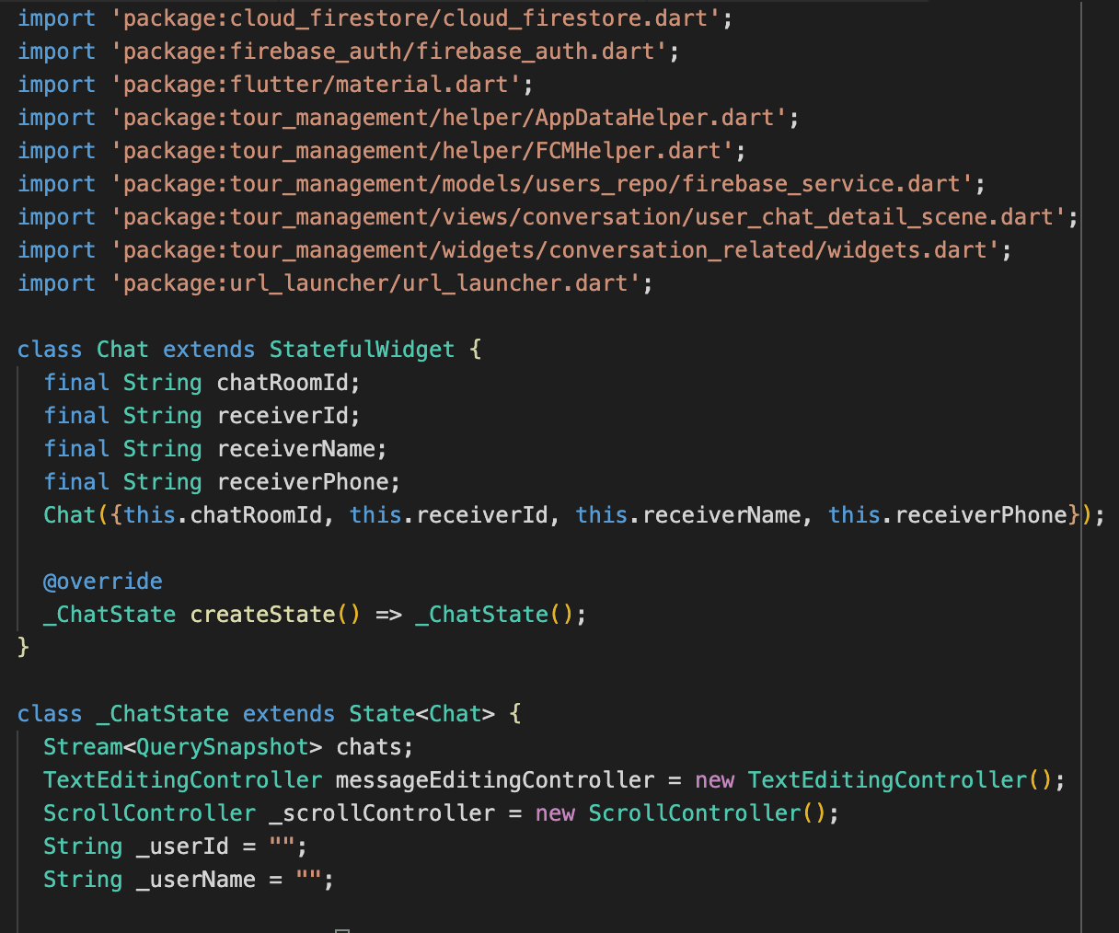

*Figure 97: chat.dart*

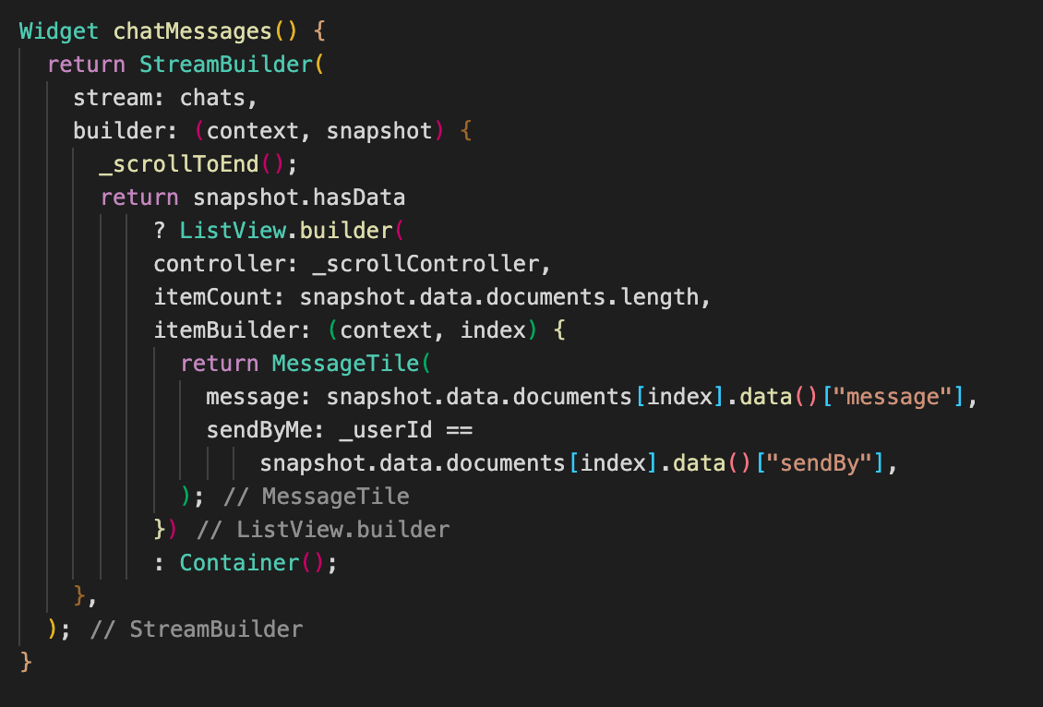

*Figure 98: chatMessages widget*

From Figure 98, chat follows its own stream called ***chats***, with the ***chatMessages*** widget that listen to the data and events of the stream. If the stream has data, then the chat windows will show a list of messages sent between the users using the widget ***MessageTile***.

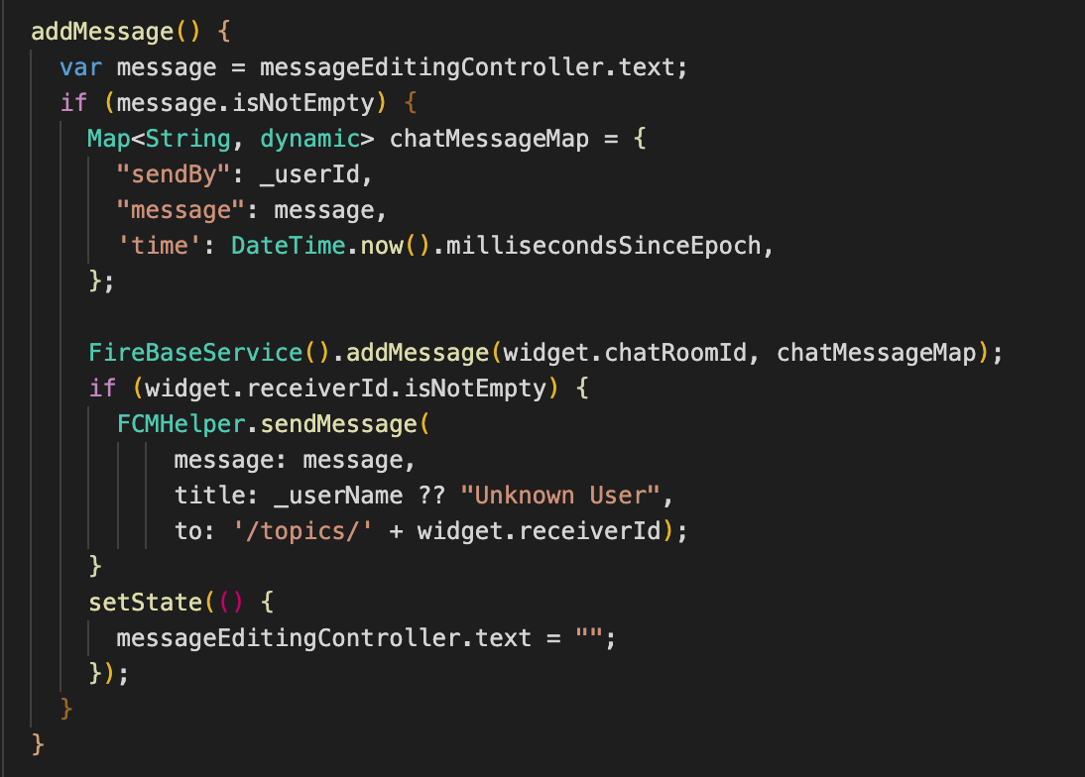

*Figure 99: chat.dart addMessage function*

The function ***addMessage*** will get the message content from the text input field, add in some information such as sender’s information, time stamp. The messages will then be converted to documents and sent on Firestore and save into the chat room ID document. After that, the state of the widget will be change to an empty text input field, waiting for the next message to be typed out. We also see a ***FCMHelper*** class, this is the class for handling the push notifications, this will send a new message notification to the receiver after the message is sent by the sender.

***4.1.7 Implementing helper functions***